ACAS
Applewood Computers Accounting System

Sales Ledger

Reference Manual

v3.3

This document is the Reference manual for Sales Ledger,
Applewood Computers Sales Ledger System which is, in turn is part of ACAS
(Applewood Computers Accounting System) and is
Copyright © Applewood Computers and Vincent B Coen 1980 - 2025 and later.

Which includes :
IRS – Incomplete Records System (used in place of GL)
Nominal or General Ledger also referred to as GL
Sales Ledger also known as Accounts Receivable
Purchase Ledger also known as Accounts Payable
Invoicing (module/s added into Sales and Purchase Ledger)
Stock Control (also known as Inventory) with links to Sales & Purchase.

This and the accompanying documents relate, to these Open Source packages.

Each sub system has its own documentation.

Applewood Computers
17 Stag Green Avenue
Hatfield
Hertfordshire
AL9 5EB
United Kingdom

Lead Programmer Email: vbcoen@gmail.com

Support Email: vbcoen@gmail.com
Website: www.sourceforge.net/p/acas

Copyright © 1980 – 2025 Applewood Computers

WARNING: This manual is still being rewritten as the ACAS package is being updated and tested for the current Cobol based system.
Some figures (menu and report items) have not yet been included - System testing will allow these to be added.

Author: Vincent Coen, The author asserts his copyright over this work.
Document update: 19 Sep 2025 17:38:28
Revision: 115
Software Version Date: September 2025 and nightly releases.
Software Version 3.2 and for final release of v3.3.
Word Processor: LibreOffice 7.5

1 3 5 7 9 0 2 4 6 8
Contents
1. System Update Advisories 8
2. Overview 1
2.1. Using the Documentation 1
2.2. The Operating System. 3
2.3. Cobol 3
2.4. Facilities Overview 4
2.4.1 System Configuration 4
2.4.2 Using the System 5
2.4.3 Responding to the System 5
2.4.4 SL System Facilities 7
2.4.4.1. Itemised Statements 7
2.4.4.2. Invoice / Statement / Late Letter Masters 7
2.4.4.3. Aged Debtor Analysis / Trial Balances 8
2.4.4.4. Cycle Billing 8
2.4.4.5. On-Line Enquiry 8
2.4.4.6. Credit Limit 8
2.4.4.7. Sales Analysis & Sales Statistics 8
2.4.4.8. IRS and GL Interface 9
2.4.4.9. Line / Stock Item Accounting 9
2.4.4.10. Sales Reporting 9
2.4.4.11. Late Charges 9
2.4.4.12. Prompt Payment Discounts 9
2.4.4.13. Late Payments & Reminder (Dunning) Letters 9
2.4.4.14. Adjustments / Credit Notes 10
2.4.4.15. Autogen (Recurring Invoices) 10
2.4.4.16. Invoice Production 10
2.4.4.17. Online Order Entry Support 10
2.5. Operating Summary 11
2.6. Using the Entry programs 16
2.7. Using the Print programs 16
3. System Set Up 17
3.1. The System and Parameter Files Set up - Option Z 17
3.2. Sample ACAS Parameter File Set up Report 34
3.3. Analysis Recording and Reporting Set up - option L. 36
3.4. Billing Cycle 38
3.5. The General Ledger Interface 39
3.6. The Customer Record - options B. 40
3.7. The Customer Print programs 42
4. Transactions 46
4.1. The Invoice Batch 46
4.1.1 Prerequisite Settings 46
4.2. The Invoice Proof - option F. 52
4.3. Posting the Invoice Batch - option G. 54
4.4. The Payment Batch 56
4.5. The Payment Proof. 58
4.6. Posting the Payment Batch 60
4.7. Recurring Sales Invoicing - options T. 9. 1 62
4.7.1 Entering and Amending Recurring Sales (sl810) 62
4.7.2 Proofing the AutoGen File - sl820 63
4.7.3 Auto-Generating and Posting Invoices - sl830 63
5. Pre and post Applied Reports 65
5.1. The Aged Trial Balance / Aged Debtor Analysis Reports - option Q 65
6. Payment Application 67
6.1. Payment Entry program 67
6.2. Printing Statements 68
6.3. Formatting the Statements 73
6.4. Late (Dunning) Letters 73
6.5. The On-Line Enquiry 75
6.6. Required system settings and changes 76
7. Operations 77
7.1. Option A - Date Input - sl000. 77
7.2. Option B - Customer File Maintenance (Data Entry) - sl010. 77
7.2.1 Set-up Customer records 77
7.2.2 Amend Customer records 78
7.2.3 Delete Customer records 78
7.2.4 Print Customer records 78
7.2.5 Display Customer records 78
7.2.6 Amend Back Order Status 78
7.3. Option C - Sales Ledger Enquiry - sl020. 79
7.4. Option D - Sales Transactions Input - sl910 79
7.5. Option E - Sales Transactions Amend - sl920 79
7.6. Option F - Sales Transactions Proof sl050 79
7.7. Option G - Sales Transactions Post - sl060 80
7.8. Option H - Payment Input - sl080 80
7.9. Option I - Payment Amend - sl085 80
7.10. Option J - Payment Proof - sl095 80
7.11. Option K - Payment Post - sl100 80
7.12. Option L - Set-Up Sales Analysis Codes - sl070 80
7.13. Option M - Sales Analysis Report - sl130 80
7.14. Option N - Sales Day Book - sl140 80
7.15. Option O - Statement Production - sl110 80
7.16. Option P - Dunning Letters Generation - sl190 80
7.17. Option Q - Aged Debtors Analysis - sl120 80
7.18. Option R - Alphabetical Customer List - sl160 80
7.19. Option S - Customer Turnover Report - sl180 80
7.20. Option T - Invoice Sub-System - sl900 81
7.20.1 Option 1 - Enter or Amend Invoicing Fixed Data 81
7.20.2 Option 2 - Enter Invoices For Batch Printing - sl910 82
7.20.3 Option 3 - Enter Invoice For Immediate Printing - sl910 82
7.20.4 Option 4 - Amend Invoices - sl920 82
7.20.5 Option 5 - Delete Invoices - sl940 82
7.20.6 Option 6 - Invoice Deletion Report - sl200 83
7.20.7 Option 7 - Print Delivery Notes/Picking Lists - sl950 83
7.20.8 Option 8 - Print Invoices - sl930 83
7.20.9 Option 9 - Recurring Invoice Processing - sl800 83
7.20.9.1. Option 1 - Enter / Amend Recurring Invoice - sl810 83
7.20.9.2. Option 2 - Proof Recurring Invoicing - sl820 83
7.20.9.3. Option 3 - Post Recurring Invoices - sl830 83
7.21. Option A - BO Reporting and amendments 84
7.22. Option X - Return To System menu 84
7.23. Option U - End of Cycle Processing - xl150 84
7.24. Option V - Customer File Dump - sl170 84
8. ACAS System wide File and RDBMS Table Usage Chart 85
9. Individual file details where needed. 87
9.1. ACAS System file 87
10. Reporting problems with ACAS products 89
11. Error messages used within the ACAS system 90
11.1. Cobol and C Error Messages 90
11.2. ACAS Error Messages 90
11.3. SSDs and Garbage Collection. 91
12. Sales Ledger Error Messages 93
12.1. ACAS System wide Messages 94
12.1.1 From FH (the Cobol File Handlers) 95
12.1.2 From DAL (the RDBMS Data Access Layer) 95
12.1.3 From FH-and DAL Logger (During Testing only) 95
12.2. System wide Messages for Sales 97
12.2.1 System wide Sales FH ~(File Handlers) 97
12.2.2 System wide Sales DAL (the RDBMS Data Access Layer) 97
12.2.3 Specific Sales Messages by Program or program 97
12.3. File Access Error numbers 105
12.4. RDBMS error codes 106
12.5. MySQL SQL Status messages 106
13. Error Recovery 107
14. Scripts 108
14.1. acasbkup.sh 108
14.2. acasbkup-Post-EOY.sh 109
14.3. acasbkup-Post-EOY.sh 110
15. Command Key Summary 111
16. Manual errors or omissions 112
17. Appendix 1 - Program names by purpose by file usage. 113
18. Appendix 2 - Detailed program amendments. 114
19. Appendix 3 – Sample Reminder Letters. 118

Table of Figures

Once I find out how !

But if you know please drop me a note as to what to do, see inside front cover for email address.

This manual is under rewrite / updating during full system testing for v3.2 and final v3.3.

This manual like all of the ACAS manuals, may well have errors in grammar, detail or by absence or presence of information that does not match the software discussed.

Every endeavour is made to ensure accuracy, but manuals like software, can have bugs despite multiple readings of the same document. After a time, you end up with word blur so having others to read them helps. If you find any faults, please report it along with any suggested changes, see inside front cover for email contact details. Please do not assume that others have done so.

System Update Advisories
2024-03-28 BO (Back Ordering) has now been implemented but subject to full system testing. This requires that the parameter file is updated for the following fields:

1. In SL (Sales) - Set BO Flag to "Y", Set BO Default to "N" (default) or "Y" - this is the default for all new customer records but all existing ones are treated as "N".
For BO to be used, a customer must be set as "Y". A facility in Sales Customer amend will allow the entire customer file to be updated so that BO Flag is set to "Y" or "N" as required.

2. Invoicing must be at level 2 only (default) with Stock control linked. Previously when entering order quantity, the on-hand stock quantity is shown on quantity input, where user changes it to the amount required with no option to increase beyond the on-hand amount - now this can be higher and the amount above on-hand amount is allocated to a BO record and only the on-hand amount allocated to the invoice. If the entered quantity is zero, that line item is cancelled and restarted for another line item or finished for totals, etc., as previously.

3. The BO file holds stock number; quantity required; customer number, purchase order, reference number, active invoice no (if applicable otherwise zero), date of order, current price, invoice type, estimated arrival date and lastly a flag to indicate that stock has arrived as input in the stock additions program. This program has also been changed to update any BO records for that stock number that has updated the on-hand quantity by setting the arrived Flag.

4. New program SL970 via menu option T, A will produce reports for outstanding orders by Customer and by Item showing all the fields as indicated in (3). An option is also provided to allow for the rarely required, maintenance of the BO file to Create, Amend and Delete a record. Here it is expected that for amend, that only quantity, arrived flag and price is to be changed if really needed. Input to accept all fields for a new record and lastly to be able to Delete a record if the order status has changed such as been cancelled by customer or no new stock will arrive, etc. or a manually new invoice has been entered for the BO item.

5. Another option allows the invoicing program (sl910) by default, to read the BO file and create (subject to any changes needed by user) a new invoice for the newly arrived stock. This change allows for any other BO items for that customer that is now in stock to be added with the invoice type recorded from that of the original invoice used and then the BO record deleted, when writing out the invoice for printing, before which, the totals screen is shown to allow for such items as post and packing charges to be added, etc.
The processing of BO records can be skipped as a message will appear to request continuing of such shown as Process Back Orders as there are nnn to Invoice ? [ ].
Responding N will skip all BO invoice processing.

Otherwise the user can use up to date reports from SL970 as input to create the new invoices manually and the use SL970 to delete the now newly arrived stock that has been invoiced, otherwise the record would remain in the system. The default option (5) is now the normal. to cut down on extra work loads by the invoice entry personal.

6. To confirm, this processing of the BO records allows for quantity to be changed and the stock retail price and some other conditions, but not for receipts as it is assumed that it has been prepaid.

Overview

Using the Documentation

This manual should be read in conjunction with the manual ACAS- Building the ACAS System and this one, should be read first, at least for an overview of the system.

The first section of this manual presents an overview of the system and an explanation of how to run the various programs. The remainder devotes a chapter to each individual process or program in the system. later on is the process undertaken by each program on a program by program basis, see chapter 7 , page 77.

References to programs, modules or processes should be accepted as the same thing in that they are separate units that act as a process or function as indicated from the menu. They in turn may call others as needed. Here consider that files and tables (for rdbms) mean the same in that they hold data for a given requirement. These are documented later in this manual and in the Building the ACAS System manual. All references to Sales, Purchase and Nominal Ledgers, Stock Control and IRS have the same meanings as Accounts Receivables, Accounts Payables, General Ledger, Inventory again).

In many instances, Nominal is referred to as General depending on where it is presented, just depends on where you are from, but the former are normally the terms used in the United Kingdom and the later in North America although it can even differ in different part of the UK based on the profession of the user.

Read the overview before moving on to the rest of the manual. Read all the documentation thoroughly before setting up and running any of the programs.

After reading the documentation decide which of the optional features you desire. After making these decisions, re-read the operating summary before you begin entering real data. You may find it beneficial to create a practice set of data first, before you invest time keying in real data.
A practice company could consist of 10 to 15 customers, 10 - 20 stock items and 25 to 30 invoices. Running through one or two accounting cycles (e.g., monthly, quarterly, etc.) with this data which will help to clarify the operating procedures.

If you are converting from a previously used system it is possible to transfer the data from the old system to ACAS. To do this, you will need to obtain details of that system including the file names and data layouts for each file used where ever possible, and pass them on to us. In the worse case scenario, a copy of all the data files and a printout (or .pdf) of each system report such as lists of customers, outstanding invoices, etc., as is available. You should contact us using the details on the inside front cover, detailing what you want to migrating from.
This facility is offered to ALL users of ACAS but under some conditions you may be asked to contribute a donation to the 'keep the light on' fund :)

If you encounter difficulties using ACAS please, examine the documentation carefully before contacting us to make sure your questions are not answered there. While we are happy to discuss constructive ideas and welcome your comments and opinions, we cannot act as a substitute for our documentation. If however, you spot omissions or inaccuracies in these documents that do not reflect with the current version of the software please report it via email Attn: ACAS Technical writers to vbcoen@gmail.com mentioning the system being used and the software version and submit a bug report on the ACAS website using the bug reporting tool.

This applies to the open source version as well as to the paid for version.

The Operating System.

The ACAS Sales, Purchase & General Ledger systems along with the IRS (General / Nominal Ledger) and Stock Control, makes use of the facilities of the O/S (operating system) regardless of the type e.g., Linux, Unix, Windows, OSX, etc. Questions relating to the O/S, should be referred directly to your IT department or the original computer supplier or even a Google search.

Cobol

All of the ACAS programs are written in the 2002, 2014 & 2020 and later dialects of the Cobol programming language with some aspects of older dialects, using GnuCOBOL (a free to use and own) Cobol compiler. This needs to be installed (and built if needed) on the computer used to build the system, which may also be the same as used for running the ACAS system. Note that if you are using one computer for building (compiling the source code) the ACAS system and other computers to run it, then the version of the operating system should be (exactly) the same to minimise problems, e.g., using the Linux distribution Mageia v9 to build then it should also be installed on systems running the ACAS system. Failure to do so could result in a range of error messages saying that some elements of the system can not be found such as libraries or their components. See the manual “Building the ACAS System” for instructions for obtaining the GnuCOBOL compiler and for installing it on your computer. These type of issues can be resolved by simply installing the missing packages and doing so for each system ACAS will be run from. This should be done first before compiling the ACAS source code into a form that can be used, again see the Building the ACAS System manual for more details on how to do it.

Note that the GnuCOBOL compiler is not the only compiler that can be used e.g., Micro Focus Cobol can also be used but some changes may well be needed to the ACAS source code in order to compile without errors, again see the Building the ACAS System manual for more details. The changes needed will vary depending on the compiler used. Note that use of Cobol-IT (which uses a version of the original Free to obtain and use OpenCobol v 1.1 (now named GnuCobol) compiler) is a very old copy and many functions may well not be available in it, that are used within ACAS, and therefore we cannot support Cobol-IT in any way but in any event we do not hold a copy of it as this is a expensive chargeable product, likewise Micro Focus Cobol.

The same issues regarding Cobol functionality could apply with any other compilers. These changes will require Cobol programming experience and If this is an issue then you can contact us for support to resolve such issues. This is a chargeable service along with any license for any required software, e.g., the compiler.

Using the current GnuCOBOL compiler is the cheapest option as it is totally free, regardless of the number of computers in your company and is the recommended Cobol compiler to use.
This is available for use on Linux, OSX and other *nix based systems as well as Windows running Msys or better still via the optionally installed WSL (2 or later) with Linux installed using a range of different Linux distributions. Note that in-house testing using WSL has been very limited.

Facilities Overview

System Configuration
The ACAS system runs on any computer system under the control of one of the operating systems that can run the GnuCOBOL Compiler (or a commercial alternative). The system should have the following minimum hardware components (for which almost all modern systems will have):

- 4 Gb Random Access Memory (RAM). ACAS uses under 100Mb when running. For Windows based it should be 8 to 16 Gb when using version 10 and higher.
For Linux 4 to 8 GB subject to the number of staff that will be using the ACAS system at any one time.
- One hard drive with at least 1 GB (one gigabyte) free space but a lot more is seriously recommended to improve the performance of the ACAS system and all others on your computer.
- It is recommended to be above 64 GB at all times.

- One and up to three suitable printers that can be a Ink jet, laser, matrix or line-printer type, that has been set up using the CUPS printer spool system or a similar tool.
- Note that the last two printer types can use continuous paper and be preprinted with your company logo and other information such as might be needed for Invoices etc.
- These printers should by choice, be connected via the office LAN (local Area Network) to your internet router (or similar) or via Wi-Fi, assuming you have a good Wi-Fi service throughout the office building making use of Wi-Fi repeaters as needed. These days almost all printers can connect via Wi-Fi and the LAN (via wired cable). In the event that Wi-Fi service is poor, due consideration for wiring up a LAN network around the office to connect up all computers in the building and allowances for future one's to be added but note that using the LAN cable that is close to any power cabling is NOT recommended due to interference caused by it and here the use of good quality LAN cable that has an earth strap/wire that is connected through to the building earth system is the best fix but still avoid routing LAN cable next to power cables (other than crossing such at 90 degrees angle only).

- Any monitor type e.g., oled, led, lcd. etc., to name but a few now available

- Any modern processor type from Intel, Amd, Arm, and even an IBM mainframe.
- When sharing data, a LAN (Local Area Network) with a speed of 100Mb or higher - see comment regarding printers.

Most if not all computers these days, match and exceed these requirements but systems can usually be expanded or adapted to meet these requirements if needed. Your IT department or local main computer dealer can give you specific information regarding hardware availability.
If you system will be set up to use one of the community edition (Free to obtain and use) database packages such as MySQL or Mariadb, you must set this up on a system that will be running at all times and it is recommended to set up a second one so that the database systems can run in Parallel - that is, the primary systems passes to the other, all transactions so that the system is fully resilient in the event of a problem such as a hardware failure.
The database systems can be configured in this way - see the DB documentation.
See the manual ACAS - Introduction to the ACAS system for more advise regarding system set ups to support usage of ACAS and any other software used within the business.

Using the System
It cannot be stressed too strongly that computers are liable to break and that computer users are liable to make mistakes when using a computer. Because such errors cannot be completely avoided, they must be provided for. The way to protect data from accidental loss is to make copies of your data and store them in a safe location. Every time the ACAS data go through a major transition, such as every time invoices or cash is applied, all data files should be copied onto another medium. The value of your data is always worth more than the media itself whether it is a CD, DVD, USB stick or an external hard drive including a cloud service.
Whenever any ACAS system terminates via the exit option (X), an automatic back up occurs of all of the data files used by the system to an archive with a fixed file name along with the current date and time. This should be copied to an external medium such as the cloud or other similar service immediately after.

Using Mysql or Mariadb rdbms, you will have to set up a back up procedure for it on a regular basis even if you will run it in parallel with other in-house MySQL, Mariadb systems subject to the requirements of any other systems in use. The same will apply to any other rdbms in use. Under Linux you can use the optional tool webmin to set up a back up for the database for many such systems, although there are other ways to do so.

Always keep at least one full copy of the ACAS system backup, but it is recommended to keep at least three generations of backup. If running standard Cobol data files the sizes are quite small and if running the system using a rdbms (Relational DataBase Management System) such as Mysql or Mariadb they are not much larger – the ACAS data, that is, but all data should also be backed up.

Responding to the System
All sub-systems (e.g., Sales, Purchase, IRS, Stock and General, etc), in ACAS are interactive, which means the programs display requests for information on the console and the user types in the desired response. The response is usually checked instantly, and if found to be invalid, an error or warning message is displayed and the request re-issued. All responses may be made with either upper or lower case characters but Y or N are always converted to upper case for testing. After the proper response has been typed in, the return key must be usually pressed, and must generally follow every response since it signals to the system that the data has been entered and the programs may proceed. It cannot proceed until return is detected. In many cases as described in the manual, hitting only the return key is a valid response. The one exception to this is for menus where the option letter or number is often only required.

All the programs that make up Sales Ledger (or for that matter any of the other systems) must be run from ACAS or a system menu, e.g., sales, purchase, stock, irs. Figure 2.1 shows the Sales Ledger menu. To select a function you simply type in the letter of that function. Selection can be upper or lower case, i.e., A or a.

To run the system you need a terminal console program such as konsole or QTerminal, etc. that must have been configured as a minimum of 80 columns wide and at least 24 lines deep - it can be as deep as your screen can cope with, such as 52 and the extra will be used for the data input and data display programs.

The menu is called via a terminal or command program by typing:

ACAS and selecting B for Sales Ledger, see figure 1.1

or

sales

at the command prompt.

The same applies to the other ledgers or sub systems (for example, sales, purchase, irs, general, stock, oe, payroll). Of course you may set up a desktop link to a bash script (when using Linux) that also calls 'sales' having moved to a suitable directory if needed such as ACAS, although the system is set up to use a specific directory (as set up by the user) for all data files regardless of where it is run from. After selecting a specific function, a fresh screen appears and the program name and its version number is displayed in the top left hand corner along with the system date which might not be today's date. This can be changed by the first selection offered on the menu (option A), but for normal processing would be today's date. If the system is set up to use a database instead of Cobol data files, this process must still be followed as the ACAS parameter file is always required as it informs the system of where and how to access the database or data files.

Note that a data directory location override feature is available by specifying to any of the systems as a parameter to it, such as
sales ACAS_LEDGER=/home/username/test-dir-1.

This is not normally needed but it is there, if you do.

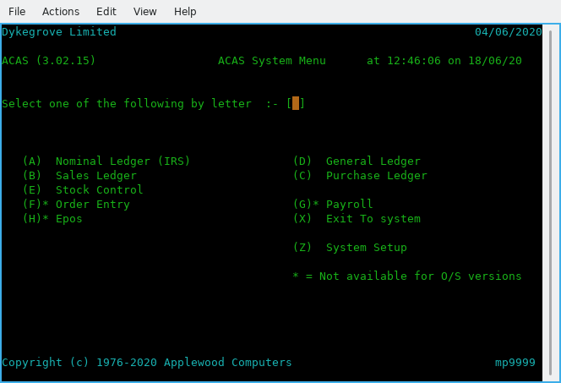

Figure 1.1 - The ACAS menu

SL System Facilities

The SL (Sales Ledger) system is designed for use by business management and accountants who need to maintain control over their outstanding sales invoices. The package is very generalised so that it can be adapted to a wide range of business applications. The system utilises an open item invoice system in that all unpaid invoices remain in the system for reporting or to display upon until paid.

The following section describes briefly the advanced facilities obtained from the menu as shown in figure 1.2, which are available with the SL system.

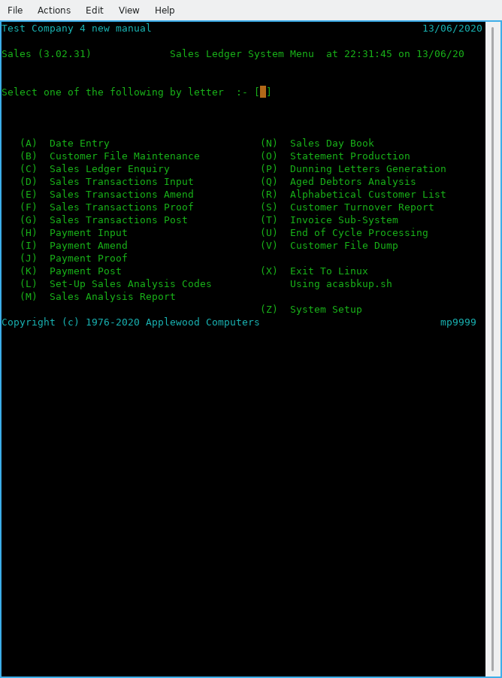
Figure 1.2 - Sales System Menu

Itemised Statements

Individual periodic statements may be generated for some or all customers. Statements are normally generated once per billing period, e.g., monthly. The format of the statements may be modified to suit the requirements of the user. See the statement program sl110 source code and chapter 68 along with figures 22.2, 3 and 4.

Invoice / Statement / Late Letter Masters

Artwork is distributed with the system that may be used for printing Invoices. Statements and Late Letters. Space is left for the company name and address to be preprinted at the top. Forms with the company name area left blank may also be used. Please note that some elements may not be supplied with the open source version of ACAS due to copyright issues.

The system will automatically print the company's name at the top of the form and the stub. Continuous Statement forms are available in limited volume from Applewood Computers as well as a sample page via mail that can be used by a paper supplier to match to your requirements. In addition all three forms can be produced using a word processor such as LibreOffice that uses a template for creating any logo, company name and address etc..at the top of each document that can be linked in to mail merge and here the better quality laser or inkjet can be used for such. In addition, all three document types can be sent via Email instead of by post, therefore reducing costs and warranting definitive delivery to each recipient assuming the email address has been set up on each customer record where available and setting up the correct flags for each form type, see later.

Aged Debtor Analysis / Trial Balances

Aged Debtors Analysis and Trial Balances, are available from the system: detail, summary and exception reports where you can select from various criteria.

Cycle Billing

If the number of customers or the need to spread the periodic workload requires it, the system can support cycle billing. Processing can be broken into logical parts based on the cycle. Each cycle is represented by a single letter of the alphabet and zero through nine. Thus, up to 36 cycles may be defined for use which with a customer number in the form of A12345n where A = cycle, n = check digit. Gives 99,999 x 36 as a total customer count of 3.600,000 – 36. Changing the system to also accept lower case a-z as separate values from A–Z would increase it to over 6.2M.
Note for version 3.02 this has been reduced and cycle billing will be done via account numbering and selective statement production if needed. There again, faster printers also solve the problem, as well as using the Email method of delivery.

On-Line Enquiry

Information on the sales or debtor status of any customer can be retrieved instantly by the on-line enquiry program. All information, including non-applied cash and non-billed (not yet printed) invoices can be displayed on request.

Credit Limit

Each customer may be given a specific credit limit. All reports will flag any customer whose outstanding debtors balance exceeds their stated credit limit. The limit can be changed at any time. A credit limit check also occurs when creating an invoice.

Sales Analysis & Sales Statistics

For each customer, yearly sales figures broken down by three monthly (quarters) is maintained in round robin mode. These figures are net e.g., no Tax / Vat, post and packing figures are included in these statistics.

IRS and GL Interface

If the ACAS IRS or GL system is also used, the system will feed summarised sales and debtors information into the IRS system into a special posting file and the GL into the batch and GL posting files. The collection of data is automatic but the actual transfer between systems is for IRS handled by a special process that may be run at any desired interval within IRS via program Transaction Posting menu option 66 before or after processing 88 - Add to Existing Postings.

Line / Stock Item Accounting

If the sales entry level 2 (default) option is enabled during initial system (parameter) set up, any invoice may be entered into the system in Stock / line item format. This allows an invoice to be entered as a series of individual stock items rather than as a single unit. Items such as Vat and shipping may be accounted for separately in this fashion. Also, product sales data can be entered in separate analysis codes this way. This is the method that must be used if you are also running the linked Stock Control system as they are inter-twined. Using the Stock Control link also allows for charging for other services such as labour as an daily or hourly rate, renewable subscriptions, rents, equipment hires, etc., allowing extra statistical reporting. It is recommended to make use of the Stock Control system when selling products of all types and it make entering invoice so much easier and quicker.

Sales Reporting

If the default line item accounting is used, the information entered can be reported using the sales analysis feature. This report shows the accumulated sales data on an analysis code basis for the current period, last period, and year-to-date. For audit purposes this is the recommended method and is in addition to all other processes.

Late Charges

This option allows the system to automatically levy late charges on customers who fall behind in their payments. This feature can be specified in a variety of different ways.

Prompt Payment Discounts

This option allows a system wide feature that if invoices are paid within a defined time period such as 14 days then an automatic discount of a fixed percentage, is taken from all affected invoices. This help to encourage early payments and improve cash flow.

Late Payments & Reminder (Dunning) Letters

If specified, the system will automatically print reminder (dunning) letters to any customers who fall behind in their payments. Up to three letters may be defined using either the text supplied by the system or any message you desire. The letters can be issued with increasing severity every billing cycle (normally 30 days) starting at either 30, 60, or 90 days. Individual customers can be exempt from receiving them. The system produces files for each period (30, 60 & 90) which can then be input to the mail merge function within a word processor such as LibreOffice Writer or Microsoft Word or Enscript to generate .pdf files sent via email if turned on for the specific customer. Note that Libreoffice and Enscript are free products there is no fee to download or use.

Adjustments / Credit Notes

Adjusting entries in the form of credit notes can be made through Invoice entry.
Credit adjustments can be made for individual customers or for individual invoices.

Autogen (Recurring Invoices)

When invoices are generated regularly for the same customer and amounts, this subsystem can be used at any time to enter and modify the recurring invoices. The system keeps track of when the autogen cycle is required and will produce an invoice to be feed into the system. The entries are not updated at time of posting to the Invoice file so if any need changes it must be done using the Autogen amend program.

Invoice Production

Invoices can be created in a variety of differing ways to cater for the range of different businesses. These include batched input and printing or ad hoc, as well as input via the optional Order Entry system. Packing/Picking notes can also be printed and be sent to a specific printer such as one in the packing department. The print order is Packing lists before Invoices otherwise you run the risk of not being able to unless you answer a few questions as override.

Online Order Entry Support

With the latest version of ACAS, all data processing using files or database processing is handled via two special modules, one for all files and the other for all tables. For each file used within ACAS, there is a similar table. There is two modules for each file and table, and these are called, for file processing a FH (File Handler) and for tables, a DAL (Data Access Layer). These can be called by other applications such as online OE (Order Entry) to access the stock control data to verify stock availability and to update stock when an order is accepted as well as transferring the order information to the invoicing system to generate a receipt. The only requirement is that the OE must be able to call them using the C (programming language) call interface and many programming languages can do so. In this way there is an automatic interface between OE and ACAS with minimum user interaction required. Please note that the Invoicing option within Sales handles most if not all of the functions of Order Entry including dealing with Back Orders (as of March 2024.

Operating Summary
The 11 sections in this chapter correspond to the 11 major processing steps in the Sales Ledger system (Figure 3.1). The text describes when each step can or must be run from the viewpoint of a computer operator or user, If the printer is required, and any other operational concerns are also discussed. The programs mentioned in this chapter are described in greater detail in the remaining chapters. This section is an operational guide only.

Some steps will only be run once or twice, such as the Set up's e.g., System, Invoicing or Analysis Codes. Other steps are run on an irregular basis with no relationship to the billing / invoicing and statement cycle timing, such as Customer File Maintenance. Others are run very regularly, yet not necessarily on a one to one relationship with the billing cycle such as the invoice or payment input steps.

Even programs in the individual steps need not be run at the same time. For example, you might run the invoice entry programs more often than the invoice proof and posting programs, yet all of these programs are considered part of the invoice entry step.

Steps 1, 2, 3 are preliminary steps that are run infrequently normally on the initial set up of the system where steps 1 is the same for all of the ACAS sub-systems and step 2 for both Sales & Purchase Ledgers which is also tied to IRS (or General Ledger) as the accounts need to be set up in order to provide account numbers to link to each Analysis code. Step 3, to set up invoice i.e., layout and if company name and address to be printed etc.

Step 4 for creating and maintaining the Stock control system records for products or services sold or charged for including to record new stock arriving but also see Purchase Ledger.

Step 5 is used to create the data for each customer when required or to modify information on existing customers such as address changes, credit data, email addresses, phone numbers, etc.

Steps 6 and 7 are the main financial transaction steps in the system and are used most often. These steps may be run often, depending on the volume of transactions. There is no sequential relationship between invoicing entry and payments entry. Payment receipts programs may be run as many times as necessary without regard for the number of times the invoicing entry programs has been run. Most of the data entry work is in these two steps.

Note that if you are using the optional Order Entry sub-system or the E-shop Data Transfer programs, then both of these will create invoicing or payments data as well as passing information to the stock control system and this in turn will cause additional report information in the Sales and even the Purchase ledgers. Simply put, all of the ACAS sub-systems pass data between themselves which is stored onto the correct files for further processing where required. Thereby minimising work load.

Step 7 - Payment Posting, is the one step required by the system to be run on some fairly fixed schedule. The payment apply program must be run at least one time per cycle per billing period although often daily is the more usual time frame, but it does depend on how often you are doing bank and mail / email receipt reconciliation's.

For v3.02 this may not still be valid, in that postings can be done at any time but it is still sensible to run on a regular minimum schedule such as once or twice daily subject to frequency of obtaining bank receipt information via an online facility.

Steps 8 through to 12 are optional steps. Reports (step 9) may or may not be generated on a specific schedule, however the IRS (or GL) data extract (step 10), must be run after posting the days final invoices and payments, so that reporting is valid as at say, the end of each day.
Step 11 recurring invoice creation, as needed if being used.

- System Setup & Parameter Entry
- Set-Up Sales Analysis Codes
- Invoice Setup
- Stock Control Setup
- Customer Entry
- Invoice Entry
- Payment Entry
- End of Cycle
- Producing Reports
- IRS or General Ledger Extracting
- Auto Generate Invoices
- Back Order Reporting
Figure 3.1: Processing Steps

Step 1: System Setup & Parameter Entry

System set up must be performed once before any other programs in the ACAS system are run, except for the menu program ACAS or 'sales', from which the System setup program is automatically run if no system files exist. If you need to rerun this, it is always option 'Z' from any of the main menu's in Sales, Purchase, IRS, Stock and General. System Set up may be run any number of times after its initial execution.

A printed report on the current system parameters is available from this program. The report serves as a backup and should also be considered part of the audit trail.

Step 2: Set-Up Sales Analysis Codes

This step is normally only done once and after having set up IRS (or G/L) accounts that will retain the totals from the analysis codes. On first entry, it will create predefined codes for Vat / sales tax etc for both Sales and Purchase. Any others required, can be added. This step can be used at any time if you need to create more codes. This function is available for Purchase as well as Sales.

Step 3: Invoicing Sub-System Setup - option T

This function is usually only needed to be done once and is selected via menu option 'T' and defines the basic processes that Invoice Entry will adopt e.g., invoice number generation, discounts etc along with invoice entry level and this defines: do you only require a total amount for entry or a line by line entry for each product or service which is the norm.
The second option is the one recommended for most business types, even if you are service oriented only, as each service type can be entered into Stock control.

Step 4: Stock Control Setup

Enter your sales products as stock items with retail, cost pricing, produce source (suppler etc) , stock location (for the packing team) and other sundry items. You will need a stock list to be taken at a quiet time such as a weekend or bank holiday so that the current stock position is fully recorded for all items sold. This applies to any time where no packing is taking place.

Step 5: Customer Entry

Customer entry must be performed at least once before any higher numbered steps. It may be run any number of times at any point after step 1, 2, and 3.

The customer entry step consists of a data entry step, an optional printing step that may precede the others. This prints the customers in customer number order, however other options are also available.

Step 6: Invoice Entry

This step may take place any time after steps 1, 2, 3, 4 & 5.
The Invoice Entry step consists of four programs: entry, amend, proof and can be run as many times as desired independently of each other. Running post is the final function after completing a last proof step. A function exists that allows you to create a new customer should the need arise during invoice entry instead of using step 5. The notes for Step 7 also apply.

Step 7: Payment Entry

The payment entry step may be run any time after steps 1, 2, 3, 4 and 5. You cannot process payments if invoices do not exist and have been not been proofed and posted.
This step consists of four programs: entry, amend, proof, and finally posting. The entry, amend and proof programs may be run as many times as desired independently of each other. These programs can build, modify, and report on a batch of payment transactions until that batch is posted.

You may proof a batch any time during its development and a proof report must be processed before posting. A proof is part of the audit trail assuming it is taken immediately before posting (i.e., no intervening executions of a Payment Entry). If run before an execution of Payment Entry or Amend, the proof is considered a work sheet only. The final audit proof must be taken just before posting.

Once the current batch is complete and accurate and has been proofed for the final audit report the batch can be posted to the open item file. You can only input a payment to a posted invoice that is now on the open Item file so where a payment is sent with the order etc, you must only issue a receipt instead of an invoice.
Payments should be checked again your bankers online service which, for the UK at least occurs within minutes of the purchaser sending the money online. Some small banks may not offer this service and if you are with one, you should seriously consider opening an account with a main line bank that does offer such a service, even if you transfer such funds over daily or weekly to your primary account.
Step 8: End of Cycle

This step is normally run at the end of the last business day of the month and processes statistical data for the monthly cycle and passes data to the IRS (or G/L) systems. It precedes this with a Analysis and Day Book report for S/L and similar for P/L and the other sub-systems then updates all system files for end of month. Note: This is done for all of the sub systems, Sales, Purchase, Stock, etc, at the same time but the user can specify. Prior to running this step is is recommended to always carry out a back up of all of ACAS data files as there is no recovery from this action other than restoring the files. The same applies, if you are running a rdbms system in place of the standard Cobol data files but note that if you are, the system (parameter) file is always maintained in the ACAS data directory. The system, unless changed when installed, will make a back up of the standard Cobol data files after the user selects 'X' for exiting the system and as supplied it does not do so for rdbms as there is multiple ways of doing so, at controlled intervals. For IRS and General (if used over IRS), these have their own end of cycle processing so read the relevant manual for more information although in most forms this is only required at the end of year.

In the event that this process is run after the last day of the month e.g., a few days into the new month because of holidays or weekend, then the date set function which is menu option '1' should be set to reflect the last day of the preceding month before running End of Cycle if only for the date that is printed on the reports.

There is also a end of year cycle that runs for all subsystems that are used within ACAS, again IRS or GL differ as at least for IRS can be run into the new year, see their manual for more details.

Step 9: Producing Reports

Any of the report programs can be run at any time after step 1, but the results will not be meaningful until the appropriate steps have been completed and normally step 7 has also been run, and the various Sales reports after steps 7 etc).

The Sales Day Book and the Aged Debtors Analysis report should be considered part of the audit trail as well as for the users in the Sales team who require them on a day to day basis. The same applies for the Purchase Ledger reports and as needed for Stock Control.

Step 10 IRS / General Ledger Extracting

The IRS (and GL) extracting step is a non selectable process. It applies for both IRS and GL It is done automatically during steps 6 and 7 within the posting processes for both invoices and payments. These steps are taken only if the IRS (or GL) interface is requested during Step 1 System Set up.
IRS has a step that accepts these postings into the system via menu option 4 - Posting, sub option 66 - Add PL or SL Postings from file.
For GL, data is sent direct to the posting file and this again, also applies to Purchase Ledger.

Step 11: Auto Generate Invoices

The Autogenerate Invoices step is optional. It is sometimes used in place of, but usually in addition to the invoice entry programs.

An example for this is to create periodic invoices such as monthly, quarterly and yearly invoices for maintenance contracts for software support or charges for rent, rates or hire charges.
It is normal to create in stock control service items for use here, where such items defined as a service only record sales but has no effect on actual stock. You could of course use actual stock products if it is required, although more unlikely. No doubt some one can provide an instance of this.

The Proof Autogen file program may be run at any time to print a proof sheet. This report is not part of the audit trail but you should retain the latest copy as a record if you ever need to amend existing records or know what is in the system at any point in time. You can create these entries to be for ever or have a limited number of uses per customer by using the repeat field. The Amend process will also need to be run if any of these Stock Control items have had a price change made as this is not checked.

The Autogen posting program must be run before the end of a invoicing cycle but can be for invoices issued monthly, quarterly or yearly. This step actual posts these records to the invoice file and therefore the invoice post program must be run after, but in any event, Autogen posting will be run, prior to the processes that runs the invoice posting program, see step 6.

Step 12: Back Order Reporting

Back order reporting has two elements for this,:
1. Report by Customer and
2, Reporting by Stock Items.

It is normal to run both so that you get a list of all customers by customer number who has outstanding orders awaiting for stock to arrive and this will also show what stock has now arrived by the use of a arrival flag on the reports. The second report is a list by Stock item number showing what is outstanding.

You use these to chase up outstanding stock items that have not as yet arrived and what is due by customer and use that report to create a new order and invoice for newly arrived stock. Once you have processed all orders for newly arrived stock you should use the option in the same program (sl970) to delete the BO record.

When in the invoicing program (sl910) the first process it does is check if there is any BO records present and if so will process them for any stock items that are now in stock as created by the stock program st020 - Stock Additions. To this end some of the fields that are entered normally for invoicing a pre-supplied by the contents of the BO records otherwise it is as for normal invoice data entry.
After this process, the program return for the normal processing of invoices.

Using the Entry programs

There are three types of programs in the S/L system: Entry, Processing, and Print programs (Figure 4.1). The print programs produce reports, statements, or lists and are described in various chapters. Each processing program is treated in a separate chapter. This chapter discusses the features common to all but the Invoice Entry, Payment Entry, and the optional Build Autogen / Recurring invoice File programs.

Using the Print programs

Most ACAS print programs including S/L, produce 132 column reports and therefore the printed text size is adjusted to fit on the page. In some cases the report is printed in Portrait style and in the others in Landscape. It is up to the spooler settings to ensure that for printers that can run in duplex mode, that the printer is correctly set for long edge (although you might want to use short edge) Landscape and in Portrait modes and this is set up in an included routine as required by each program. The programs themselves, help to ensure this is true, by forcing the correct modes when issuing the 'spool to print' command that in turn is a hook to the Cups printer system that is installed as part of the operating system, at least for *nix systems such as Linux. It does depend of being able to override the default printer setting in Cups if needed. For other systems such as windows it depends on the installation and use of printer drivers such as from HP, Epson, etc being correctly set up. Some of the print programs only use 80 to 96 columns such as Invoices, Packing (also called Picking) sheets, Statements and late letters.

Almost all print programs are "read-only". Because they never write data to the files, a printer malfunction will never damage valuable master files. There are some exceptions to this procedure, such as when invoices and packing notes are produced, the open item record is flagged to record these on a per invoice basis. Likewise when statements are run, the above file records are also flagged. In both cases this is to prevent unintentional duplicate reporting.

The only exception is the reports produced by some of the 'End of Cycle' steps, the reports which were not printed before running, as this is not re-runnable without restoring the data from a back up.
There are many checks to try and ensure that all needed reports are done in order, but it cannot be guaranteed.

In this regard it is important to exit the system so that a back up occurs, checking that no errors occurred during the backup, before rerunning S/L and then selecting the 'End of Cycle' processing step. During this process you are offered the options of running End of Cycle for Sales and for Purchase ledgers and any others which require it.

For IRS, the end of cycle process is done via the IRS menu, likewise GL. For stock control this usually consists of producing the current state of stock both by numbers of items per product and valuations for both cost and retail as well as lists of items that have fallen below the re-order point although these reports can occur at any time.

You must always have a run a back up step or just prior, exiting the system so that one is created before running any end of cycle processing.

System Set Up

The System and Parameter Files Set up - Option Z
This option will be selected using program sys002, regardless of the system or sub system that has been started so running ACAS or one of the sub systems such as Stock, Sales, etc, will result in the ACAS parameter file set up process to start and this is the same as selecting Z when running ACAS.
This chapter is also in Building the ACAS System manual and may be more up to date and go in to more detail than here.

System parameters are items of information that are used by programs from the ACAS (Applewood Computers Accounting System) Sales, Purchase, IRS, General, Stock, Order Entry and Payroll systems to control the various processing functions. This applies to each of the ACAS sub systems. The set of parameters used by the system defines the kind of Ledger application being maintained and the way it will run. The data entered can and in many case will effect the way the whole ACAS system operates and can be entered and changed by any of the ACAS sub systems and more or less at any time however, when turning on RDBMS file processing after using the normal Cobol file processing, care must be taken before turning off the Cobol file processing to ensure all data has been transferred to the database by running the load programs. See Building the ACAS system manual for detailed information.

One file contains the ACAS system parameters (system.dat). This is built and modified by the Parameter Setup program. Many but not all parameters have a default value (the value assumed if no value is explicitly stated by the user). As new versions of ACAS are created new parameters may well appear along with default settings and are shown on the existing screens where ever possible. It is possible that the manuals may not reflect 'the' latest version of any sub system but it is hoped that a manual is always updated to reflect the new changes and additions to the accounting software.

Modifying the default parameters takes place through entry screens. At first time start-up however, you should not change the defaults of the Payments, Sales, Purchase and Stock account numbers until you have run Chart of Accounts Entry in IRS or General Ledger if you wish to use one of them to process your Nominal records, and created the accounts to which you want to change them to. In this regard setting up IRS (or G/L) should be done first before entering the account numbers. However there is no reason why you cannot update these after you have set up IRS or G/L and it is logical to do so. For IRS there is a standard Chart of Account file that you can use to create your CoA, so see the IRS manual for details.

The Set up Parameter Entry program behaves the same as the data entry programs, except that the programs is always in "changing" mode. The current value of each parameter appears on the screen and new input requested. If you hit the RETURN or TAB key, the existing (or default) value remains. When a valid parameter value is entered, it becomes the new parameter value.

Certain parameters cannot be changed once transactions have been made in the system. The set up parameter program will not issue requests for these "protected" parameters.

Most parameters may be changed at any time, but the range of changes is restricted. For example, the maximum number of billing cycles may not be lowered unless unused cycles are being eliminated.

At the end of the entry session, the program asks whether to print a hard copy record of the parameters. If the reply is Y (yes), the report will be sent to your printer via the printer spooler as are all reports.

Note that the graphics shown in this chapter may not be for the latest build of the parameter maintenance program.

The questions in the very first screen 0, will only be requested once at the start of creating the parameter file for the first time so make sure you have entered the Company name correctly and also the sub systems that will be used. If you 'might' use any sub system set it to 'Y' to be sure the relevant parameters are pre set up. This is a security feature for the commercial versions of ACAS but for most of the sub systems, they will turn on this setting but not set the parameters they might require.

For a new system the first screen will request the name of the company or business that will be used in the title of all system screens as well as for all reports, statements, invoices etc. See figure 6.1.

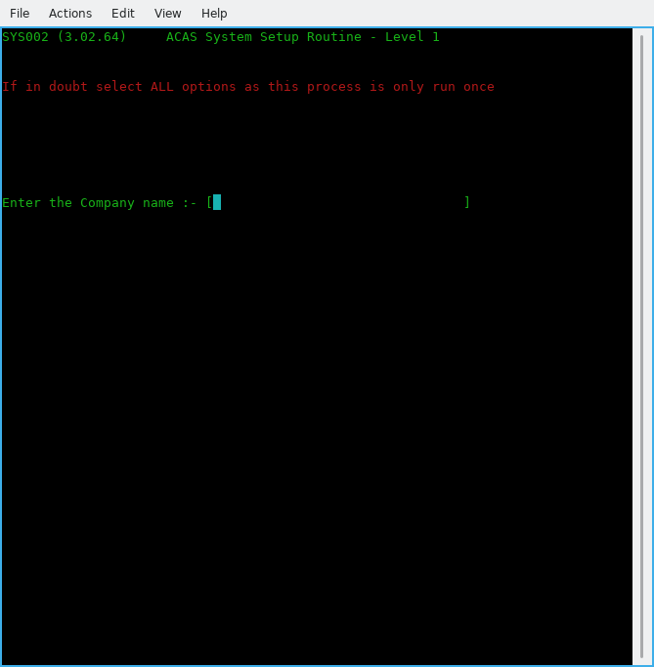

Figure 6.1 - Business name entry

(0-01) Enter the Company Name

This is the name of the company for whom ACAS will process. If ACAS will be used on several client companies, this name clearly separates the data of different companies. Maximum length is 32 characters. After typing the name and hitting enter you will be asked to verify it is correct by entering Y or y. If not, enter N or n and you can re-enter the information.
Check CLOSELY, as you will not be able to amend it only delete the system file and enter the information, all again.

Note that if you will be using the IRS system you will be asked for the name of the IRS client (which is the business that requires the accounting processes) which will more than likely be the same name but might not depending on group requirements.

The IRS client name can always be changed later should the need arise.

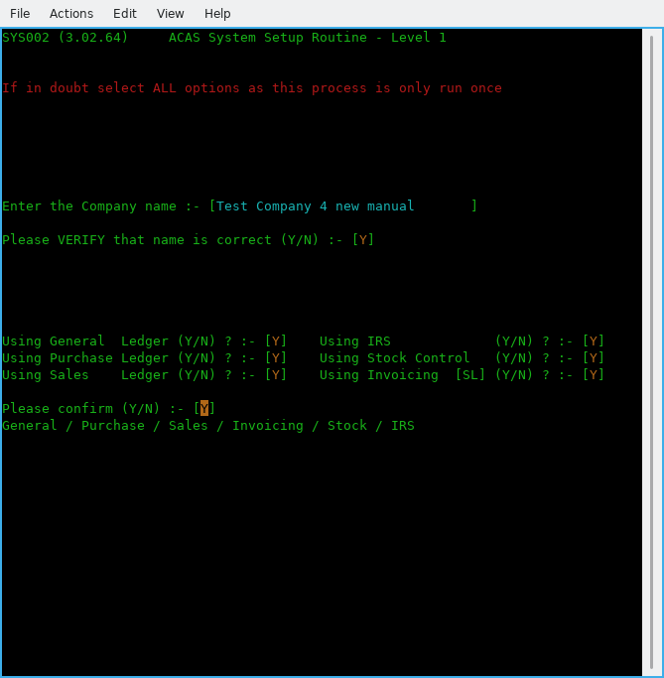

Figure 6.2 - The various ACAS systems to be used

The next series of questions requests what ACAS functions will be used, see figure 6.2.

(0-02) Using subsystem xxxxxx

By default all responses are set to Y. Here enter a Y or N against each entry in turn depending on your requirements. If in any doubt, turn them all on unless you know that you will not be using them e.g., Stock Control, Order Entry if you are a services only company and do not hold stock but you should still use it as it will reduce the amount of data entry needed. Having responded to all questions you will be asked to confirm selection and at the same time a display below the question will show what has been selected. If you are happy, enter Y and return else enter N and you can re-enter the answers.

[ You can not re-do this group of questions, so always specify all sub systems and make sure that the business name is also correct before moving on. It will not hurt to do so but you could be really upset if you are forced to rerun parameter entry having deleted the system.dat file]

The parameter requests and their defaults are shown and described individually in the remainder of this chapter. The number in parentheses is not displayed by the system but is printed in the manual for reference.

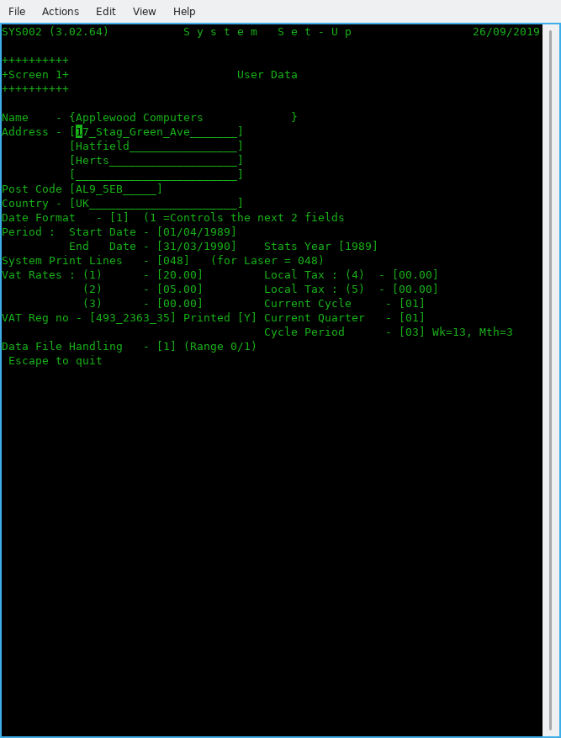

Figure 6.3 Screen 1 – User Data

(1-01) Company Address – 4 lines

Enter up to 4 lines of address (24 Characters each) excluding Postcode and country, that's next.

(1-02) Company Postcode or zipcode (12 characters) then Country (24 Characters) followed by the company email address.

Enter the postcode then the County or state.

(1-03) Date format.

Select the format used in your country.
Select 1 for the UK (dd/mm/ccyy),
2 for the USA (mm/dd/ccyy)
3 for international (ccyy/mm/dd)

(1-04) Start Date
(1-05) End Date

Enter the start and end dates for the current financial year in the format selected above in (1-03) you can use '/', ',' or '.' to separate the day, month & year as it will be converted to '/' as needed.
For example in the UK they would be:
01/04/2022 and 31/03/2023

(1-06 Stats Year

This is the year used for all Statistic reporting. Normally set to the same year in End-Date, but can be changed if different.

(1-07) System Print Lines.

For a laser and Inkjet set to 048 as a good starter and adjust if your reports are printing, too long or too short. For a matrix or line printer use 66. This is NOT for Invoice or Packing note printing but for all other normal system reporting.

(1-08) Vat Rates (1), (2) and (3)

Enter the current Vat / tax rates with the more commonly used at the beginning. Using TAB to go to next field. This normally would be: rate 1 – Standard, rate 2 – Reduced and rate 3 – any other, such as zero.

(1-09) Local Tax (4) and (5)

If needed set these similar to Vat Rates. (For the UK leave as zero). The O/S (open source) versions do not currently use these two rates but if needed issue a Feature Request.

(1-10) Current Cycle

Enter the cycle to be used, e.g., in the UK and at the start of the financial year using for month 1, week 1 enter 01.

(1-11) VAT Reg no

Enter your VAT or DST registration number then select Y if it is to be printed otherwise N.

(1-12) Current Quarter

Likewise in previous entry (1-09) e..g., in the UK at the start of the financial year enter 01.

(1-13) Cycle Period

Enter the relevant period e..g., 03 for Monthly, 06 fortnightly and 13 for weekly. The normal value here is 03 for monthly.

(1-14) Data File Handling

Set this to zero for normal Cobol files and for RDBMS (Database) processing set to :
1 for MySQL,
[ The following are not yet implemented and will be subject to user requests. ]
2 for Postgres,
3 for Oracle,
4 for DB/2 and
5 for MS SQL Server,
6 for ODBC.

See later for setting the RDBMS entries in (3.01) onwards.

Pressing enter now will bring up a confirm message and the screen has changed to reflect your entered data. If you need to change any of the settings, e..g., Date format, Cycle period, Cobol data files used, etc, select N and re-do any that are in error.

If all is correct enter Y to go to screen 2.

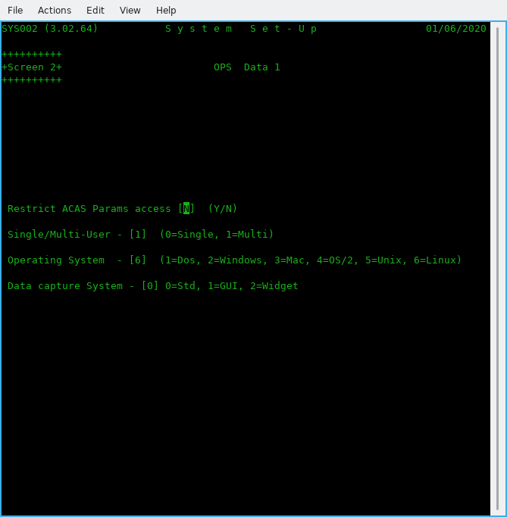

Figure 6.4 Screen 2 – OPS Data 1

(2.01) Restrict ACAS Param access [N]

Enter N (for No) or Y (for Yes). Normally leave as N unless you wish extra security to prevent users changing this option. It can be set as NOT allowing users accessing program sys002 by changing Group and other privileges via Linux / *nix and possibly in Windows, subject to what version you are running.

(2-02) Single/Multi-User – [0]

Enter 0 = for Single or 1 for Multi-user systems. If more than one user will be using the ACAS system possibly at the same time select 1. Normally enter 1.

(2-03) Operating System - [0]

Enter the correct value for the OS (operating system), Make sure you select the correct value as ACAS will function differently depending on system in use. Most common is Linux or Windows. If in doubt ask your IT department.

(2-04) Data capture System - [0]

Enter zero for now but options are 0=Std, 1=GUI, 2=Widget. This entry is for future expansion.
After pressing the Return key, the system will ask to confirm your answers.

(2.05) A new box appears for all, other than Dos, requesting the print spool names as set up e.g., in Cups when using Linux, Unix or OSX.

Type the name in exactly, as set up in Cups, be careful regarding case e..g., upper and/or lower case – they are treated differently.

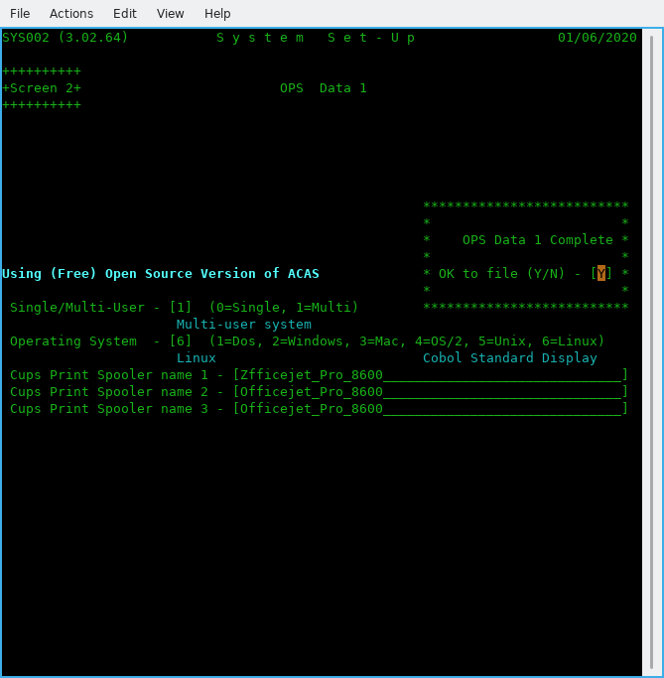

Figure 6.5 Screen 2– OPS Data 1 after data entry

If this is wrong you will not get any reports. A good test that this is correct is after you say Y to the print a hard copy of the parameters question at the end it will produce a report. The typical error produced for this is: 'lpr: The printer or class does not exist' as shown at the command prompt having exited from ACAS.

If you selected RDBMS processing then screen 3 will now appear.

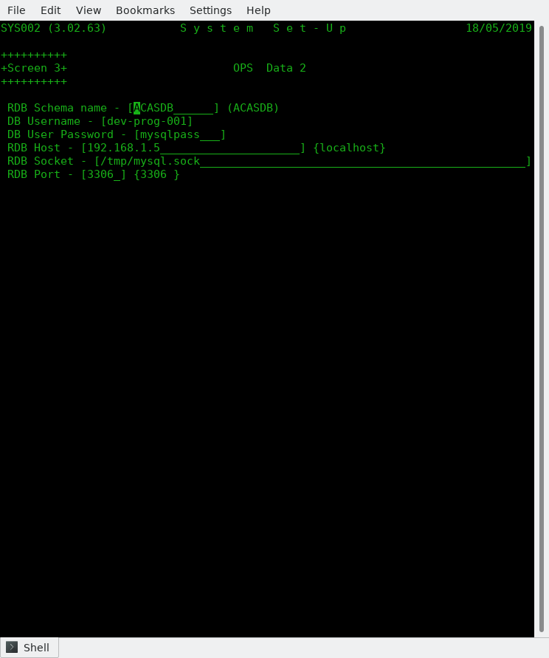

Figure 6.6 Screen 3 -- OPS RDBMS Data

Here you enter the various parameters for access to the data base.

(3.01) RDB Schema name -- Defaults to ACASDB.
(3.02) DB Username -- Give the user name as set up in the data base.
(3.03) DB User Password -- Likewise their password.
(3.04) RDB Host -- The IP address of the system running RDBMS. Default
localhost (the same computer you are running ACAS on.
(3.05) RDB Socket -- As set up in MySQL configuration file normally - my.cnf.
(3.06) RDB Port -- As above and defaults to the normal value of 3306.

You are asked to confirm your entries and giving N will restart again on OPS data.

Note that you must have the RDBMS system installed, running and configured with the ACAS data base tables - see Building the ACAS System.

Failure to do this and answering Y to update the parameter file with your data will result in error when the ACAS system attempts to update the data base table SYSTEM-REC having already updated the parameter file which is always created.

Should you not be in a position to have the RDBMS running with the ACAS database loaded you should change the setting for (1.13 to 0 (zero) to keep file processing active at least for the moment. You can, having got the Database loaded etc, go back into parameter set up via menu option Z and set (1.13) to 1.

If having entered the RDBMS data and set Y(es) to save the param data and gotten error messages saying ACAS cannot access the database, when the system returns back to the beginning of parameter data entry, you can do the same and set (1:13) to 0 and the RDB information will be saved but the system will use Cobol data files for all processing -- very useful during system testing, etc., but note that the parameter report will not show RDB data is set to file processing.

Screen 4 is now displayed and that covers G/L Data.

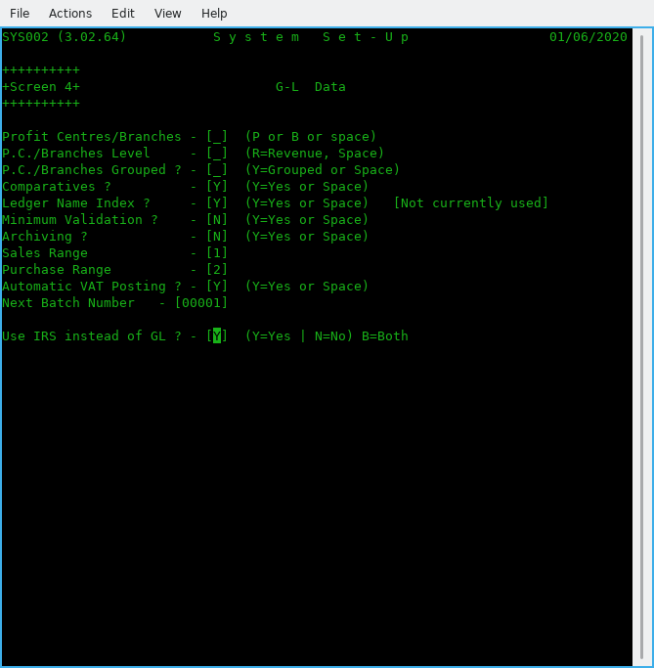

Figure 6.7 Screen 4 – G/L Data

This screen is only if you are going to use G/L instead of IRS in which case read the G/L manual for more information about the values but for the moment enter as per figure 6.7, i.e., enter a space for the three questions on P.C. (Profit centres) and 'Y' for comparatives and Ledger name index. Then enter space for the next 2 question on Minimum Validation and Archiving. Change as ** zero respectively for the next 2 questions on Sales and Purchase ledger ranges (which are preset to 1 and 2) followed by 'Y' for auto VAT posting. Use 00001 for Next Batch number, and finally Y if using IRS instead of G/L. **Note that if you need to set up the Sales and Purchase account entries in G/L you must leave these values initially as zero in order to create these accounts, otherwise the system will refuse to allow accounts starting with 1nnn and 2nnn to be created.
If you are going to use both IRS and G/L, set this value to B for Both.

After these have been set up you can change these two values to the correct leading numbers respectively however they do not seem to be currently used – Subject to system testing but for all system testing, we currently only use IRS as that is used for company accounts and for our clients.

Now pressing enter, will again let you confirm the answers with the display changing to show what has been set. Use N if you spot any errors and re-enter the correct answers and enter to go to the next screen. Use TAB or the arrow keys to move between entry boxes, this applies to most screens.

Now we finally get to parameters that relate to Sales Ledger on Screen 5

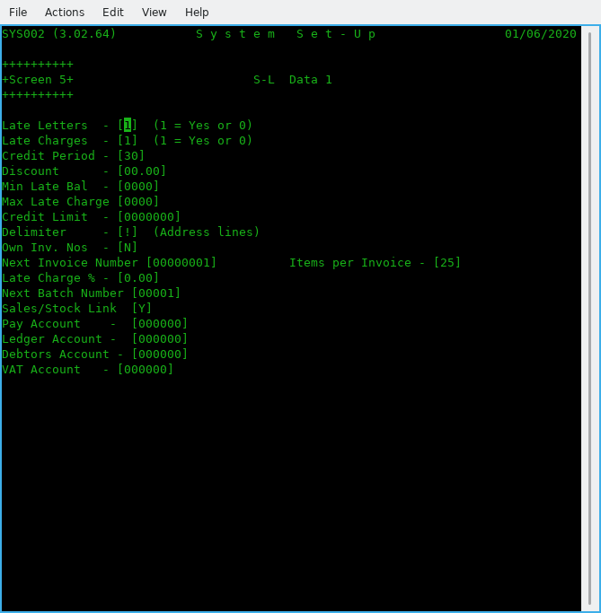

Figure 6.8 Screen 5 -- S/L Data 1

(5-01) Late Letters [1]

This request determines whether Late payment reminders (dunning) letters are used.
If yes set to 1, the late letter program may be used to write reminder letters to overdue customers otherwise enter 0.

(5-02) Late Charges

This request determines whether or not late charges are used throughout the system. If yes (1), the payments apply program will generate charges on overdue balances otherwise enter 0.

(5-03) Credit Period

This is the normal number of days to give for credit. You have the option of changing this for individual customers.

(5-04) Discount

Default discount offered to customers and again can be change for individual accounts.

(5-05) Min Late Bal

The Minimum Late Balance is the value below which late charges will not be applied.

(5-06) Max Late Charge

The highest amount that will be charged for late payments.

(5-07 Credit Limit

During Customer Entry this is the amount that will be placed in each customer's record to show their credit limit, in the absence of other instructions and you can over ride this value. It must be an integer from zero to 9999999. Balances over the credit limit are acceptable, but these clients will be flagged on reports and on Invoice entry. Do not use large values.

(5-08) Delimiter

This is the character that delimits address lines. It is recommended to be set as '!'. unless you get the same character within addresses in which case select another that is not used and one to consider is ‘|’. Despite what was acceptable for earlier version of ACAS you cannot use the slash symbols e.g., ‘\’ or ‘/’ as these will interfere with running using rdbms and are now not allowed. This should be the same as P/L (Purchase Ledger).

(5-09) Own Inv. Nos

Will the users be entering your own invoice numbers?
Set to N if you want the system to handle it. If so, the system will also reallocate deleted invoice numbers so you do not end up with missing numbers for audit purposes.

(5-10) Next Invoice Number

Leave this set to 1 for new system set ups -- this will be incremented by 1 for every invoice created in the system so if it is a higher number normally you should leave it as is.

(5-11) Items per Invoice

Defaults to 25 but change it for the number of item lines to be printed in one invoice page. The system will create more invoices if this is exceeded as Page n of y. etc.

(5-12) Late Charge %

This is the percentage of the outstanding amount that will be used as the late charge.
This number may contain 1 digit to the left and up to 2 digits to the right of the decimal. For example, the default of 1.50 is one and one half percent of the overdue balance. Lowest values are 0.00 and highest 9.99. This charge applies per cycle e..g., monthly.

(5-13) Next Batch Number
Normally set this to 1 if S/L not yet processed any invoices otherwise shows current next batch number that will be used.

(5-14) Sales/Stock Link

Set to Y if using Stock Control and you want it linked for invoice production. Else set to N.

(5-15) BO Link

Set to Y if you wish to use the Back Order process functions as and when needed.

(5-16) BO Default

Set to N or Y for all Customer records as the default value. Defaults to N - customer can not have any BO processing for their account. This applies to only newly created accounts and any existing ones will continue with the default set to N. You can of course change these one by one to Y as needed but an option is being made to Customer amend to allow a one pass change to all records or records where the account number has a specific prefix. This is under development as of 12th April 2024.

(5-17) Pay Account

This is the number of the account to which all payments/cash receipt transactions will be debited.

(5-18) Ledger Account

This is the number of the account to which all sales transactions will be credited.

(5-19) Debtors Account

This is the number of the account to which all sales transactions will be debited and all cash receipts transactions credited

Note: Assuming IRS or G/L has been set up with a CoA (Chart of Accounts) you can enter the relevant accounts. If not set up or you will not be using either system then leave as zero. Not setting IRS up, will result in additional work load as you will have to enter such data manually on a possible daily basis.

(5.20) VAT Account

Enter the account that you have or will set up to hold VAT for Sales inputs.
If using IRS and the supplied accounts file coa-archived.txt, the number is 000277.
After pressing enter for this last parameter you will be asked to confirm the S/L settings with the screen being updated to show your settings. Entering Y will move on to the next S/L screen.
The next screen is for the last four remaining options for S/L.

Company detail printing, only four entries here, all with a Y or N as valid data
Should the company name and address be printed for :

(6-01) Invoices
(6-02 Statements
(6-03) Late Letters
(6-04) Delivery notes
Enter Y for Yes otherwise N for No. If you are using plain paper or Email for any of these reports, the normal setting is Y. If not you need to be using preprinted stationary such as for a Matrix or Line printer. Many modern up market Laser and Inkjets can use a template that is preloaded prior to printing off these documents. Just remember to clear the template after printing unless you are reserving one printer to do each reporting type.

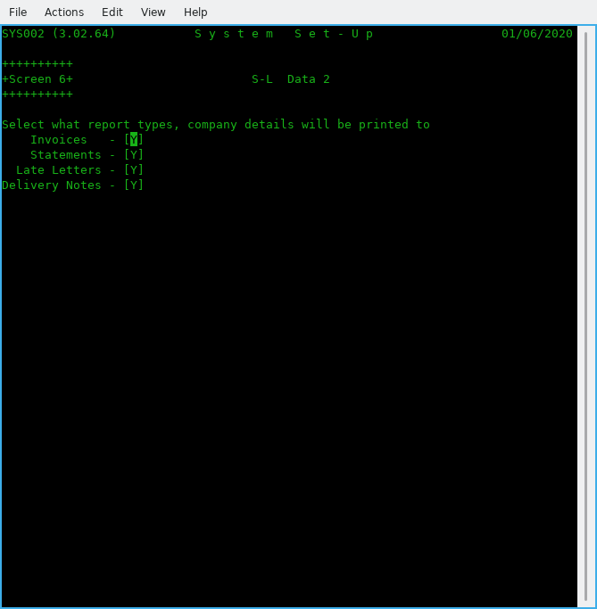

Figure 6.9 Screen 6 -- S/L Data 2

The next screen, 7 is for P/L data

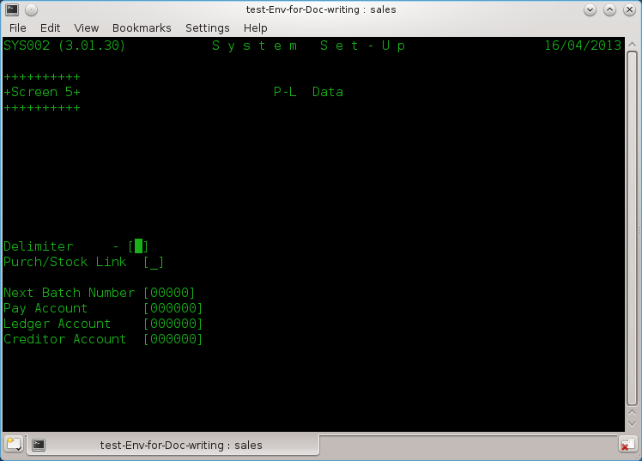

Figure 6.10 Screen 7 – P/L Data

Purchase Ledger parameter data is a small but similar element of the S/L data. So now you know what is what regarding S/L, P/L will be a 'piece of cake' as there is a lot less parameter fields to enter.

(7-01) Delimiter

This is the character that delimits address lines. It is recommended to be set as '!'. unless you get the same character within addresses in which case select another that is not used and one to consider is ‘|’. You should be using the same one for both Sales and Purchase Ledgers to avoid confusion when entering data. Despite what was acceptable for earlier version of ACAS, you cannot use the slash symbols, e.g., ‘\’ or ‘/’ as these will interfere with running using RDBMS and are now, not allowed.

(7-02) Purch/Stock Link

Set to Y if using Stock Control and you want it linked for purchase orders. Else set to N.

(7.03) Next Folio Number

Normally set to 1 when entering data for the first time otherwise leave as is currently.

(7-04) Next Batch Number

Normally set this to 1 if P/L not yet used otherwise shows current next batch no.

(7-05) Pay Account

This is the number of the account to which all payment transactions will be debited.

(7-06) Ledger Account

This is the number of the account to which all purchase transactions will be credited.

(7-07) Creditor Account

This is the number of the account to which all purchase transactions will be debited and all cash receipts transactions credited.

Note: Assuming IRS or G/L has been set up with a CoA (Chart of Accounts) you can enter the relevant account numbers. If not set up, or you will not be using either system then leave as zero. Also see comments earlier regarding using both IRS and G-L.
Warning: The system will not check that these accounts have been set up, the same applies to S/L, so any postings could just disappear.

After pressing enter for this last parameter you will be asked to confirm the P/L settings with the screen being updated to show your settings. Entering Y will move on to the next screen.

We now move on to the secondary systems.

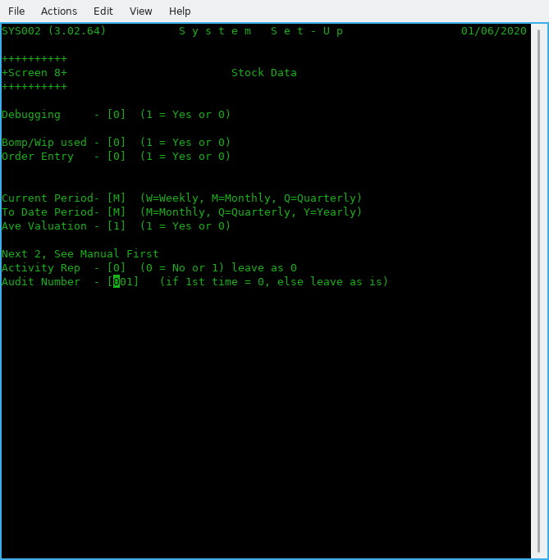

Figure 6.11 Screen 8 - Stock Control

See the ACAS - Stock Control System manual for more information on these, if needed.

(8-01) Debugging
Unless requested by ACAS technical support, leave this as 0.

(8-02) Bomp/Wip used

Set to 1 if you need Bill of Materials Explosion / Work In Progress functionality. Otherwise set to 0.
See the Stock Control manual for more details for this and the other parameters in this section.

(8-03) Order Entry

Set to 1 if using the Order Entry system. [Not for the O/S version, so is set to 0.]

(8-04) Current Period

Declare what the reporting period is: M = Monthly (recommended), W = Weekly & Q = Quarterly.

(8-05) To Date Period

Declare what the 'To Date' Period is;. M = Monthly, Q = Quarterly or Y = Yearly
(Yearly is recommended).

(8-06) Ave Valuation

Set Average valuations on for current stock, otherwise you will need to maintain stock valuations yourself – a tiresome and possibly long winded and error prone process.

(8-07) Activity Rep

Set to 1 for recommended setting, and this produces reports for all stock movements (needed for Audit).

(8-08) Audit Number

Start number. Set it to 0 unless system has been running then leave it unchanged.

On pressing return will ask you to confirm settings having displayed the summary details.

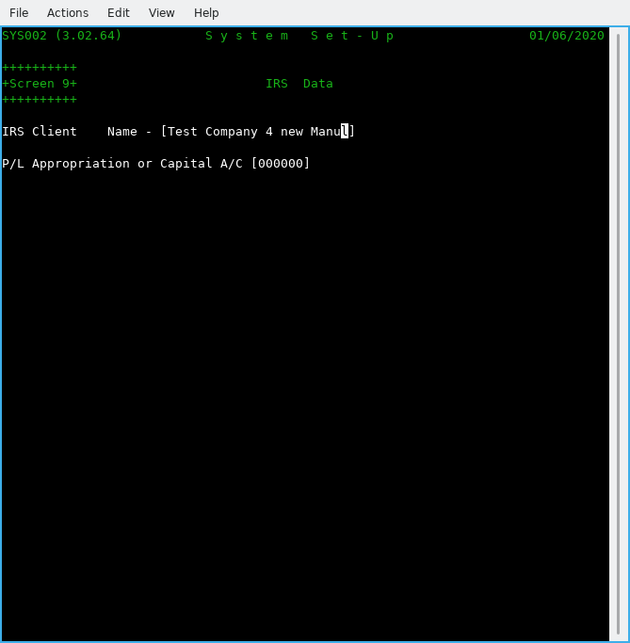

Figure 6.12 Screen 9 -- IRS Data.

Specific data for IRS as all other required data is taken from the previous screens.

(9-01) IRS Client Name

Enter the name of the client for the IRS system or use the name of the business / company as entered in 0-01 and this would be the normal entry unless you will use IRS for processing more than one company accounts. In which case this process has to be done for each, in their own folder / directory. If using the DB (database) option, then a unique DB must be created for each business.

(9-02) P/L Appropriation or Capital A/C

Enter here the IRS or GL account number for this account which if using the supplied sample IRS accounts would be more likely 000295. This is the account that will be used when running EOY (End of Year) processing at the end of the IRS menu option 7 ‘Accounts Production’ where it asks if you wish to run end of year. Here the system having cleared the posting file and reset all of the CoA (Chart of Accounts) will post OTB (Opening Trial Balance) entries for all the brought forward accounts. The account entered, is not checked that it is present. See the IRS manual for more information.

Now to print out the details of the parameter files for your records, so select Y.
Warning: This does not print out all the parameter file settings as there are a lot of them but does for all important one's.

Note that new parameters can be added to the data entry screens discussed in this chapter at any point during testing and upgrades that might not be detailed, see the README or Update notes regarding any such changes, although these days it is now very rare.

System Note:
As at the date of updating this document (see inside front cover) GL (General Ledger) does not function the same way at all as IRS, but just clears down the posting file at the end of each reporting period. This is the way it was designed but is not the way this author thinks it should work, and two additional programs may well be added to do this correctly, that will cover Final Accounts Setup and Reporting, and this after completion of testing v3.02 of IRS, SL, PL, Stock and Stock Control.

One additional program for sundry processing to support the processing of garbage collection (bad data recovery) will should also need adding, subject to Final Accounts processing. It might be necessary to add or change other processes that are missing or buggy in GL during unit and system testing.

GL has not had any testing since migration over to GnuCOBOL due to time constraints and the fact that IRS does all General Ledger processing but without the extra complexity of handling separate Branch or multiple Profit Centre processing or for that matter, SCFP (Statement of Changes in Financial Position).
It is not being anticipated to rebuild the later, as most business will require the use of a CA (Chartered Accountant) to utilise correctly, and also requires updates subject to changes in government requirements for taxation which occurs each year around budget time and this varies between countries.

Very similar to Payroll, in that both require continuous chargeable support through a yearly maintenance contract.

If you use an independent payroll package you can request that the facilities in ACAS are used to transfer the data to IRS or GL or even both using the previously discused FH (File Handlers).

Therefore these options will not be provided for the open source version of ACAS.

Sample ACAS Parameter File Set up Report
SYS002 (3.02.64) S Y S T E M P A R A M E T E R S 2020/05/31 Page 1

User Parameters G/L Parameters
**************** ****************

Name Test Company for new Manual Using IRS instead of GL - Yes
Address Any old Road Neither P/C or Branches Selected
Any Town

AA1 2BB, UK Comparative Figures Required
Company Email test-co-sales@gmail.com
Date Format Intl Format Alphabetic Ledger Index Selected
Period Start 2020/04/01 Statistics Year 2020 Full Validation During Data Entry
End 2021/03/31 Transactions Deleted at End of Cycle
VAT Rate 1/4. 20.00 / 0.00 VAT Reg: GB493123498 (P) Sales Range most Significant Digit is - 1
Rate 2/5. 5.00 / 0.00 Purchase Range Most Signif. Digit is - 2
Rate 3. 0.00 Auto VAT Posting Selected
Current Quarter 1 Cycles per Quarter - 3
Current Cycle 1 Next Batch Number - 1
Print Lines 48

ACAS Parameters P/L Parameters
**************** ****************

Environment Multi User Address Delimiter !
Op. System Linux Next Batch Number 00000
System version Using (Free) Open Source Version of ACAS Next Folio Number 00000001
Cobol Data Files Used Pay Account 000000
Path to BIN /home/vince/bin Ledger Account 000000
Path to Ledgers /home/vince/ACAS/Building-Manual Creditor Account 000000
Prt Spool Name 1 Zfficejet_Pro_8600 Stock Control Link Yes
Prt Spool Name 2 Officejet_Pro_8600
Prt Spool Name 3 Officejet_Pro_8600

Inv. Parameters S/L Parameters
**************** ****************

Next Inv. Number 00000001 Computer Generated Invoice Numbers Selected
Dunning Letters Selected
Late Charges Selected
Inv. Data Level 2 Credit Period 30 Days
Standard Credit Limit 500
VAT Account 000000 Standard Discount is 0.00%
Print VAT Nunber Yes Min. Late Balance 0
Prt Inv Max Itms 25 Max. Late Charge 0
Late Charge Rate 0.00%
Address Delimiter !
Proforma Retent. 0 Next Batch Number 00001
Company Heads Print on Delivery notes: Y Stock Control Link Yes
Company Heads Print on Invoices : Y Pay Account 000000
Company Heads Print on Statements : Y Ledger Account 000000
Company Heads Print on Late Letters : Y Debtors Account 000000
SYS002 (3.02.64) S Y S T E M P A R A M E T E R S 2020/05/31 Page 2

Stock Parameters IRS Parameters
**************** ****************

Debug Mode No IRS Client Test Company for new Man
Manufacturing No
Audit in Use Yes
Movement Audits Yes
Current Period Monthly
To Date Period Monthly
Stock Averaging Yes
Current Audit No 00000001

Payroll Parameters RDMBS Parameters
****************** ****************

Payroll in Use No

System Parameters
*****************

PL Approp A/C 000000

End of System Parameter Report
==============================

Analysis Recording and Reporting Set up - option L.

Having set up the system parameter data, it is necessary to also run the Set-Up Sales Analysis Codes process option L from main menu and having selected this, it will first create the default codes required for both S/L and P/L. and this step may be run in Purchase Ledger but both do exactly the same setting up the default analysis codes.]

You should select print to get a hard copy then providing you have set up the CoA (Chart of Accounts) in IRS or GL or both, run the Amend process and update the current zero default GL codes with the correct one’s to be used.

It is not possible to predefine these, as there are too many variables for the system to guess at the one’s you would select to be used, but it does give you the opportunity to add to the CoA, more accounts to satisfy your needs.

At the same time you can add additional codes that you wish to use but there is no rush to do so unless you require more control over the analysis processing. These codes are used in each Stock Control record and therefore can provide more detailed statistics if required as well as the individual stock items statistics over a course of a year etc.

The usage beyond the default codes being set up, is totally optional.

See the sample report next, and the report is exactly the same for both S/L and P/L.

Sample report from sl070 option L:

SL070 (3.02.19) Product Analysis Codes Page 1

Applewood Computers 03/04/2023

Lgr Code Gl.Nos. <-----Description------> Print -Type-

P a 000000 Default Group Group
a1 000000 Default Purchases Detail

P v 000000 VAT Control Group
vi 000000 VAT Input Invoices/CN's Detail
vj 000000 VAT Input Receipts Detail

P z 000000 Computer Control Group
za 000000 Purchase Carriage Charge P&P Detail
zb 000000 Purchase Late Charges LCG Detail

S a 000000 Default Group Group
a1 000000 Default Sales Detail

S v 000000 VAT Control Group
vo 000000 VAT Output Invoices/CN's Detail
vp 000000 VAT Output Receipts Detail

S z 000000 Computer Control Group
zc 000000 Sales Carriage Charges P&P Detail
zd 000000 Sales Late Charges LCG Detail

Warning: One or more P.A. codes contain a zero value for IRS or GL numbers

Billing Cycle
Historically, all processing in S/L can be divided into cycles. This allows the manual work load to be spread over two or more days. If statements are mailed weekly in a system with a monthly billing cycle, the payments load will be more evenly distributed over the month.

Well, that was the way it was done some years back when computer systems and more importantly printers were slow. These days, this is not the case and invoices, statements and late letters can be sent via email with payment receipts, checked online to verify, matching customer emails confirming payments, etc, 1, 2 or more times a day as needed.

So the need to spread the work load over many days has gone, when using a modern computer system to do the hard work.

In the event that you still need to use cycle billing then the first letter of a S/L account can be used to split billing into separate cycles, and where this first letter or a group of them can be specified to the Statement print run but with more and more customers using email to receive correspondence which includes Invoices, Statements and late / chase up (dunning) letters instead of using the mail services, the need has mostly gone away but the facility is there if needed.

As the first letter of an account can be A to Z, 0 to 9 this allows a maximum of 36 cycles. However during the Statement print run, all accounts can be processed and this would be the normal mode and the same applies to late letters.

For Invoices, they tend to go out daily as soon as ordered goods or services are processed having preceded the invoice print run, with one for Packing Notes (also called Picking) and this, must be run before printing invoices as it is an activity of invoicing. Packing notes look similar to invoices but do not included pricing but do include product locations to help finding stock assuming stock location has been entered for all stock items.

Again most of these issues regarding billing cycles have become redundant, all with the benefit of using email and other modern methods.

The General Ledger Interface

The S/L (Sales Ledger) system, functions equally well as a stand alone system or with the ACAS IRS or General Ledger. Hereafter just called GL. If the GL is used, the S/L system will produce posting records into the GL posting file that contains accumulated and summarised accounting information.

Every time the invoice or payment posting programs are run, the GL posting file is updated to reflect the new activity posted to the open item or payment files. The differences between IRS and GL is :

- When IRS is run, the user selects menu option 4 Posting, then selects option 66 'Add PL or SL Postings from file' and IRS posts to the accounts the values from each posting record before clearing down the file having made a copy of each posting to the IRS posting file.

- When GL is run the user selects menu options F, G & H to proof, report and post all postings and transfers the net of all activity on to each account.

For IRS or GL this process removes the need to process S/L or P/L transactions individually hereby reducing work load and costs which for a busy sales office can be considerable, the same applies for the purchasing office. Within IRS a option is used to post this data file but within GL as the main GL posting file is used the posting function will also process records added by SL or PL.

For most businesses, one payment account and one sales account are sufficient since most businesses deposit payment receipts from their trade accounts sales ledger in one bank account as cheques, credit card receipts and cash, however with most businesses paying their bills by bank to bank transfers it is very useful to have an extra account that just receives such payments that is checked on-line at a fixed time each day, in order to get a list of all transactions then printed off which is retained until the next days report in order to check that there is no duplicate data in the later listing. This is used along with emails from customers detailing a breakdown of their payments that is then used as input to the Payment Entry program . This last part does depend on co-operation with your customers but most seem to do so. At the end of each day the funds received into this account are transferred to the primary payment account as needed.

For example most of our customers use a standard format detail in the reference field when paying, which specifies: account number: then the last 4 digits of each invoice paid followed by a comma e.g., : A1000012:0041,0055,0195.
This account should be the one defined as the payment account. Similarly, only a single trade sales account is used. to report the sales asset in the GL financial statements. In effect, this is the controlling account for the sales subsidiary ledger maintained by the SL system.

In practice, there can be several sales accounts since some businesses separate their sales into categories to keep closer watch on which products, departments, or regions are performing exceptionally or not. In addition, one sales account is usually a liability account, Accrued Vat Payable. Special accounts may also be required for such things as consignment sales. In this case the sale may be partially credited to an P/L (Purchase Ledger) account.

The Customer Record - options B.

The customer record, created and modified by the Customer Entry and Amend programs, contain the name, address, phone, and credit information of all customers eligible for credit. Customers can also be added using the Invoice Entry program by selected the function key 'F1' during input. The same file can also be used for the issuing of Proformas or receipts for prepayments such as generated via proformas. Any proformas can be converted to a receipt by a simple process that does not require the entire order being entered again once payment has been confirmed as received by just changing the transaction type from proforma to receipt during invoice amend.

Before a sales invoice can be placed on the system, an account must be established for the customer by entering the name and address information using the Customer Entry program . This allows the user to assign the customer a six character customer number of the form:

cxxxxxq

where "c " can be A – Z or 0 – 9 which can represent a customer type, region/location etc, "xxxxx" is a unique five digit account alphabetic or number, and "q" is a single check digit used to protect against transpositions and key errors. One or more letters can be allocated to signify that the customer is a cash only customer and/or proformas are always issued etc. A number can be set up as a 'Cash Customer' say if the customer has collected the purchased items directly such as a shop counter, exhibition etc., and this way you can still track sales both for S/L and Stock Control purposes and is the recommended way as it will save time back in the office. It is suggested that for the address you use the office one for the in-house shop or company name and exhibition site name and address if at another location type.

When adding a record, the Customer Entry program displays the new customer's number with the check digit and requests information relating to the account. In addition to name and address, delivery address if different, whether the customer is to receive late (dunning) letters and/or have late charges levied on unpaid invoices as well as a minimum amount outstanding before late charges are added, a maximum late charge amount, credit period, Discount % off all invoices, Email preferences for sending invoices, statements and late letters as well as recording telephone and fax contact information along with space for additional notes and other information not mentioned here.
The entry is complete once a Escape code (see bottom right of screen) is entered which is S to Save, B is Back to beginning or Q to Quit the entry program.

Each customer may be given a credit limit between zero and 9,999,999. Whenever the outstanding sales balance exceeds the customer's credit limit, an identifying flag is printed on the Trial Balance reports next to the customer's name. This is also checked and if needed a warning displayed during Invoice Entry if the limit will be exceeded. A system wide default credit limit is established on the system parameter file that can be changed for each customer as desired. Do not enter the commas shown above, so from the above only enter 9999999.

When using rdbms and more than one user is inputting invoices and two or more are processing for the same customer the active balance may not be up to date at a given point in time so the check may pass when a minute or two later it would not. It is not recommended to have more than one invoice input stream at a time, as the risk of reusing a new invoice number is possible.
See Figure 7.1 for the Customer Entry screen.

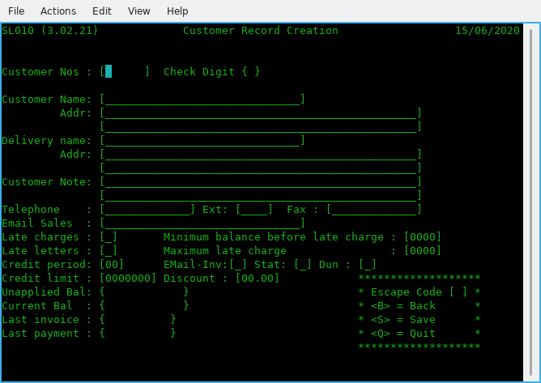

Figure 7.1 Customer Entry screen

When entering the address details the usage of the delimiter character as defined in the Setup Parameter file is compulsory as failure to follow this will result in an error message, for example here is a valid address:

Line 1: Applewood House,!Epping Road,!Roydon!Essex!Unite
Line 2: d Kingdom

The limit per line is 48 characters and the end of line one then continues to line two.
When you wish to close a customer account, the delete function removes the record from the customer file. Before deleting a record be sure there are no active payment records or open invoices for that customer however the system should prevent you from doing so. Clearly if there are outstanding invoices and you still need to delete the customer you must credit off all such invoices however it is recommended that such customers are left on the system but with their credit rating reduced to zero and a note added to the account specifying what has happened as a reminder for all staff, such as legal action.

Each customers number contains a check digit as the last digit which is a number calculated on the basis of the other digits in the customer number. The selection algorithm for the check digit enables almost all key entry or transposition errors to be detected instantly.
All calculations are done automatically by the system.

The Customer Print programs

The various Customer Print programs may be run at any time. The programs produces an ordered listing of the data in the customer files. You can change the form of the report by selecting any of the report attributes as shown in figure 8.1 below and this capability is available for most of the reports throughout ACAS (the Applewood Computers Accounting System).

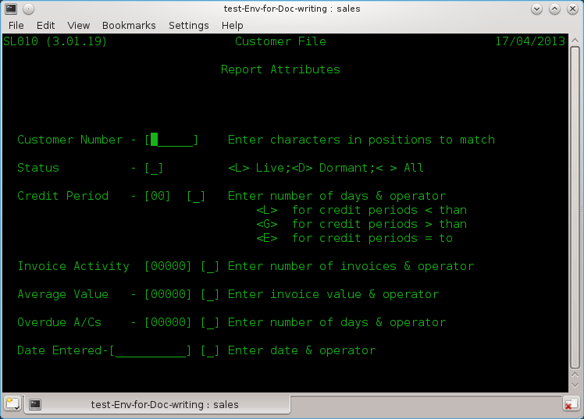

Figure 8.1 Report selection Criteria request

All entered criteria will be tested for, prior to printing.

Sample printouts are shown in Figures 8.2 to 8.4. The customer print is a handy reference when printed in customer name order, allowing cross referencing between name and number.
The Alphabetic ordered print is listed by customer name and the last report is a Customer file Dump which prints out all information for each customer and this one is not commonly used except as a back up. Note that this report, also shows the address delimiters.
These sample records are from test data only, loosely based on available information from over 40 years ago. You will noticed that the default credit limit is 210 with terms set at 28 days and that these are Dormant accounts, i.e., no activity and sales status as dead.

Figure 8.2 - CUSTOMER REPORTS in landscape:

SL010 (3.02.21) Customer Listing Page 1
Applewood Computers Report On : All 15/06/2020

Customer Status <---------------Name & Address--------------> ----Telephone---- -----Fax----- Late Credit Disc
Number ------ Chg Let Limit/Days %

SA00046 Dormant University of Oxford 086581-7728 Y Y 210 28
Dept Obstetrics&Gynaecology,John Radcliffe Hospital,Headington,Oxford OX3 9DU,

SA00054 Dormant Mr P Y Mills (M D) 012488-895 Y Y 210 28
Intercompany Communications,Techology Ltd,76 Cannon Street,London EC4N 6AE,

SA00062 Dormant B.Walist 22-5375 Y Y 210 28
Harry Mitchell & Partners Ltd,P.O. Box No 2,Beeston,Nottingham,

SA00071 Dormant Mr J Creutzberg 01223-7730 Y Y 210 28
OFF Records,Computer House,58 Battersea Rise,Clapham Junction,London SW11 1HH,

SA00089 Dormant Mr Sutherland Ext.3198 031337-2442 Y Y 210 28
Ferranti Computer Systems,St Andrews Works,Roberston Avenue,Edinburgh,EH11 1PX,

SA00101 Dormant Mr Mills 077273-5753 Y Y 210 28
Preston Borough Council,Preston ITeC,Lanceshire House,Watery Lane,Preston PR2 2XE,

SA00119 Dormant Strathclyde Regional Council 041429-7767 Y Y 210 28
Glasgow Coll. of Nautical Std.,21 Thistle Street,Glasgow G5,

SA00127 Dormant Mr J.H.Lawrence 045432-1088 Y Y 210 28
Lawrence Associates,10 Somerset Avenue,Yate,Bristol BS17 5SF,Avon,

SA00135 Dormant D Woods 027944-3561 Y Y 210 28
Daro (Office Furniture) Ltd,Daro International House,East Road,Templefields,Harlow CM20 2BJ,

SA00151 Dormant P.Copin 071813-861 Y Y 210 28
I.PH.I.B.,I.Ph.I.B. c/o I.R.E,Batiment 9,Service D,6220 Fleuris Belgium,

---- Cut for brevity ------

SL010 (3.02.21) Customer Listing Page 86
Applewood Computers Report On : All 15/06/2020

Customer Status <---------------Name & Address--------------> ----Telephone---- -----Fax----- Late Credit Disc
Number ------ Chg Let Limit/Days %

SP00613 Dormant Mr D. Hadfield 024835-2042 Y Y 210 28
Tryfan Computers Ltd,65 High Street,Bangor,N. Wales,LL57 1NR,

SP00630 Dormant Mr D.M Grech 356511-143 Y Y 210 28
Telamon Ltd,7 Ponderosa Court,Mrabas Street,St Julians,MALTA,

SP00648 Dormant Mr F.J Hunter 020425-396 Y Y 210 28
Advanced Computers Ltd,27 Doe Hey Road,Bolton,Lancashire,BL3 2LW,

SP00656 Dormant Mrs S. M Walton 044277-4881 Y Y 210 28
Castle Business Systems Ltd,ECL House,Park View Road,Berkhamstead,Hertfordshire HP4 3EY,

Figure 8.3 - Alphabetical Customer List

SL160 (3.02.18) Customer Alphabetical Listing Page 1
Applewood Computers Report On : All 15/06/2020

Customer Status <---------------Name & Address--------------> ----Telephone---- -----Fax----- Late Credit Disc
Number ------ Chg Let Limit/Days %

SA18883 Dormant S Mehta 01450-9803 Y Y 210 28
Technomatic Ltd,17 Burnley Road,London,NW10 1ED,

SA20993 Dormant A Butler 046267-0468 Y Y 210 28
Froscroft Ltd,12 Lapwing Dell,Letchworth,Herts SG6 2TE,

SA16155 Dormant A Christopher 020439-7838 Y Y 210 28
Broadsword Systems Ltd,Park View House,179b Chorley New Road,Bolton BL1 4QZ,

SA18131 Dormant A D Stiegler 01979-5537 Y Y 210 28
A.D. Stiegler,121 Hanworth Road,Hampton,Middlesex,

SA10696 Dormant A F Broughton (MD) 062355-3436 Y Y 210 28
H.N & L Fisher (Huthwaite),264 Huthwaite Road,Sutton in Ashfield,Nottinghamshire,NG17 2HG,

SA16244 Dormant A G Johnston 073235-3069 Y Y 210 28
C-Matic Systems Ltd,Rocks House,Stone Cross,Crowborough,E Sussex,

SA16716 Dormant A H Wells 052528-774 Y Y 210 28
ABC Computers Ltd,Systems House,Houghton Parade,Dunstable,Bedfordshire LU6 1DA,

SA13229 Dormant A J Clewett 021443-4392 Y Y 210 28
Cle.Com Ltd,Kings Court,92 High Street,Kings Heath,Birmingham B14 7JZ,

SA19324 Dormant A L Wood 01546-2984 Y Y 210 28
Microprocessor Support Ser Ltd,48 Eaton Drive,Kingston,Surrey,KT2 7QX,

SA16686 Dormant A Morgan 063261-0871 Y Y 210 28
Newcastle Health Authority,Supplies Division,10-12 North Terrace,Newcastle Upon Tyne,NE2 4AD,

SA13598 Dormant A R Lamont (MD) 042879-3636 Y Y 210 28
Crown Management Systems Ltd,Beech House,Ballsdown,Chiddingfold,Surrey GU8 4XJ,

SA11811 Dormant A. Murray 028123-865 Y Y 210 28
MBS Soft,Unit A,Horton Trading Estate,Stanwell Road,Horton, SL3 9PF,

SA10149 Dormant A. Perkins 09325-3488 Y Y 210 28
Perkins A.,Microfin House,,Chapel Grove,,Addlestone,,Surrey, KT15 1UG,

---- cut for brevity -----

SL160 (3.02.18) Customer Alphabetical Listing Page 80
Applewood Computers Report On : All 15/06/2020

Customer Status <---------------Name & Address--------------> ----Telephone---- -----Fax----- Late Credit Disc
Number ------ Chg Let Limit/Days %

SA07059 Dormant Wordsmiths 045845-359 Y Y 210 28
West End St.,Somerset,BA10 0LQ,

SA07709 Dormant Yvonne Lyons 032286-2181 Y Y 210 28
Microsource Ltd,Lyons House,9 New Road,Rochester,Kent Me11 1BG,

SA07181 Dormant Zenner Enterprises Ltd 095973-383 Y Y 210 28
267 Main Rd,Biggin Hill,Kent,TN16 3CA,

Figure 8.4 - Customer file dump

SL170 (3.02.09) Sales Ledger File Dump Page 1

Applewood Computers Report On : All 15/06/2020

Sales-Key SA00011 Sales-Credit 28.00 Sales-Current 0.00
Sales-Name Mr. K. Farmer Sales-Discount 0.00 Sales-Last 0.00
Sales-Addr1 Moldavia Ltd!418-420 Cranbrook Road!Gants Hill!I Sales-Late-Min 0.00 Turnover-Q1 0.00
Sales-Addr2 lford!Essex! Sales-Late-Max 0.00 Turnover-Q2 0.00
Sales-Phone 01554-6262 Sales-Limit 210.00 Turnover-Q3 0.00
Delivery-Tag 0 Sales-Activety 0.00 Turnover-Q4 0.00
Notes Tag 0
Sales-Status Dead Sales-Last-Inv
Sales-Late Yes Sales-Last-Pay
Sales-Dunning Yes Sales-Average 0.00
<-------------------------------------------------->

Sales-Key SA00038 Sales-Credit 28.00 Sales-Current 0.00
Sales-Name Mr. H. Curtis Sales-Discount 0.00 Sales-Last 0.00
Sales-Addr1 FCA Computer Services Ltd!418-420 Cranbrook Road Sales-Late-Min 0.00 Turnover-Q1 0.00
Sales-Addr2 !Gants Hill!Ilford!Essex! Sales-Late-Max 0.00 Turnover-Q2 0.00
Sales-Phone 01518-0226 Sales-Limit 210.00 Turnover-Q3 0.00
Delivery-Tag 0 Sales-Activety 0.00 Turnover-Q4 0.00
Notes Tag 0
Sales-Status Dead Sales-Last-Inv
Sales-Late Yes Sales-Last-Pay
Sales-Dunning Yes Sales-Average 0.00
<-------------------------------------------------->

Sales-Key SA00046 Sales-Credit 28.00 Sales-Current 0.00
Sales-Name University of Oxford Sales-Discount 0.00 Sales-Last 0.00
Sales-Addr1 Dept Obstetrics&Gynaecology!John Radcliffe Hospi Sales-Late-Min 0.00 Turnover-Q1 0.00
Sales-Addr2 tal!Headington!Oxford OX3 9DU! Sales-Late-Max 0.00 Turnover-Q2 0.00
Sales-Phone 086581-7728 Sales-Limit 210.00 Turnover-Q3 0.00
Delivery-Tag 0 Sales-Activety 0.00 Turnover-Q4 0.00
Notes Tag 0
Sales-Status Dead Sales-Last-Inv
Sales-Late Yes Sales-Last-Pay
Sales-Dunning Yes Sales-Average 0.00

--- cut for brevity ----

SL170 (3.02.09) Sales Ledger File Dump Page 278

Applewood Computers Report On : All 15/06/2020

Sales-Key SP00656 Sales-Credit 28.00 Sales-Current 0.00
Sales-Name Mrs S. M Walton Sales-Discount 0.00 Sales-Last 0.00
Sales-Addr1 Castle Business Systems Ltd!ECL House!Park View Sales-Late-Min 0.00 Turnover-Q1 0.00
Sales-Addr2 Road!Berkhamstead!Hertfordshire HP4 3EY! Sales-Late-Max 0.00 Turnover-Q2 0.00
Sales-Phone 044277-4881 Sales-Limit 210.00 Turnover-Q3 0.00
Delivery-Tag 0 Sales-Activety 0.00 Turnover-Q4 0.00
Notes Tag 0
Sales-Status Dead Sales-Last-Inv
Sales-Late Yes Sales-Last-Pay
Sales-Dunning Yes Sales-Average 0.00
<-------------------------------------------------->

Transactions

The Invoice Batch
Financial transactions in the Sales Ledger system go through two stages. Before posting they are considered Batch transactions, when they are held in the invoice file. After posting, transactions are considered Posted or permanent entries as they are transferred to the OTM (open item) file. Batch transactions are unofficial and thus can be added to, changed, or deleted at any time without any record keeping requirements. Once the batch of transactions is posted, however, they become permanent entries that require standard accounting procedures to modify or delete such as issuing a credit note. These standard procedures leave an audit trail that can be used to trace a transaction through the system.

Technically there can be only one invoice batch at any one time. This batch remains current until posted to the open item file by the Invoice Posting program. The proofing report does not effect such records.
The number of invoices allowed on the system per customer is limited only by the amount of disk space available. The same applies to the number of customers. See the appendixes for record size information on the primary files or rdbms tables. We have commercial users who have in excess of 100,000 customers although not all are active and produce well in excess of 1,000 invoices per day and on top of that total, there are many invoices which are prepaid (receipts) and proforma invoices as well as credit notes. Purchase Ledger would be smaller. For SL, Holiday periods such as Christmas time or other holiday periods, these numbers are a lot larger.

Prerequisite Settings

You have to set up the invoicing system via menu option T and sub-option 1 (Amend Invoicing Fixed Data) adjust these value according to your needs (figure 9.1):

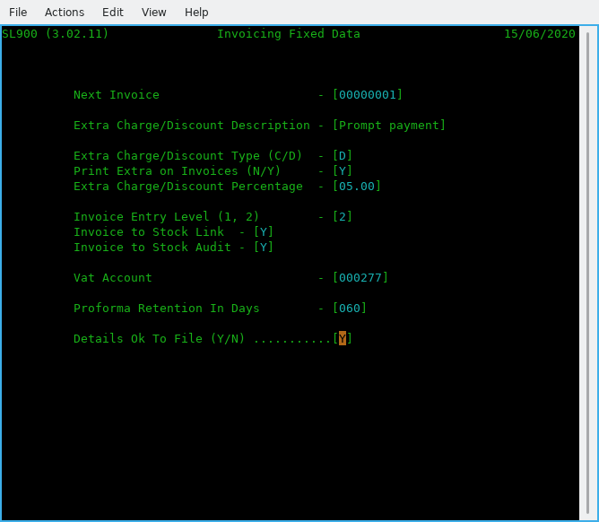

Figure 9.1 Invoice settings

Lets quickly go through these in order:

- Next Invoice Number: Set this as needed, but not less than 1.
- Extra Charge/Discount Description: If you require a standard discount or credit, you need to start here. For example we use it to offer a prompt payment discount on all invoices that all carry 28 day terms and the discount is offered for all invoices paid within 14 days of issue. As you can see this has been set up in fig 10.1 and we have called it a Prompt Payment discount.
- Extra Charge/Discount Type (C/D) it is set to 'D' for Discount.
- Print Extra on Invoices (N/Y) it is set to 'Y' as we do want it printed on invoices.
- Extra Charge/Discount Percentage, set to the discount rate and here it is 5.00%.
- Invoice Entry Level (1, 2): To use detailed select '2', then invoices will be recorded in their component parts for more detailed accounting and reporting and for linkage into the Stock Control system. See figure 10.1 & 10.2. This extra level of detail is simple to implement and is entirely optional. If you select 1 instead, then you will only be entering the Net and Vat amounts. The detailed information is maintained at the batch level and in the open item files. For example, in many cases an invoice is for several items and/or some kind of surcharge such as Vat and shipping. These normally must be accounted for in different sales accounts for the sales report or the GL interface. The invoice would then consist of a controlling record containing the grand total of the charges on the invoice, and one or more line items that each, represents a component charge and each can be credited to a different sales account.
In figure 10.1 it is set to 2 as we require full detailed invoices that we also link to Stock Control but is still applicable even if not using the Stock system. It just means you have to type in the descriptions for each line item as well as the price, and that is a good reason for using Stock Control as it can also support service items such as P&P.
- The next two for entering the IRS or G/L accounts that relate to both Vat and the Discounts or extra charges given/taken so that the accounts are always up to date without the need to enter this type of information into IRS manually.
- Proforma Retention In Days, if you issue proformas then the number of days they are valid for, after which they get removed from the system. You can amend a proforma to a receipt after the payment is received but before it expires.
- And the last one, 'Y' to confirm all of your settings otherwise 'N' to go back through the screen. Of course you can just enter Y and reselect the screen to go through it again updating previous data.

The sub menu option T is the second menu to enter or amend invoices in addition to via the main menu options D, E, F & G Sales Transactions Input, Amend, Proof, Post, the later two can only be done here via the main menu. The other differences are that option T also offers the facility to enter invoices for immediate printing as against doing them in a batch also printing the invoice batch as well as printing Delivery Notes/Picking Lists, see figure 9.2.

While most is understandable, we will highlight the others that might need some explanation:

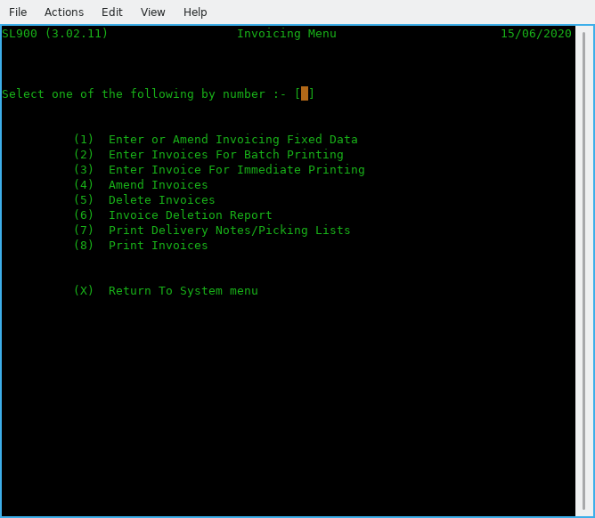

Figure 9.2 Invoicing Menu

- Enter or Amend Invoicing Fixed Data: Detailed previously.
- Enter Invoices For Batch Printing: This is the normal mode to enter invoices into the system using option 'D' via the main menu.
- Enter Invoice For Immediate Printing: This is to enter the odd one or two invoices instead of doing them in batches, If used, it is for a last minute invoice that needs to be created, after all batch invoices have been processed by being proofed and posted.
- Amend Invoices: Same as main menu option 'E'.
- Delete Invoices: Allows you to totally delete one or more invoices. Note that the invoice numbers deleted will be reused (if using system generated numbers).
- Invoice Deletion Report: You need to run this if you delete any invoices (for audit).
- Print Delivery Notes/Picking Lists: This can be printed to a local printer in the shipping department. It must be run before printing invoices, otherwise the option is lost.
- Print Invoices: Print all batched invoices.
- Recurring Invoice Processing. New.
- (Actually option A) BO Reporting and Amendments. Reporting for Back Orders. New.

Line Items

The normal invoice production processing flow, is having set up the invoicing parameters via menu option 'T' is to Enter, Amend, Proof and Post via the main menu and only go to option T to print them along with packing notes if required. Printing should occur after running Invoice Proof and before Posting but can, be run after posting. It is recommended to print after proof and before post. Delivery notes and Packing/Picking lists must be printed before posting and invoices being printed.

The number of line items that can be used per invoice is limited to 40. For most businesses they create a new invoice way short of this number.

To Enter or process the maximum line (Stock) items per screen it is recommended to set the size of the terminal program you use to run ACAS to:80 columns wide (Most important, as if wrong, the display will look very odd and possibly unreadable.
Any length, as long as you would like, e.g., 40 lines by 80 columns and on a A4 screen in portrait mode 90 lines by 80 columns will also work. ACAS reads the size of the terminal screen when loading and adjusts data displays and input for the length. It cannot adjust for width at this time as it would cause more problems than it fixes
.
Note that if you change the terminal size after ACAS has loaded it will not re-read the size as the changed information is not available as it is only read by each program when first loaded and run.

Using The Invoice Entry programs

When you select Invoice Entry from the system menu, the Invoice Entry screen appears as in Figure 10.1 with· the cursor waiting at date where you change it if needed otherwise press enter

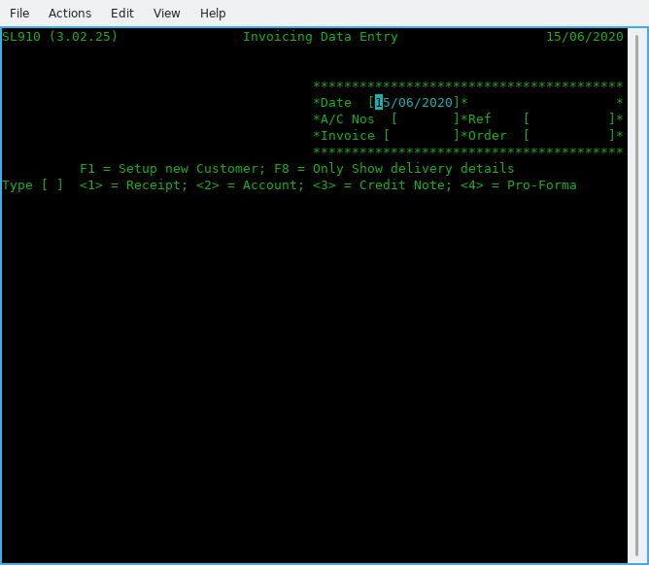

Figure 10.1 Invoice Entry Customer a/c details

to move to the customer number field. You now enter the customer number or if this is a new customer you can press the F1 function key (or enter 'NEW' in upper case as the customer number). If you have selected F1 (or NEW), you go through the normal process to create a new account and after saving the data will go back to this point. So having entered the account number then pressing return it brings up the name and address details for the selected account. If you keyed in an incorrect account you remain on the account field so re-key the account and the cursor moves to the next field, Ref(erence), key this in if available (or leave blank with return and the next field is Order number if applicable if not, leave blank, now when pressing return you need to select what type of entry this is, e.g., 1 = Receipt, 2 = Invoice, 3 = Credit note (for a existing invoice) and 4 = Proforma.

At this point the screen changes (see fig 10.2) where you can enter all line items but note thts is for systems not using linked stock control.

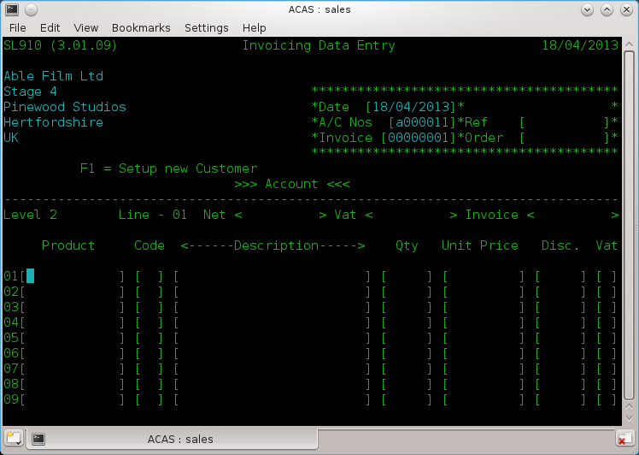

Figure 10.2 The Invoice body enter screen

Starting with product code as a full or a abbreviated code, which if using 'linked Stock Control' will obtain the description and price otherwise you enter each field from left to right one line item at a time. A running total is displayed above the line items for your reference. If you press return at the start of a new line you will go to another screen (figure 10.3) for additional information.

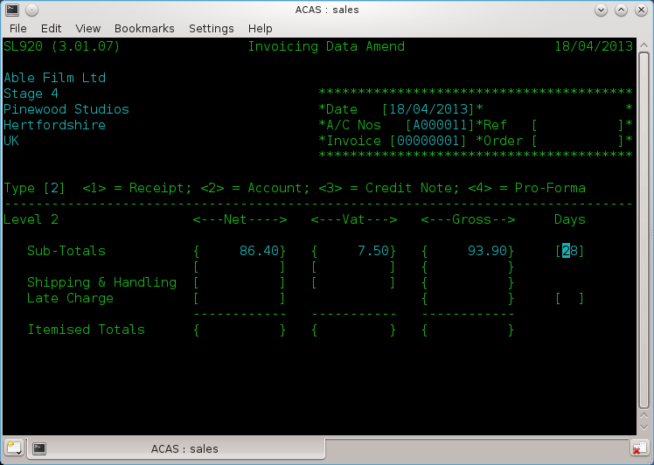

Figure 10.3 Invoice Entry – Sub totals & postage

Now to finish off the invoice you can change the default credit period in days and down arrow or return goes to the next line in this case 'Shipping & Handling' where you can amend a previously entered set of figures or by using the return or down arrow keys accept the displayed amounts.
After which you are asked to confirm everything is correct and that it is ok to save. If not enter N and this screen will restart using the previously enter data that you can amend. If it is correct entering 'Y' will save it and you will be asked if there are more invoices to enter and if so screen 10.1 will be redisplayed to enter more invoices otherwise you will be returned to the menu.

During entry, all the normal control keys can be used (return, down arrow etc.) to position the cursor including backspace to erase the character under the cursor. The function of the control keys and what is available does depend on your systems (Linux, Unix, Mac OSX, Windows etc.) settings so you may need to change them for all to be available.

How to Add invoices to the batch - option D.

This is exactly the same process as for entering Invoices. Whether invoices are entered in one session or hours, minutes or even days latter the same function is used and new invoices are added to the batch and this continues until you proof, print and post the entered invoices, credit notes, receipts and proformas.

You should always run a proof before printing the invoices as it might save you the effort of having to raise a credit note for an invoice because of a silly mistake. You should try to avoid deleting an invoice even if only to keep the audit records clean. Deleted invoice numbers, using the auto number mode (default) will re-issue a deleted invoice number taken from the delete pool.

How to Change Invoices on the Batch - option E.

To change invoices while still in the batch state, select 'Sales Transactions Amend' from the main menu. You will need to know the invoice number. You will see the same screens as for invoice entry the existing information will be displayed allowing you to change any of the fields including the customer account number. The other options are to raise a credit note against the incorrect item lines, or to delete the incorrect invoice and totally re-enter it.

How to Examine Invoices in the Batch

The simplest way is to produce an Invoice proof report which has to be done anyway, prior to posting them.

To examine an invoice, select the Invoice Amend option from the system menu, and when the entry screen appears enter the invoice number and thereafter keeping pressing return to move forwards through the invoice.

How to save Records to Disk to Prevent the Accidental Loss of Data

The only way is to leave the Sales menu by entering 'X' at the menu prompt, this will run a backup before returning to the command prompt. At this point you can rerun sales in the normal way. That said, leaving any program will have closed all data files which saves all data currently in the programs buffers, however running under Linux which has its own file buffers, it may take a few seconds before Linux has flushed the file buffers to file.
Does depend a bit on the way your system has been set up, so the above is based on the normal set up.

The Invoice Proof - option F.
The invoice Proof is a formatted hard copy report on the current invoice batch. A sample proof is shown in Figure 11.1. The data 'for each invoice and line items is printed in the order it was entered. The invoice proof serves as a working report and as an integral part of the S/L system's audit trail.

While the invoice batch is being build, the Invoice Entry programs can be ended at any time, and a proof report printed. This working proof can be used to verify the accuracy and completeness of each transaction. As many proofs as desired may be made.

A final proof must be taken immediately before the batch is posted. This final batch proof is a hard copy link in the audit trail that shows the exact transactions that were part of the batch when it was posted to the open item invoice file. This printout is the only hard copy report that shows line item details for each transaction. If this final proof is not made, the invoice posting program displays a error message and requests confirmation. The program can be stopped and the hard copy proof taken.

The last page of the invoice proof report includes account totals.

A sample printout of this summary total page is also shown in Figure 11.1.

Figure 11.1 Invoice Proof Report

SL050 (3.02.19) Unapplied Sales Transaction Report Page 1
Applewood Computers 23/08/2023

Number ---Date--- <------------Customer------------> --Type-- Goods Anal Vat <---Net--> <---Vat--> <--Gross->
<-Code->

1 06/08/2023 SA00011 Mr. K. Farmer Invoices 454.95 454.95 90.99 545.94
ACAS Sub fee 12 mths 450.00 1 450.00 90.00 540.00
Post & packing 1 - 1 - 2 4.95 1 4.95 0.99 5.94

2 06/08/2023 SA00011 Mr. K. Farmer Receipts 450.00 450.00 90.00 540.00
ACAS Sub fee 12 mths 450.00 1 450.00 90.00 540.00

Goods Discount Prompt Pay Carriage Net Vat Gross

Total Receipts 450.00 0.00 0.00 0.00 450.00 90.00 540.00
Total Invoices 454.95 0.00 0.00 0.00 454.95 90.99 545.94
Total Credit Notes 0.00 0.00 0.00 0.00 0.00 0.00 0.00
Total Pro-Formas 0.00 0.00 0.00 0.00 0.00 0.00 0.00

V.A.T. Reconciliation Receipts Invoices Credit Notes Proformas

Vat Code 1 20.00% 90.00 90.99 0.00 0.00
Vat Code 2 5.00% 0.00 0.00 0.00 0.00
Vat Code 3 0.00% 0.00 0.00 0.00 0.00

Posting the Invoice Batch - option G.

Once the invoice batch is accurate and complete, it can be posted to the open item file. The open item file is the master file of all sales invoices due and unpaid. An invoice is not considered a permanent transaction until posted.

If the batch file has not been completely proofed, the Invoice Batch Posting programs prints an audit proof however it does provide additional information and this should also be retained for the audit trail.
If the Invoices have not been printed an error message is produced that allows you to leave the program and print them, however if you really know what you are doing you can still force an Invoice Posting. This is not recommended as you cannot automatically print any invoices in this batch afterwards unless you know the starting and ending invoice numbers.
If you wish to print packing / shipping notes run that program before you post and before printing the invoices.

This course of action is not recommended. You should always print off all invoices, credit notes, receipts etc. See figures 12.1 & 12.2. for screen output and Figure 12.3 for a sample posting report. It is not possible to print packing notes after printing invoices.

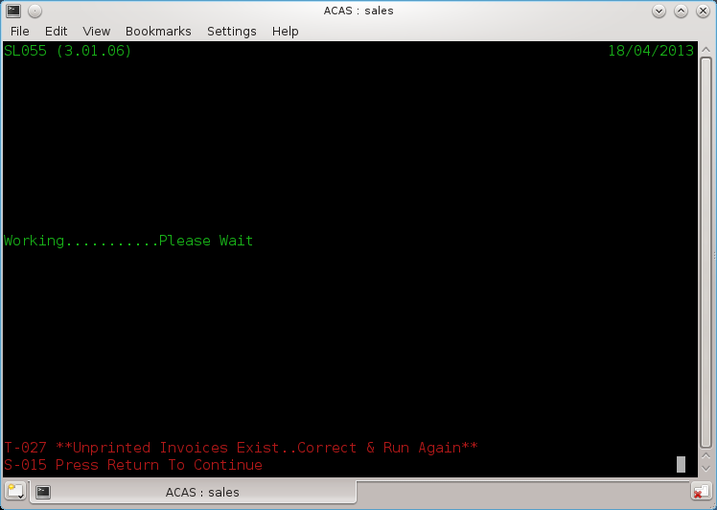

Figure 12.1 Proofing Error warnings

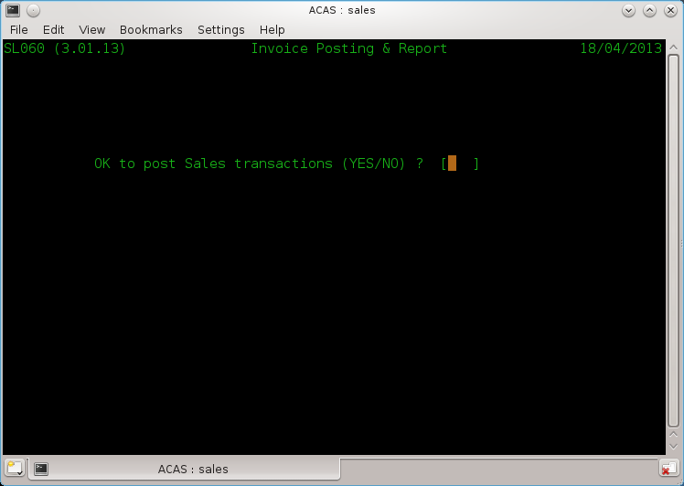

Figure 12.2 Do you really want to do this without proofing?

Figure 12.3 Sample report:

Place a sample report here from 3.02 in 6.67 point.

The Payment Batch

Payment receipt transactions go through the same batching procedure used for entering invoices. Receipts are entered in using the Payment Entry program and placed in the OTM (open item) file.

There can only be one payment batch at any one time.

The payment batch remains current until posted by the Payment Batch Posting program. Entering account data is not required as this has already been set up in the parameter file.

Applying Payments to Particular Invoices

Payments are applied to specific invoice and the invoice number must be entered. Otherwise, the amount of the payment entering the system goes toward paying the earliest invoice on the account or is marked as un-applied. The invoice remains on the open item file, but is reduced by the amount of the payment. If the payment entry is greater than the amount of the invoice, the invoice is paid in full and the overpayment applied to the earliest pending invoice as usual. If no other invoices for that customer exist on the open item file, the overpayment is placed on the open item file as a credit balance un-applied, and remains until it is applied to an invoice.

Adjusting Entries

An adjusting entry is an internal transaction that credits a customer account but does not involve an actual payment but uses un-applied payments previously applied to the customer's account and that was more than likely caused by not having the correct invoice details for which it is to be credited at the time of entry. The adjustment is applied to a specific invoice. If the adjustment is not equal to the invoice amount it is handled as a regular payment of a non-matching amount.

In order to more accurately reflect returned merchandise and other transactions which should reduce sales account balances, the correct procedure is to issue a Credit Note using the Transaction/Invoice Entry program to offset against specific item lines in a specified invoice.

This way stock control will always be accurate as a credit note will add back to stock.

Removing Late Charges

Late charges may be removed for any customer through the Payment Entry program . You do this during the entry to a particular invoice

Using the Payment Entry programs - options H and I.

When you select Payment Entry from the system menu, the screen appears (Figure 13.1) with the cursor waiting at the Customer number field. Thereafter it is straight forward to go from field to field using the down arrow or return key. If you do not have an invoice to apply the payment against, you can leave it in the system as un-applied. The systems reporting related to customer accounts will show any such customers along with all outstanding invoices so you can trace likely suitable invoices to apply against.

How to Change Payment Receipt records on the Batch

To change payment transactions prior to Payment Posting, select the Payment Amend program from the system menu. When the entry screen appears enter the customer and invoice details to amend, un-apply or delete. Note that payments can only be made to posted invoices.

Figure 13.1 Payment Entry Screen

TO BE ADDED during system testing

The Payment Proof.

The payment proof is a formatted report of the current payment batch file. A sample proof is shown in Figure 14.1. The data for each payment and adjustment is printed in the order it was entered. The payment proof serves as a working report and as an integral part of the S/L system's audit trail.

While the payment batch is being built, the Payment Entry program can be ended at any time, and a proof report printed. This working proof can be used to verify the accuracy and completeness of each transaction. As many proofs as desired may be made.

A final proof should, be taken immediately before the batch is posted. This final batch proof is a hard copy link in the audit trail that shows the exact transactions that were part of the batch when it was posted to the system. This printout is the only hard copy report that shows account detail for each transaction. If this final proof is not made, the payment posting program displays a warning error message and will stop.

The last page of the cash proof will report account totals.

If neither the IRS nor GL interface nor sales reports are selected, only totals of payments and sales offsets are shown. If either option is selected, the total for each account specified is displayed alongside the account name and numbers. A sample printout of this summary total page is shown in Figure 14.2.

Figure 14.1 Payment Proof Report

TO BE CREATED during system testing

Posting the Payment Batch

Once the batch of payments is accurate and complete, it can be posted.

If the batch file has not been completely proofed, Payment Batch Posting displays an error message indicating that the audit proof has not been made and will abort. so you can run the proof report before returning to the posting step.

The posting of payments can be as frequent as needed, many times a day or daily etc., but must be done prior to producing Statements, Late Letters (Dunning) or Aged Trail Balance reports.

As we have had the question a few times in the past - Why is Late letters also called dunning ?

Dunning is named from a company that is used to record businesses with bad payment records that can be search against, i.e., Dun and Bradstreet.

ACAS has three levels of Dunning letters set by number of days late i.e., 30, 60 and 90 and over, although at one stage it allowed up to nine - just thought it some what pointless many years ago having queried it with registered customers as we never used more than 3 as by then it went to the lawyers for action and they agreed.

See figure 14.2 for sample report.

Figure 14.2 Payment Posting Report.

TO BE CREATED DURING SYSTEM TESTING

Recurring Sales Invoicing - options T. 9. 1
Recurring sales Invoices are invoices that debit a customer's account for the same amount each defined invoicing / billing cycle for such things, as property rent, equipment lease, loan payment, or service contracts. The invoices vary only in the invoice number and the entry date.

The Sales Ledger system provides for the creation and maintenance of recurring sales through the Recurring sub-system (also known as Autogen), which is turned on by the actual entry of recurring Invoices. Likewise, it is turned off again, when there is no such invoices in the system and this process will allow the invoice generating process to be run at specific points in the system such as prior to when normal invoices are been posted. Note that when these are generated they are passed to the invoice file so they in turn can also be reported on with the Invoice proof report if needed.

Three programs are used to enter and maintain information on recurring sales, to proof the recurring entries and to post any such invoices that are due to be generated to the invoice file, ready for invoice proof and posting in the normal way.

Entering and Amending Recurring Sales (sl810)

This program is entered via the Invoicing option T, selecting 9 for Recurring Invoicing ( Autogen) then 1 and this creates and maintains all information on recurring sales. The program is almost identical in operation to the Invoice Entry program described in Chapter 4.1. All functions, add, amend / change. delete, save, etc. are available. Invoices must contain stock item transactions and would normally be items marked as service items. All defaults are the same and may be overridden as desired. The program creates and maintains an autogen record rather than a normal invoice record but the data is more or less the same apart for some small additions, such as action date (instead of invoice date), invoice frequency and repeat count.

The process requests an entry date just as Invoice Entry does. This date is never used as the invoice date, but it is placed in the autogen file as a reference for when the "master" recurring invoice is to be issued for the first occurrence, i.e., the start of the first cycle and is there after held as the date the invoice will be next issued and a copy of the date it was last issued.

The pricing used, is that on the date Autogen runs and that is currently on the stock record at the time.
Each such item must be in the Stock Control system and usually as a service (item).
Service items could also include such things as Post & Packing for various weights, i.e., up to 1Kg, 2 - 4.99 Kg, 5 - 9.99, 10 - 19.99 etc, where the costing includes costs of boxing, packing materials plus the actual courier change (ex VAT - where applicable).
The frequency for other services, which could include software such as monthly or yearly service fee's or rental, or support contracts, chargeable monthly or yearly. Hire of equipment, etc., the scope of this can be wide, and during the input of the autogen invoice you can specify the frequency where the date provided is the first date (in the future) when it will be applied, for the first time and all subsequent invoice generations will be on the anniversary of that initial date.

This will assume that the generate process will be run up to two days prior or two past for all such dates. The choice of using the last day of the month or the equivalent such as 30/mm/ccyy will act as the last day of month providing the current day is not less than 27th (to allow for February). However the best and safest form for this date usage, is when set to the 1st of the month and the process run up to two days before and after. This four day gap allows for weekends and short holiday periods. also see details of the posting program (4.7.3 on page 63).
This four day period gap can be changed via the sl830 program source code and then the system rebuilt but be very careful of doing such a change, as it might have adverse effects that are not wanted. The autogen system cannot cope with a business that totally closes for say a holiday of weeks where the period is within the first of the month and the four day gap, i.e., the 1st minus two and plus two days. If this occurs the next period will be missed for invoice creation.

The process does not request an invoice number since the master sales on the autogen file does not need one. Each invoice in the batch auto-generated from the master, is automatically assigned an invoice number as the next one in sequence, assuming you have the SL system set to auto create them and this is the recommended and practically the only way to, use it.
If any deleted invoice numbers exist, they are used first.

Proofing the AutoGen File - sl820

The Autogen proof program produces a report on the autogen invoices as stored. In operation, the program is almost identical to Invoice Batch Proof. This proof is not part of the audit trail and need not be run but very useful to confirm invoice settings and pricing and is therefore the recommended action and may be required for internal auditors if not others such as the sale team. It should be run at least monthly to confirm what recurring invoices are still active along with the details for each. It should be used to verify that the amounts used are the current one's and if not then the stock records checked and then the specific entries updated before running Entering and Amending Recurring Sales (sl810) and changing the amounts as needed.
This process has been fixed so that incorrect Stock items and amounts can be resolved prior to posting as against a method of using the Posting recurring invoices to get the current pricing from the Stock records. It is a bit of six of one and half a dozen of the other - there is no one solution that is right for all occasions.

Auto-Generating and Posting Invoices - sl830

The Autogenerate Invoices program can be executed once, for each monthly period. Although an autogen file may have entries for any valid period schedule such as monthly, quarterly or yearly, only those specified at the time it is run and due, are made into current invoices on to the invoice file based on the next invoice date and frequency and the date the program is run allowing for the four day window as specified in section 4.7.1.

The Autogenerate Invoices program reads the autogen file, adding an invoice for each customer's autogen entry (or entries) to the invoice batch for all valid periods as specified on the individual entry.

The Autogenerate Invoices program only uses auto created invoice numbers. It is therefore recommended to use the auto invoice number creation process as set up in the parameter file as option (5-09), see Parameter Set-up procedure from page 17, and a very good reason for such is the fact that this program can be run as a batch process outside of the menu cycle - more information on this later. This is, the default mode as this program is also run before the invoice posting program runs in the event it has not been manually run this month but does therefore assume that such a run occurs during the four day window.

The run date is used for the entry date field in each invoice record as it is transferred into the invoice batch file.

If the Autogenerate Invoices program has already been run this period and a invoice generated it will not be done again until the next defined cycle as specified in the frequency field during data entry as the date it did create an invoice is recording in the record.

REMOVE ALL DISCUSSIONS REGARDING CYCLE PROCESSING THROUGHOUT THIS
MANUAL ,- NOT LONGER USED OR NEEDED as processed can be based on first char of customer number and the manual selection criteria when such programs are run if needed at all.

Pre and post Applied Reports

The Aged Trial Balance / Aged Debtor Analysis Reports - option Q

The Aged Trial Balance also known as Aged Debtor, is the most important internal report for the users of the Sales Ledger system. The report shows the status of all sales by customers, broken down into columns.
This reporting program (as all others), first asks for three pieces of information :
Report date, account numbers to match, and the minimum amount outstanding to report on.

A sample of the Detail Aged Trial balance is shown in Figure 15.1<<< ??? >>>. This report shows complete details for every customer. Every outstanding invoice is shown along with any payments or adjustments applied in the last period. Each invoice amount is listed under a date column corresponding to the amount of time the invoice has been in the system. This is a lengthy, comprehensive report, that can serve as a primary working reference for your S/L department throughout the billing period.
CHECK THAT THIS IS TRUE FROM SAMPLE REPORT DURING SYSTEM TESTING AND THAT THE TEXT BELOW IS CORRECT.

All the reports show the customer's number, name, and phone number. The detail reports show the following data for each item:

- The invoice number of each transaction. If the transaction is a payment, this is left blank, unless the payment was applied to a specific invoice. If the transaction is an adjustment, the characters "ADJ" appear. If the transaction is a late charge, the invoice number consists of the word "LATE".

- The date of the transaction. This is either the date it was entered onto the system by Payment Entry or Invoice Entry or the date it was created if it is a system generated transaction such as a late charge or credit.

- The amount of the transaction. This prints in the column corresponding to the number of cycles (or months etc) it has been on the system. The first column for one cycle, the second column for two, the third column for three and the fourth column for four or more cycles. The fifth column is for payments and adjustments.

- Un-Applied cash amount, Credit balance, and if over credit limit.

If you wish to print a trial balance for a range of customers, enter the relevant criteria.

The report finishes with a total break down for all customers listed of :
Number Of Invoices
Amount Average O/S Amount Unapplied Cash
Payments Credit Balances Late Charges
No. of Live Accounts Number of Active Accounts % Active

and under Reconciliation Data provides :
Balance B/Forward Invoices Posted Credit Notes Posted,
Payments Posted Pay Late Chgs Taken C.Notes, Late Chgs Taken
Balance C/Forward
and a warning if it is Out Of Balance.

Other reports available are :

Sales Day Book
Customer Turnover
Sales Analysis

Payment Application

Payment Entry program

Payment Entry is the central program in the Sales Ledger processing cycle. Execution of payment entry is a landmark by which the many other S/L programs make their processing decisions. During the payment application process, payment or cash receipt transactions offset outstanding invoices on the OTM file (open item) and it can be run at any time and as often as required providing all invoices have been posted.

Three types of payments can be applied to the open item file:
1. A previous credit balance
2. A regular payment
3. A credit adjustment.

Regular payments and credit adjustments are entered with Payment Entry (See Chapter 4.4).

Payments are normally applied to the specific invoice otherwise to the earliest invoice on the open item file which is determined by the date of the transaction. A regular payment or a credit adjustment may be made to offset a particular invoice through Payment Entry. The payment (adjustment) is applied directly to the invoice regardless of its age or the existence of other invoices. If the payment exceeds the amount of the invoice, the credit balance is applied to other pending invoices as a normal payment, or it can be left as an non applied payment and applied at a later time through the same process. Such payments will appear on Aged Trial Balance reports and such like, as well as statements.

Any payment smaller than the invoice amount reduces the amount by the payment amount, but allows it to remain on the open item file bearing the same description, date, and invoice number.

If any payment or combination of payments exceeds the total of all outstanding sales, the overpayment becomes a credit balance and is reported as such on both the Aged Trial Balance and statements. If more orders for this customer are likely, the overpayment can be left on file to be used as a prepayment. Otherwise a invoice of a equal amount must be created to remove the credit balance using a service type item in the stock control system for this purpose and a payment made to the customer to clear it down.

Late Charges:

The payment entry program creates late charges if the option is requested during parameter entry. A late charge is generated at the end of cash application if an invoice remains unpaid that has been on the open item file for the number of days exceeding the setting on the system parameter file. The amount is a percentage of the overdue balance. This charge can be instigated by other processes during the running of the system but before the running of statements.

Late charges are a percentage of the overdue invoice balance, they are calculated only on the amount overdue in the period when late charges begin and anything older. For example: if late charges start at 60 days and the customer has outstanding sales 30, 60, and 90 days old, the late charge is calculated on the sales that are 60 and 90 days old. The 30 day old invoice, and any current invoices, are ignored. Late charges are truncated and not rounded up after the second digit to the right of the decimal point. Late charges may be removed from the OTM file (open item) through Payment Entry. Refer to Chapter 4.4 for instructions.

The program updates the sales customer record as well as the OTM file when it applies payments.

Printing Statements

The Print Statements program generates the customer statements. The statements which normally are generated and mailed via post or email attachment once per billing period, i.e., monthly, and shows all current invoices and all payments or adjustments entered in the last billing period. Sample statements are shown in Figures 22.2 and 22.3 using preprinted stationery.

The print format of the statements is pre-set for standard continuous form statements or on to a single sheet of paper as defined in parameter settings. Additional settings can be made directly to the program sl110 for fine tuning and then re-compile the program when testing is completed.

The Print Statements program may· be run any time after payment apply which in turn must be run after the invoice posting (otherwise it is difficult to apply payments to a non-existent invoice). It requests the date that will be printed on each statement as the reference or statement generation date.

When it starts the Print Statements program will ask if a dummy form should be printed if using continuous forms. If the answer is YES, a one page statement with dummy data is printed to make sure the pre-printed forms are aligned correctly. The dummy statement can be printed as many times as necessary by responding to the request with YES. When you answer NO the program begins printing real data. This function is only of use to businesses that use continuous statement stationery such as used on a matrix or line type printer. It will not happen if in the system parameter set up you specified that the Company name, address and heading titles are to be printed, implying that preprinted stationary is not being used.

The statements are always print in ascending customer number order.

Facilities are present so you can print statements for only a range of customers as might be needed if a printer malfunction occurred previously.

If the detail items (i.e., invoices, payments etc) for a customer will not fit on one page, the statement uses as many pages as necessary. The summary line at all but the last page of the statement will be blank.

The system operates as a strict open item system. This is reflected on the statement. All invoices current and not current but unpaid, will print on the statement. No summation of any open items takes place.

Notice that the amount in the left amount column shows the balance due on the invoice at the beginning of the period. The amount in the right or stub amount column shows the current balance due on the invoice after all current period payments have been applied. An invoice that has been completely paid off shows a zero.

The payment amounts are shown as negative numbers and print only in the left column. If the amounts in either the left or the right column are added together, the sums will equal the pay amount (total due) shown in the box at the bottom of the column.

Payments applied directly to a specific invoice show the invoice number in the invoice column. The amount applied to the invoice is the difference between the amount in the left column and the amount in the right column. This can be seen in Figure 22.2 for invoice 24791. The payment dated April 21st is earmarked for invoice 24791 even though an older invoice exists. The invoice amount in the left column shows 290.11, the original amount of the invoice. The amount in the right column, zero, indicates the amount currently due on the invoice. In this case the invoice has been paid off entirely. The payment dated 04/20/78 is not directed to a specific invoice and thus the payment goes toward the earliest invoice first. In the example, the fifty dollar payment is applied to invoice number 23345. The difference in the amount figures in the two columns for this invoice is fifty dollars. Figure 22.3 shows a statement with a credit balance. Notice that these statements uses the North American date format as set up in the system parameter file as this example is for an American company.

Figure 22.2 Sample Statement (Not actual size)

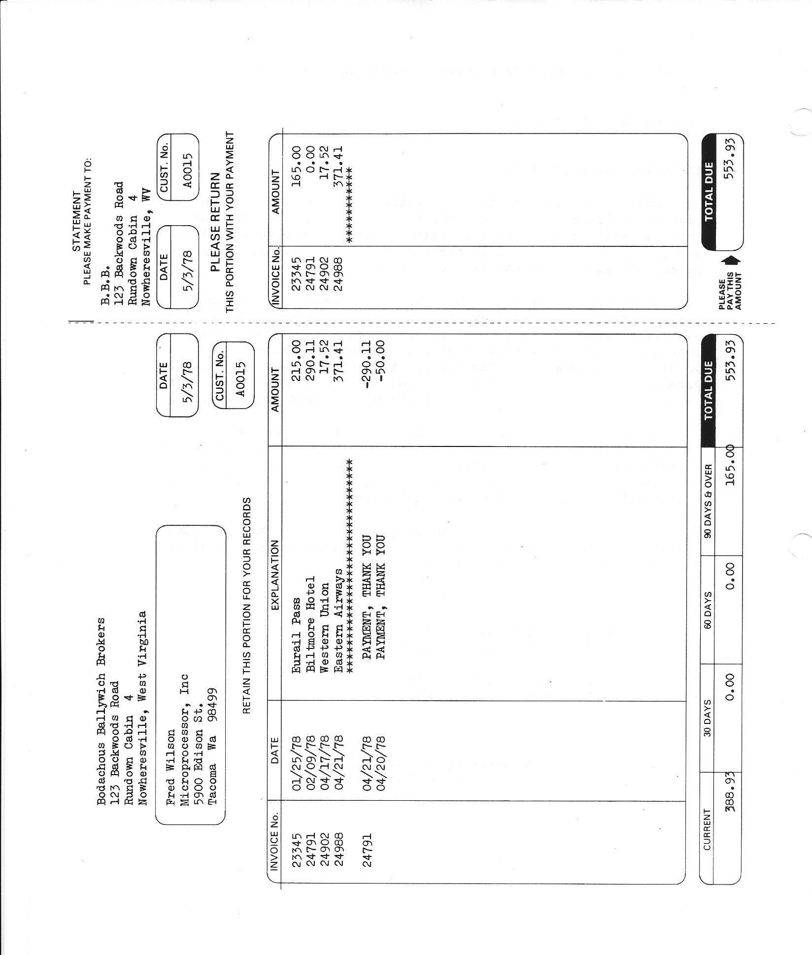
Figure 22.3 Sample Statement (Not actual size)

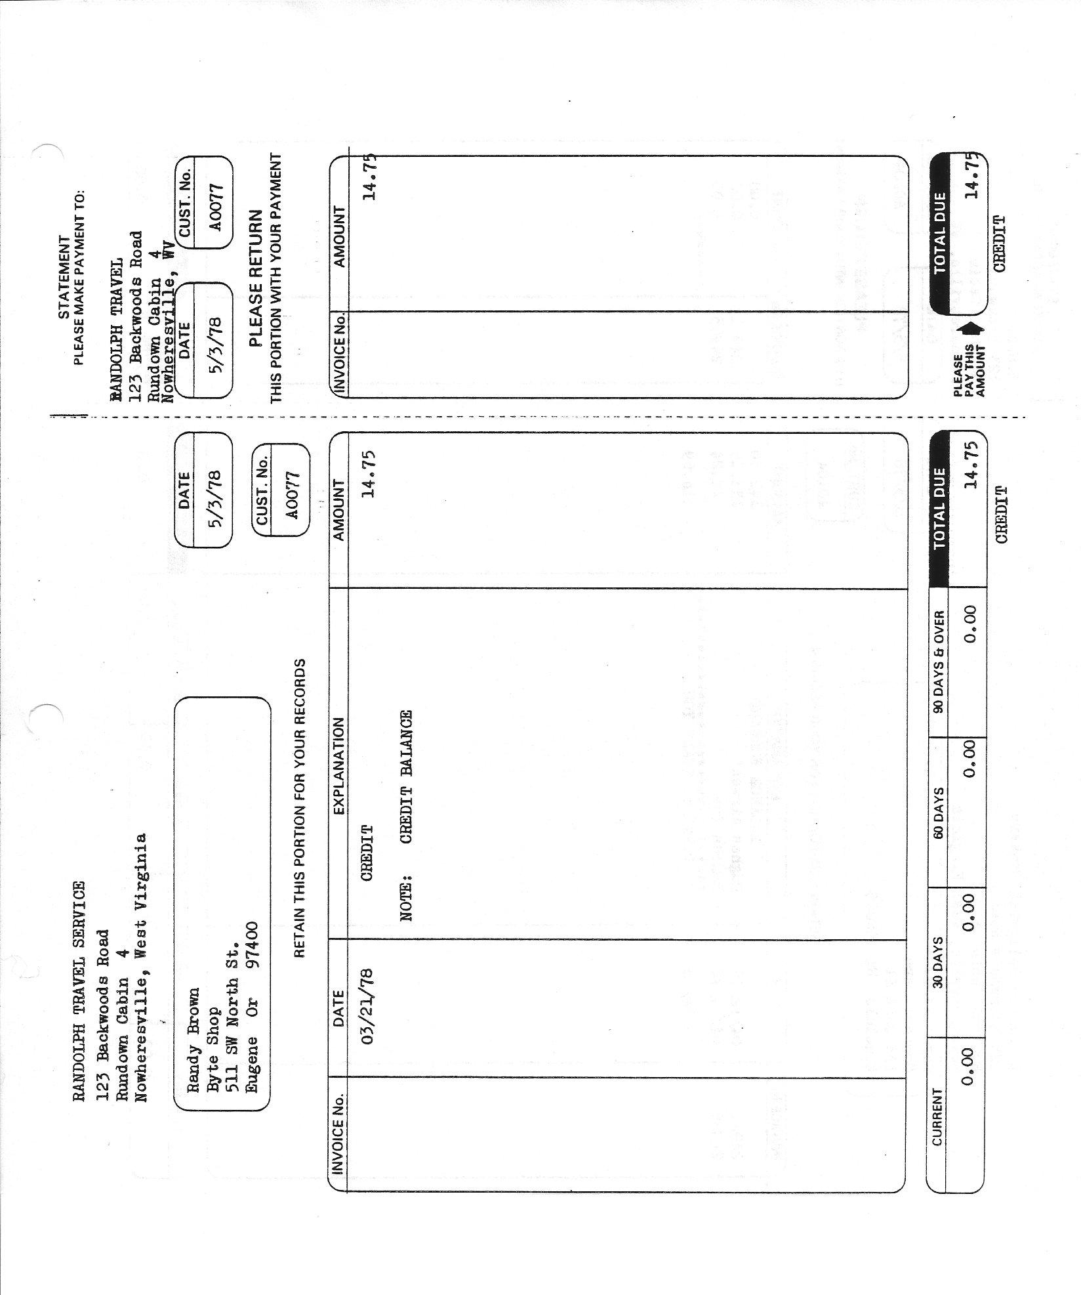
Figure 22.4 Statement Variable components - Set up layout

Layout information that will assist in changing the statement program sl110 if needed.

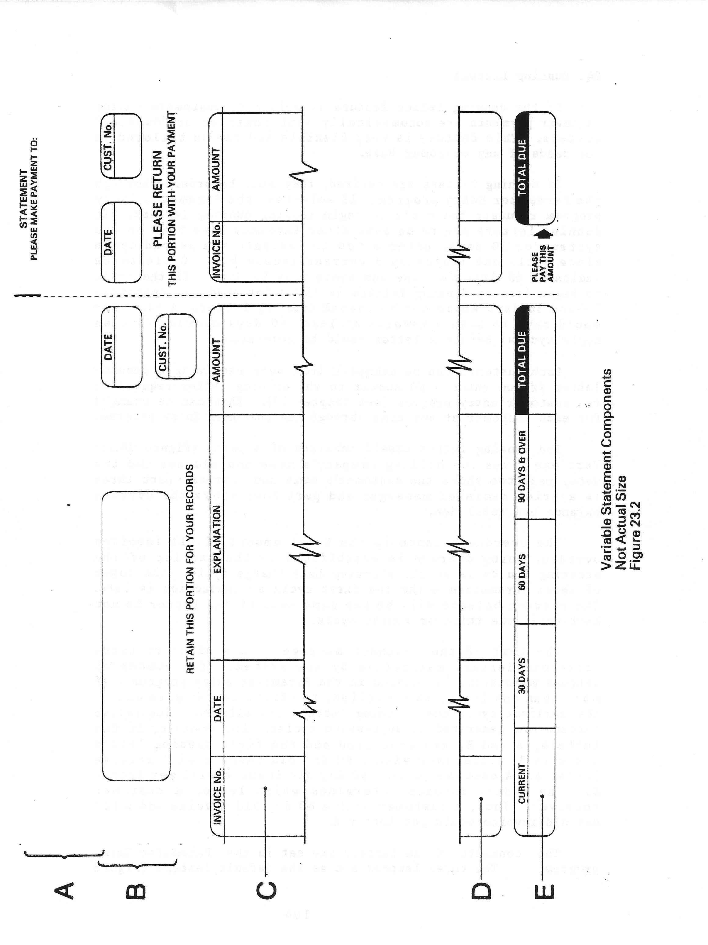

Formatting the Statements

The contents and placing of the data on the statements can be varied by the user to suit individual requirements. The basic format of the statements remain constant so the variation is somewhat limited.

The information printed on the statements can be divided roughly into two categories, 1) the statement heading, and 2) the statement body. The statement heading can consist of the company name and address and the customer's name and address. Also in the heading is the customer's number and the statement date. The body of the statement contains the detail information on invoices and payments and their respective totals.

Late (Dunning) Letters

If the dunning letter feature is selected, customers behind in their payments are automatically sent reminder or "dunning" letters. This feature is very flexible and can be tailored to the needs of any customer base.

If dunning letters are desired, they must be set up through Parameter Entry and created using a predefined text file for each one using any text editor.

Each customer can be exempted from ever receiving a dunning letter if you enter a NO answer to the dunning letter request in the Customer Entry program (see Chapter 3.6). This can be changed for each customer at any time through Customer Entry.

The dunning letter itself consists of 4 parts (Figure 24.1):

Part one gives the billing companies name and address and the date; part two shows the customer's name and address; part three is a brief reminder message; and part four shows the overdue balance and total due.

The overdue balance is the total amount of all invoices overdue. Being overdue is established by the earlier of the starting / current date dunning cycle or the starting Late Charge cycle. The lower of these parameters marks the first cycle a transaction is late. The overdue balance will be the same even if the letter is not sent until the third or fourth cycle.

The text of the reminder message is one of up to three different letters supported by the system which is passed to a word processor such as LibreOffice in a mail merge process with the individual detail of the customer - name and address, and amount outstanding as well as the total current balance passed to the mail-merge process.

The three letters set as the default letters are shown in Appendix 3 – Sample Reminder Letters. but of course can contain any text you wish.

The mail merge processing is NOT included with the O/S version of ACAS due to copyright issues, but any one knowing LibreOffice or Microsoft Word can easily set this up to match up with the software used. Unlike Word, LibreOffice is available on all platforms including windows and linux.
Figure 24.1 Sample Reminder/Dunning Letter

Part one :

RANDOLPH TRAVEL SERVICE
123 End Road West
London
NWI 6ZZ

12/05/78

Part two:
Alan Wilcox

National Fullconductor Ltd
III Ic Lane
Reading, Berks

Part three:
FINAL NOTICE

Your account with us is seriously overdue. We must demand payment in full within 10 days from the date of this notice.

AMOUNT OVERDUE

Part four:
635.21

TOTAL DUE

640 .31

The On-Line Enquiry

The online enquiry program (sl020) is a convenient way to access information on a specific customer. Once started, you can examine a customer's demographic information and sales status by typing in the customer number.

When it starts, the On Line Enquiry program asks for the customer number.
The program displays the customer's name, address, and other demographic information (Figure 25.1) and requests if you want activity to be shown. If you answer YES or RETURN, the program displays the status of the customer's sales. All invoices including non billed / posted invoices are shown in their entirety. All payments and adjustments are also shown, including those not yet applied, in order to reflect the most current status of the account. Invoices are totalled and aged on the last line of the display.

If there are invoices not yet posted the program will issue a warning message SL121 and abort the process.

Customer records can be examined in any order.

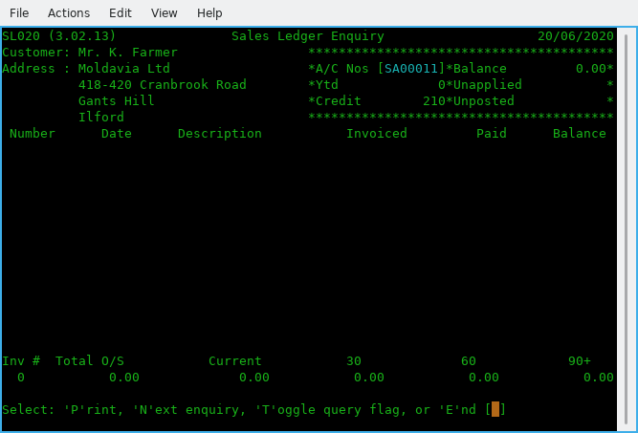

Figure 25.1 Online enquiry

Required system settings and changes

The following programs may need to be changed depending on your requirements regarding stationery for Invoicing, Statements, Packing Lists and Late Letters.

If you are not using continuous versions for any of the above you must make sure that your settings in the system parameter file is correctly set for printing your companies details on these documents. If using late letters, that you can set up the procedure to link them with your word processor and mail-merge tool if required even if only to create .pdf files (or such as via enscript) to send via email to your customers.

Statement production sl110.cbl
Invoice Production sl930.cbl
Packing Notes sl950.cbl
Late Letters sl190.cbl

As set up, if you selected that you want your company name and address details printed on one or more of these the system 'assumes' that you are not using pre-printed stationery. If that is not true you should change the parameter settings accordingly and/or the specific programs but do not forget to test them using test data.

The default is that no currency symbol is used as not really needed, but this can be change for Statements, Invoices and if needed, late letters by changing the source programs as needed.

So far no one has asked us to do so as would only possibly be required if you operate multiple currencies in Sales Ledger but users tend to convert to their local currency prior to posting invoices and payments.

Operations
Instructions by Operation and Program.

What follows is not by logic steps but only by program. For a logic flow see chapter 2.5, page 11.

Figure 26.1 - Sales System Menu

Option A - Date Input - sl000.
Enter or update today's date which will be used by default for all programs in the system but can be overridden as needed on a program by program basis.

Option B - Customer File Maintenance (Data Entry) - sl010.
There are six menu options as well as return to the sales system menu and these are:

Set-up Customer records
Here to enter new customers records and while some elements of a record has defaults as set up on the ACAS system parameter file which can be modified at any time the rest requires the individual information to help in setting up each customer.

If when entering a new order you find that the customer does not yet exist you can select this process by using F1 when requesting the customer number. You can also enter this process by typing NEW or new as the customer number, same thing.

Amend Customer records
This option allows you to amend a customer record such as amending the address, contact details including email addresses etc when such information becomes available that was not when first entering the customer information.

Delete Customer records
This is for when a customer has not ordered anything for some considerable time such as over one year and the account is zero - indicating no outstanding invoices exist. Here you can only delete such a customer if there is no outstanding invoices or excess payments unless you issue a credit note to clear a old invoice or issue a cancelling transaction to clear down an over payment such as when you send a repayment to them.

Print Customer records
This allows multiple options when print out customer records by a screen showing all the options you can set to select specific types of records. See figure 27.1 for the range on offer.

27.1 ??? add during system testing current version.

Figure 27.1 Reporting selection criteria menu

Display Customer records
This option allows you to display on screen a specific customer record.
After the display you can select Q to quit this option and return to the menu, or T to apply a unapplied payment to the current sales value for this customer.

Amend Back Order Status
This allow you to change the BP (Back Order) status to and from Y (Yes) and N (No) which specifies is this customer is happy to have a back order allocated when one or more stock items are currently out of stock. When set to N this is not allowed.

Here you can select a specific customer or a range of customer that have a starting characters such as SAU which will select ALL customer with a number starting with SAU and will change all of them in this range to the BO state selected.

Lastly you can leave the customer number field as spaces to select ALL customer to be change to the BO state selected.

Option C - Sales Ledger Enquiry - sl020.
To request information about a specific customer which includes current outstanding balance, YTD (Year to Date) statistics, non applied payments amount, non posted invoices and lastly credit status,

Option D - Sales Transactions Input - sl910
Invoice data entry for batch printing (as against a one off invoice that is entered and printed immediately after). You enter the customer number, stock item numbers with quantity ordered, confirming price both against the stock item record, net cost, discount if any and once all items have been added you can the enter amounts for miscellaneous cost, post and packing and other sundry amounts before saving the invoice for later printing.
Should a stock item be out of stock or such as the total requested quantity be fulfilled then a BO record is created for the difference between current stock and the requested amount along with details of the Order and reference number, current invoice number and today's date. These BO records are updated when new stock arrives and the Stock additions processes updates these BO records that match the item number. When next the invoicing program runs these BO records are checked and if any are shown as now having stock they are processed in the normal way with many of the fields that are known about pre-filled in for you to continue with the invoice. For reports that show the status of these back order records see sl970 for more information that also provides the facility to amend or delete specific back orders.

Option E - Sales Transactions Amend - sl920
Here you can amend a specific invoice and this process is the same as for option D. Invoice Entry. You just need to provide the invoice and customer numbers to proceed.

Option F - Sales Transactions Proof sl050
This processes will produce a printed reporting showing each invoice and there corresponding stock item ordered that you can use to verify accuracy of all invoice currently created and not posted. The posting process also produces a similar report and both should be retained for your records in the event of a company audit by your accountants or by the tax inspectors. These records at least for the UK, must be retained for up to seven years but electronic copies such as a .pdf file, are valid as well as they can be printed at any point later and take up less space.

Option G - Sales Transactions Post - sl060

This includes sales transaction extract and analysis (sl055) which is hidden from view before running the last step, transaction post sl060. Report is similar to the proof report but differing slightly in layout.

Option H - Payment Input - sl080

Option I - Payment Amend - sl085

Option J - Payment Proof - sl095

Option K - Payment Post - sl100

Option L - Set-Up Sales Analysis Codes - sl070

Option M - Sales Analysis Report - sl130

Option N - Sales Day Book - sl140

Option O - Statement Production - sl110

Option P - Dunning Letters Generation - sl190

Option Q - Aged Debtors Analysis - sl120

Option R - Alphabetical Customer List - sl160

Option S - Customer Turnover Report - sl180

Option T - Invoice Sub-System - sl900
This option opens a sub menu which offers a new set of options, see figure 28.1.

Figure 28.1 Invoicing Menu

Option 1 - Enter or Amend Invoicing Fixed Data
Here you have the option of entering or amending the following fixed data, but also see 4.1.1, page 46

Figure 28.2 Invoice settings

Lets quickly go through these in order:

- Next Invoice Number: Set this as needed, but not less than 1.
Extra Charge/Discount Description: If you require a standard discount or credit, you need to start here. For example we use it to offer a prompt payment discount on all invoices that all carry 28 day terms and the discount is offered for all invoices paid within 14 days of issue. As you can see this has been set up in fig 10.1 and we have called it Prompt Payment.
- Extra Charge/Discount Type (C/D) it is set to 'D' for Discount.
- Print Extra on Invoices (N/Y) it is set to 'Y' as we do want it printed on invoices.
- Extra Charge/Discount Percentage, set to the discount rate and here it is 5.00%.
- Invoice Entry Level (1, 2): To use detailed select '2', then invoices will be recorded in their component parts for more detailed accounting and reporting and for linkage into the Stock Control system. See figure 10.1 & 10.2. This extra level of detail is simple to implement and is entirely optional. If you select 1 instead, then you will only be entering the Net and Vat amounts. The detailed information is maintained at the batch level and in the open item files. For example, in many cases an invoice is for several items and/or some kind of surcharge such as Vat and shipping. These normally must be accounted for in different sales accounts for the sales report or the GL interface. The invoice would then consist of a controlling record containing the grand total of the charges on the invoice, and one or more line items that each, represents a component charge and each can be credited to a different sales account.
In figure 10.1 it is set to 2 as we require full detailed invoices that we also link to Stock Control but is still applicable even if not using the Stock system. It just means you have to type in the descriptions for each line item as well as the price, and that is a good reason for using Stock Control
- The next two for entering the IRS or G/L accounts that relate to both Vat and the Discounts or extra charges given/taken so that the accounts are always up to date without the need to enter this type of information into IRS manually.
- Proforma Retention In Days, if you issue proformas then the number of days they are valid for, after which they get removed from the system. You can amend a proforma to a receipt after the payment is received.
- And the last one, 'Y' to confirm all of your settings otherwise 'N' to go back through the screen. Of course you can just enter Y and reselect the screen to go through it again updating previous data.

Option 2 - Enter Invoices For Batch Printing - sl910
Enter Invoices for batch processing.

Option 3 - Enter Invoice For Immediate Printing - sl910
Enter Invoice for Immediate Printing and bypass Batch processing.

Option 4 - Amend Invoices - sl920
Amend invoices produced by option 2.

Option 5 - Delete Invoices - sl940
Delete specific invoice numbers and these numbers will be reused. All stock items recorded on invoice are return to stock by stock number and deducted from all analysis records that was created by the invoicing process. This applies to all invoice types such as Credit note, Receipt, Proforma and Invoices. This process is only applicable to invoices NOT posted. For any that are a Credit note must be raised to cancel off all stock items as well as all other charges such as Post and Packing, late fees, etc., i.e., a mirror image of the original invoice so that all stock is returned and all amounts recorded for analysis is reversed.

Option 6 - Invoice Deletion Report - sl200
Produce a report of deleted invoices by invoice number, date and customer number.
Mostly for audit purposes. All listed invoices will be reused in number order by options 2 or 3.

Option 7 - Print Delivery Notes/Picking Lists - sl950
Produce all Delivery / Picking lists for all invoices not yet printed. WARNING: this program MUST be run before producing Invoices. Output is sent to the printer set up via the ACAS parameters for this purpose, i.e., the one in the packing department. It is recommended to be a 3 in one type so that for any orders that require more than one box a copy of the note can be included in each also if needed a copy can be passed to the sales team for filling and retention at least until the invoice is paid or a specific time has lapsed such as three months etc.

Option 8 - Print Invoices - sl930
This process will print all outstanding invoices created by option 2 and must only be run AFTER option 7, Print Packing Notes. You can re-run this options for any Invoices that are spoilt or did not print out due to printer or other problems. If you need to retain a copy of these for the sales team in case or query etc then after printing is as good a time as any to copy them. Another option is to print two copies for all invoice produced.

Option 9 - Recurring Invoice Processing - sl800
These options that can also be referred to as the autogen sub system.

This program offers the following options

Option 1 - Enter / Amend Recurring Invoice - sl810
This program allows the user to enter, amend or delete an invoice record based its the unique number and that of the customer number. You should refer to the printed output from option 2, sl820. See the example display shown in figure mmmmmmm, page yy. INSERT DURING BASIC TESTING.

Option 2 - Proof Recurring Invoicing - sl820
Provides a report showing all recurring invoices in the system providing date next due to be issued, frequency and line item breakdowns and the invoice totals. These line item details along with the amounts, etc are taken from when the invoice was first entered and it is NOT updated again unless you run sl810 in Amend mode, so if there are pricing updates to the stock file for these service type items they will otherwise not take effect. This is the case of two evils, where this is programming option1 and the other possibility is always taking the latest pricing but the original contract could be for a fixed pricing. Sample report to be added as figure mmmm, page yy INSERT DURING BASIC TESTING.

This can be changed in program sl830 to obtain the current prices and update the recurring invoice line details prior to posting to the invoice batch file.

Option 3 - Post Recurring Invoices - sl830
This process will examine all active recurring invoices looking for any that have a date (that was entered or has been updated by this process), for any that matches today's date, plus or minus two days as defined in the program source. This allows the program to run before or after a holiday period or weekend - providing it is within this time period. The date normally used is the first day of the month and assuming that is the case the it will process invoices providing the date run is 3rd, 2nd, 1st of this month, and last two days of the preceding month.
On finding a date that is within this test it will post the recurring invoice details to the batch invoice file so that the normal Invoice posting programs sl055 and sl060 will pass them to the sales open item file. Note that whenever sl055, 060 is run the sl830 autogen / recurring invoice post program will run first, in case this program was not run.
On finding a recurring invoice to post it will then update the date for the invoice to be next issued based on the frequency as set in program sl810 Recurring Invoice Entry saving the record for any later processing.

Option A - BO Reporting and amendments

Option X - Return To System menu

Option U - End of Cycle Processing - xl150

Option V - Customer File Dump - sl170

ACAS System wide File and RDBMS Table Usage Chart

The following chapters are to assist along with the ACAS system specific manuals full usage of the ACAS systems.

File # | File name | Table name  [ -rec ] | DAL (MT) | Isam? | GL | IRS | Sales | Purchase | Stock
00 | system | system  sysdeflt  sysfinal  systot | system  dflt  final  sys4 | Rel | rw | rw | rw | rw | rw
01 | glwork | n/a | n/a | ???
02 | archive | n/a | n/a | Seq | rw?
03 | final | n/a | n/a | Seq | rw | rw
04 | slautogen | slautogen | slautogen | IS |  |  | rw
05 | ledger | glledger | nominal | IS | rw
06 | posting | glposting | glposting | IS | rw |  | w | w
07 | batch | glbatch | glbatch | IS | rw |  | rw | rw
08 | postings2irs | psirspost | slposting | IS |  | rw | w | w | w
09 | tmp-stock | n/a | n/a | Seq |  |  |  |  | rw
10 | staudit | stockaudit | audit | IS |  |  |  |  | rw
11 | stockctl | stock | stock | IS 3i |  |  |  |  | rw
12 | salesled | saledger | sales | IS |  |  | rw
13 | value | valueanal | value | IS |  |  |  |  | rw
14 | delivery | delivery-record??? | delivery | IS |  |  | rw
15 | analysis | analysis | anal | IS |  |  | rw? | rw? | rw?
16 | invoice | sainvoice  sainv-lines | slinvoice | IS |  |  | rw
17 | delinvno | sadelinv | sldelinvnos | IS |  |  | rw
18 | openitm2 | n/a | n/a | Seq |  |  | rw
19 | openitm3 | saitm3 | otm3 | IS |  |  | rw
20 | oisort | n/a | n/a | Seq
21 | Work.tmp | n/a | n/a | Seq | rw
22 | purchled | puledger | purch | IS |  |  |  | rw | r
23 | delfolio | pudelinv?? | delfolio | IS
26 | pinvoice | puinvoice  puinv-lines | pinvoice | IS |  |  |  | rw
27 | poisort | n/a | n/a | Seq |  |  |  | rw
28 | openitm4 | n/a | n/a | Seq |  |  |  | rw
29 | openitm5 | puitm5 | otm5 | IS |  |  |  | rw
30 | plautogen | plautogen | plautogen | IS |  |  |  | rw
31 | bostkitm |  |  | IS |  |  | rw |  | rw
32 | pay | plpay | payments | IS |  |  |  | rw
33 | check | n/a | n/a | Seq |  |  |  | rw
34 | irsacnts | irsnl | irsnominal | IS |  | rw
35 | irsdflt | irsdflt | irsdflt | IS |  | rw
36 | irspost | irsposting | irsposting | IS |  | rw
37 | irsfinal | irsfinal | irsfinal | IS |  | rw
38 | postsort | n/a | n/a | Seq |  | rw
## | Various temp names | n/a | n/a | Seq | rw
ACAS File usage Table

rw = Read/Write IS = Indexed sequential
r = Read only IS 3i = Indexed Sequential but with 3 keys
w = Write only Seq = Sequential
Rel = Relative
n/a = Not Applicable – Cobol file only.

Unless otherwise indicated all files have an extension of “.dat”
## Other files exist during General Ledger running but all with extension “,tmp”
## The other systems use temp file ending .dat and are not deleted others with .wrk are deleted at end.
All temporary files are stored in current directory usually as pointed to by environment variable
ACAS-LEDGERS set up by the install-acas.sh script. The script install-ACAS-preinstalled.sh does not do this as it is previously done by the former script..
All temporary files tend to be small but not greater in size than any primary files.
All RDBMS table names end with ‘-REC’ and are ALL upper-case.
All DAL programs names end in MT but not shown above.
ALL Cobol → table loader programs have same name as DAL but ends in LD..
ALL FH programs take their name using File number (#) e.g., file 32 FH is acas032.
IRS is slightly different these are named acasirsub1, 3, 4 and 5 that replaced the old FH called sub1, 3, 4 & 5.

The invoice tables have secondary tables that are directly linked but not listed above.

Migration to other RDBMS systems will use same names but stored in another sub directory under DAL within common which already has MySQL DALs in MySQL. Copied from the common directory.

The FH (File Handlers) in both common and FH are consistent regardless of RDBMS used.

Individual file details where needed.
This chapter is mostly useful to programmers or anyone else with a wish to understand the underlying structure of elements of the ACAS system that nay be non standard etc.

ACAS System file
This file consists of four unique records:
1. ACAS parameter record containing details for the set up of the entire ACAS system.
2. Defaults record for GL (IRS has its own file).
3. Final account headings replacements for GL.
4. Sales and Purchase period totals.

Stored as relative values 1 through 4.
This is the only file that uses relative (absolute addressed) keys.

The following is for ACAS v3.02 and later.

All others use ISAM (Indexed keys for Sequential Access Method) and this is to match up with the storage methods used within DB's (Databases) such as mysql, mariadb, Postgres, DB/2, Oracle and even via ODBC.

ODBC is a common standard that can process for most Databases but is slower to access and even more, so, for a busy environment such as on the DB server where many are accessing the system but it will have a lower time requirement and savings setting up any other DB's. This slowness will only possibly by noticeable with large numbers of staff using the system at the same time otherwise not so much.

Record formats for all - Cobol files and DB tables are generally exactly the same but where there are differences, the database records are transferred in the same layout and format, as that for the Cobol file records. In some cases more than one table has to be accessed to obtain the data required for one Cobol file record and these issues are handled within each DB DAL handler without the F.H.(File Handler) being non the wiser at they just get the record as known in the file record layout only.

There is one FH for each Cobol file and there is one DAL for each table that related directly with the corresponding DB table for each FH. Invoices is the only exception where there a two tables, one for the invoice header record and another for the invoice line items (that are linked to the invoice).
The benefit of using such an approach is that the FH can be called by other programs such as used say in a web site online shop or ordering system in that they can calls the appropriate FH to access the stock file record to confirm there is current stock and the current retail price and if the order is placed another FH to add a transaction deduction record and update the stock record by the number of items so ordered. In addition another FH can be called to create a receipt / invoice for printing along with a packing note for the dispatch team.
In this way the whole process is as automated as possible - apart from the packing anyway.

Any such online system will have to be written in a programming language that support calling libraries using the C coding convention and many do but check with the suppliers of the online system and if needed get the source code or a quotation for doing the light weight extra work to integrate the systems together.

To support another database other than Mysql and Mariadb, new DAL's have to be created for each table per DB and this means that to support a new DB a new set of DAL's (Data Access Layer) has to be created / written where the first two (one for the system parameter file) and the other for the first selected normal data files and this acts as the default module that all the other can be coded from. The System parameter file is the odd one out that it is a special case in processing, that does not match up with the way that all the other cobol files used within the ACAS system are processed.

These two are the hardest or take the most time to program, but all the others can be created from the second one - the first of the normal data files once finished and tested.

This helps to keep the process as easy and simple as possible to develop for each new database. - Well that's the theory.

The record layout for all files can be seen via the source files for all the programs as included files and these can be found in the directory - copybooks.

These copy books are broken down by the type and location of where they are copied from within each program such as for the SELxxxx, (select section in file-control), FD (file definition) area in file section, WSxxxxx in working-storage for the working areas used while a program is running. Some start with the initials of the system such as sl, pl etc.

Easy to spot in a program source file as they start a line with :
copy "filename.cpy".

All such copybooks have the extension of .cpy after the filename to distinguish then from the Cobol programs which have the extension of .cbl or if they contain DB SQL code the extension is .scb (for Sql cobol), and these sources are passed through a precompiler which create a .cbl file that is in turn used by the Cobol compiler. The SQL precompiler converts the SQL type statements into Cobol which is understood by the cobol compiler as it can not understand SQL.

For example regular SQL code such as EXEC SQL READ would generate some lines of code for the compiler that can be processed. Usually in the form of a CALL statement with a number of parameters.

Reporting problems with ACAS products

Use the bug reporting function on the ACAS sourceforge website for both problems in the software and in any supplied manual. Do not forget to specify the name & version of the program with the problem, also specify the level of the issues such as : -

Priority
Level Title Description

1. Critical Cannot run a previously working ACAS system.
2. Urgent Can run the system but cannot work with some functions.
3. Partial A function is not working as described in manual.
4. Function Needs additional functionality.
5. Cosmetic A minor problem such as in screen display layout or the colours used
or the way data is entered.
6. Undefined Low priority issue not within other levels.

Commercial users should also prefix priority number with a ‘C’.
Level 1 is same day / 4 hours. [with prefix C otherwise 24 hours, where possible].
Level 2 is same day / 12 hours. [with prefix C otherwise 72 hours, where possible].
Level 3 & 4 is 3 days. [with prefix C otherwise, as time permits].
Level 5 & 6 is as time permits. [with prefix C, as time permits].

E & OE Applies.
The above timings is on a best effort basis only as holidays etc, can interfere with these.

Commercial users with active maintenance contracts, can also use the direct website as outlined in the supplied support documentation and the email address mentioned below for problem reporting.

If it is critical or urgent you can also send an email, see address on inside cover but still use the bug reporting system so other users can see that it has been reported.

Remember if it is not reported – It cannot be fixed and do not assume that some one else has reported it. Check the bug lists to see.

If in doubt issue a bug report. if warranted, retain all data files in case they need to be sent in (but only after archiving them with zip, rar or tar with a file name indicating the customer / user) i.e., applewood-bug-report-1.zip.

Subject to the problem you may be asked to send these in for inspection. After the problem has been located and resolved, these files will be deleted.

Error messages used within the ACAS system

Here is a list by system and program of all messages that signify an error or warning that can appear.
However there are warning messages that can appear during data entry that are not listed.

Cobol and C Error Messages

Applewood Computers software is designed to trap almost all errors which can arise under normal circumstances, but due to language limitations and/or hardware problems, some errors may occur which the programs themselves cannot handle. These errors are Cobol or C errors – see File Access Error numbers page 105 You should look at the Cobol compiler documentation for more information as these can change between versions of both the Cobol compiler as well as the GCC C compiler. Also see RDBMS error codes and MySQL SQL Status messages on page 106 for additional RDBMS status values that can also be displayed.

Some of these can signify problems with lack of free storage space on your hard drive, a hard issue with it or you are running in the wrong directory in which case check your environment variables for the settings of ACAS_BIN for the programs and more importantly the environment variable ACAS_LEDGERS for your data.
This you can find in konsole program by typing : set | grep ACAS_LEDGERS and this will result in a text similar to : ACAS_LEDGERS=/home/yourusername/ACAS

This applies even if you are running using RDBMS as the system parameter file is required to be a Cobol file at start up and located in this directory. An temporary override for this setting can be done whenever running any of the system programs i.e., ACAS, irs, general, purchase, sales or stock by adding to the system name the string ACAS_LEDGERS=a new path such as :
sales ACAS_LEDGERS=/home/username/temporary-directory

ACAS Error Messages

Messages that instruct you to contact your Supplier or IT support generally indicate an error condition that should not arise under normal circumstances, such as no free disk space. Ensure that the hard drive you are using has loads of free space such as over 1 GB and with the risk of fragmentation of data per file, it is always wise to make it more. Here more so in Windows based systems but can apply to *nix based one’s as well.

References to ACAS support usually mean a possible programming error that over the years has not ever appeared but with a changed Cobol compiler (GnuCOBOL) and the usage of RDBMS, anything is possible.

Program names herein are shown in upper case for ease of reading but are actually stored and used within the ACAS system using lower case letters other than the optional master menu program ACAS.

SSDs and Garbage Collection.
If you are running with SSD’s you should be aware of the problem of garbage collection on *nix based systems such as Linux. This relates to the fact that all SSD’s are not created equal, e.g., some have good controllers built-in and other – well not really.

An example, when we first installed SSD into Linux based systems we found out very quickly that you had to run a Linux utility called fstrim on a regular basis like in nightly so we set up a cron job to do just that at midnight, running as sudo (or root) ‘fstrim -av’.
Great you think, well not so much when running Crucial SSDs as their controller require 8+ hours of idle to process the garbage and even then may be not, as it forced us to shutdown the system and boot into bios and leave it – No, not a solution as the SSD filled up very quickly and I do mean quickly and I cannot spare the system time to make it offline. This is not the only brand that will cause this problem.

So SSD mk 2 – bought Samsung 850 as a test and found out that their controller did not require such idle time. Then bought two m.2 960’s SSD’s and installed in server and laptop (windows) an Samsung 850 into a Mac Pro dual quad Xeon CPU system and all work as advertised well apart from a media system that also has a m.2 that in some circumstances such as transferring lots of video media and yes I mean a lot – like 40 GB. As the SSD is the system partition all data coming in, goes to that first before being moved to the required location and that is with copying to the specific hard drive as the SSD is used as some temporary data areas although not sure why or where exactly.
So in this instance it cannot do a clear up quickly enough to cope, again do not know why. Just have to remember not to do a lot at a time :(

So what is this about I hear you ask? Well unlike a normal hard drive that, when you delete a file it is job done. It is not that straight forward for a SSD. When a file is deleted or moved or updated it has sectors / clusters on the media that are no longer in use and the SSD controller has to go through a process called Garbage Collection and this mean the onboard SSD controller goes though each sector checking if it is not in use then clear the whole sector down by setting it to X‘00000000’ (X = Hex) for every byte in the sector, so takes a wee bit of time.

Now under Linux as we run the fstrim process every midnight it keep it under control at least on the servers and Mac pro. The Windows system seems to cope without doing a thing – just as well really as I have no idea what it does as I cannot find any docs on it.

So long story very short if you run SSD’s on a Linux based system you MUST make sure fstrim is run often enough to clean it up before it gets out of space that has not been cleaned up because regardless of its size, if all clusters have been used and have not been cleaned up it is the equivalent of a filled drive, regardless of size and we are using 256GB and 500GB despite them only used for booting and minor other data requirements, they can and do get clogged up. It is wise to run a crontab job as @reboot /usr/sbin/fstrim -av but check where your one is by running whereis fstrim.
If you have rebooted a *nix based system such as Linux, Apple's OSX etc the next time you run fstrim -av you will get a large figure and this is because the reference held is lost on a reboot so you can ignore it the first time. If needed, although should not be needed, run fstrim twice per day say midnight and noon if system running 24/7.

So for *nix users, you have been warned. So keep that in mind when looking at some of these ACAS error messages regarding a full drive. I recommend you do NOT use a SSD to hold application data on and their performance is not that heavy a usage problem as most of the time most of ACAS is waiting for the user to key some thing in and the grunt work is done quickly enough even if you have say 25,000 records for each file and we are running in production over 1,000 for both sales and purchase ledgers and can (for clients) be creating 1,000+ invoices/receipts per day and over Xmas it was closer to 5,000 per day. Kept the pickers and packers very busy.

Some of these transactions came through their online shop that is linked into Sales Ledger with a bespoke program to transfer the data over every so many minutes or on every transaction. The web shop also accessed the stock control system to check for stock quantity etc. On of the benefits of ACAS using special modules to handles file processing i.e, FH (File Handlers) and for rdb databases DAL (Data Access Layer) that are called by the FH if needed. These can also be used by other software such as online web shops to access the stock system and pass on order details to create an invoice or receipt for printing subject to stock availability providing they can use the C calling interface, or be made to do so.

One of the benefits of running a batching system where all invoices go to one printer, picking or packing lists go to another (in the warehouse) may be both using continuous stationary and statements to a third (laser) when needed. The laser printer has an overlay feature that holds the graphics for a header page so that ACAS output just prints out in the correct locations on the page while the overlay also produces the titles, company details etc at the same time. This option may well also be available on some inkjet type printers including Inktank.

It should be pointed out that some clients of ACAS used both matrix and line printers as well as laser printers to push things through with auto folding and enveloping equipment where needed. With the advent of most, using email these days, printer usage has reduced a lot.

Just depend on the size of the business and volume of sales per day but the benefit is that using ACAS you can start very small, and as you grow can upgrade your computer equipment and printers to handle the volume when needed.

Sales Ledger Error Messages

This section contains the full text of all the error messages issued by the Sales Ledger system. These are also shown in the manual Building the ACAS System.
SL system errors are in the form:

SLnnn message

The "SL" indicates an SL system error. The "nnn" is a three digit number unique to this message. The "message" is a descriptive phrase explaining the problem. This appendix gives more in-depth descriptions of the errors and gives possible solutions.

Each SL programs has a unique range of error message numbers as shown in Figure B.1. Some error messages are common to all or many programs in the ACAS system and these start with SY, or AC for any FH (File Handler) and SM for any DAL (Data access Layer – rdbms processing). They all have numbers ranging from "000" to "999".

Some error messages should never occur. If they do, it is usually an indication of some more serious problem with the hardware or operating environment. Such messages will ask you to contact your IT or ACAS support. Before doing so, back up all data then restore from last known point of good data and rerun the programs, noting all actions taken. This will help to determine the problem.

ACAS System wide Messages
These apply to all system programs, ACAS, IRS, General, Purchase, Sales, Stock etc.

Messages produced throughout ACAS are prefixed by a two letter code that indicates what program produced them and the program could be called from another system, e.g., PL070 and SL070 can be called by Stock, Sales or Purchase to set up the Analysis file. The system parameter set up program can be called by any of the systems to set up or amend it.
There are other instances of this type of processing that can occur.
Messaging prefixes are :

IR = IRS
GL = General Ledger
PL = Purchase Ledger.
SL = Sales Ledger
ST = Stock Control
PY = Payroll
SY = System set up programs or programs and system wide messages.
SM = DAL’s (Data Access Layer) for RDBMS processing.
AC = FH’s common system wide messages.

From initial start up in all system programs.
SY005 Invalid Date: Formats are dd/mm/ccyy, mm/dd/ccyy or ccyy/mm/dd
only. i.e, 1/1/2011 it should be 01/01/2011.
SY006 Program Arguments limited to a maximum of two and you have specified n
As indicated, the only values currently accepted is :
ACAS_LEDGERS=path-to-data-directory.
SY007 Program arguments incorrect:
You have specified parameters to a system program
that are wrong. Correct and rerun.
The only values currently accepted is :
ACAS_LEDGERS=path-to-data-directory.
SY008 Note message & Hit return
As indicated see the other preceding message.
SY009 Environment variables not yet set up : ABORTING
Working directory environment variable not set up, fix
and rerun. Is this a new user ?
This should have been done by the ACAS setup up
process : install-ACAS.sh if so, run it for user.
SY011 Error on systemMT processing, Fs-reply = nn
Got an error when writing to the RBD for the first time
nn = return value but could have a preceding msg.
Could mean that the RDB is not running or set up
correctly. If not report to ACAS software support.

From System parameter set up program (SYS002) callable by all system programs.
SY101 Open I-O Err = nn: Contact IT support and provide nn*. Should not occur.
SY102 Read Err 1 = nn: Contact IT support and provide nn*. Should not occur.
SY103 Rewrite Err 1 = nn: Contact IT support and provide nn*. Should not occur.
SY104 Fix and Press Enter: See previous message.
SY105 Lines > 28 Print lines must be greater than 28
SY106 Error on systemMT processing
} See other info for more details, SY011 it is the same).
SY107 Error on dfltMT processing
} and provide the nn* reference as well to
SY108 Error on sys4MT processing
} IT support. Again also see SY011.
SY109 Error on finalMT processing
} These should not occur but might indicate lack of
} space on your hard drive.
SY110 Rerun Parameter Set up?
Enter Y or N.
SY111 Print Spool Name must be defined
You MUST define these spool names otherwise there
will be no printed output produced. Names taken from
the CUPS system. Use url http://localhost:631 to locate.

SY902 Program Error: Temp rec = yyy < System-Rec = zzz
This means that the record layout size is wrong in the respective FH (File Handler).
This and other XX902 – 90n is similar but for other records. XX=IR,GL,PL, SL, ST. (Listed later.)

yyy = size of temp record in bytes.
zzz = size of file record. In bytes.

This requires that the source code of the relevant program needs to be changed and re-compiled before using the system.
Report this problem to ACAS support as it is a Critical Programming Error.
Needless to say it should not happen unless you have an old copy of the ACAS sources or more likely, mixed old and new versions together.

Commercial versions only:
SY044 The system has detected an unauthorised change of user name.
SY045 Contact your Supplier or Sys Admin
Internal company name is not the same as in the
parameter file. Check what directory you are running
from or have you copied the system.dat file from
another company. You cannot continue with ACAS.
Report to ACAS Support.

From FH (the Cobol File Handlers)
AC901 Note error and hit return As indicated see the other preceding message.

From DAL (the RDBMS Data Access Layer)
SM901 Note error and hit return As indicated see the other preceding message.
SM004 SQL Err No.= xxxx Serious programming error or mysql server not online,
See specifics following text msg.

From FH-and DAL Logger (During Testing only)
FH901 Note error and hit return As indicated see the other preceding message/s.
FH903 Write failure on Log File = nn
No disk space available. Create more free space
greater than 256 MB. Other error message can appear.
Also see File Access Error numbers on page 105
SM901 Note error and hit return As indicated see the other preceding message/s.

ACAS – The top level master program who’s usage is totally optional.
None.

System wide Messages for Sales
SL002 Note error and hit return As specified.
SL004 Now Hit return As specified.
SL005 Invalid Date As specified, format is wrong, re-enter.

System wide Sales FH ~(File Handlers)
Common
SL901 Note error and hit return As indicated.

acas012 FH for the Sales Ledger File
SL902 Program Error: Temp rec = yyy < Invoice-Rec = zzz
SL903 Here it can be one of four Sales files and indicates
SL904 that the size of the temporary record is less than
the actual file record size.
SL905 The file can be Sales Ledger, Invoice, DelInvNo,
OTM3
This means that the record layout size is wrong in the respective FH (File Handler) and these respectively are acas012, acas008, acas016, acas017, acas019.

yyy = size of temp record in bytes.
zzz = size of file record. In bytes.

This requires that the source code of the relevant program needs to be changed and re-compiled before using the system.
Report this problem to ACAS support as it is a Critical Programming Error.
Needless to say it should not happen unless you have an old copy of the ACAS sources.

acas016 FH for the Sales Invoice File
SL905 See SL902 for information.

acas017 FH for the Sales DelInvNo
SL903 See SL902 for information.

acas019 FH for the ITM3 File
SL904 See SL902 for information.

System wide Sales DAL (the RDBMS Data Access Layer)
None. See specifics following text msg.

Specific Sales Messages by Program or program
Main menu (SALES)
None.

Start Of Day (SL000)
None.

Customer File Maintenance (SL010)
SL101 Addr Err Error, missing or incorrect delimiter ?
Error Data entry error.
SL103 Sales Ledger files have not been set up yet
Information, see next message.
SL104 Do you wish to create them (Y/N) ? [ ]
With previous message – create files ?
SL105 Creating Sales & Delivery Files Information.
SL106 Opening Sales file gives Error when opening/creating file, no space on
HD ?
SL107 Opening Delivery file gives Error when opening/creating file, no space on
HD ?
SL108 Abort Or Recover (A/R) : [ ] Respond A or R.
SL109 <<<Can not Delete currently active account>>>
As Indicated.
SL110 Response Must Be (Y or N) Can only enter Y or N.
SL111 Customer Record Not Found As indicated.
SL112 Customer Record Already Exists
As indicated.

Sales Ledger Enquiry (SL020)
SL111 Error On Writing Work File. Hit Return To Abort
No disk space ?
SL112 Can't open file After close so is a programming issue, advise
ACAS support as it should not happen.
SL113 Can't find it Cannot find account.
SL114 Record not found Cannot find requested account and or invoice.
SL115 Error On Rewrite Abnormal error when trying to update record.
SL116 Note: and hit return to continue As indicated.
SL117 No Work File Created..No Data As indicated.
SL118 Work file Created Information.
SL119 Sales Transactions Not Posted Post all transactions before re-running program.

Invoice Proof Report (SL050)
SL120 No Transactions to proof! ... Press return for menu.
As indicated.

Invoice Proof Report Extract (SL055)
SL121 Error writing to Open Item 2 File Out of free disk space ?
SL122 Unprinted Invoices Exist. Correct & Run Again
Print off before re-running.
SL124 Analysis record created Information.
SL125 Analysis File Does Not Exist You need to set up Post Analysis records Option L.

Invoice Posting (SL060)
SL130 Error writing Open Item 3 Record
Error when writing to OTM3 – No free disk space ?
See following messages for error number providing
error type. [see for File 12.3 or for table 12.4]
SL131 PE - CR SWOP: Return to continue
Zero value credit note – should not happen, report
to ACAS support with CR details.
SL132 Err on Batch file write : Error when writing to Batch record, No free disk
space ? See following messages for error number
providing error type. [see for File 12.3 or for table12.4]
SL133 Warning Record/s missing in Sales File
Record from Ledger not present – Removed in error ?
Report to ACAS support as possible programming
error.

Product Analysis Maintenance (SL070)
SL008 P.A. Code Already Exists As indicated, PA code already exists, use or select
another.
SL009 P.A. Group Code Does Not Exist
As indicated, you need to create it.
SL010 P.A. Group Code Used As Analysis Code
Add a detail PA record.
SL011 P.A. Code Does Not Exist As indicated, add record.
SLA12 Error on Anal processing Error on writing record, no disk space ?
SLA13 Hit return for Menu As indicated.
SLA14 Error on Value processing Error on writing record, no disk space ?

Payment Data Entry (SL080)
SL116 Note: and hit return to continue As indicated.
SL119 Sales Transactions Not Posted As indicated, There is no OTM (Open Item) records,
You need to post them first.
SL121 Invoices Not Posted; Payment Entry Not Allowed
As indicated, you need to post them first.

Payment Data Amend (SL085)
SL140 Not Yet Supporting Corrections As indicated but might be an error, report to support.
SL141 Amount Approp Or Deduct Amt Not Zero
You have not allocated one or both values, fix it.
SL142 No Payments To Correct/Proof/Post
As indicated.

Payment Proof Sort (SL090)
SL116 Note: and hit return to continue As indicated.
SL142 No Payments To Correct/Proof/Post
As indicated.
SL143 System Error - OTM3 and OTMS not the same – xxx & Sorted – yyy
The records for the two are not the same size.
This is a programming error. Did you use the
wrong ACAS sources. Report the issue to ACAS
support. Do not attempt to continue. Critical error.

Payment Proof Report (SL095)
None.

Cash Posting (SL100)
SL132 Err on Batch file write : Error when writing to Batch record, No free disk
space ? See following messages for error number
providing error type. [see for File 12.3 or for table
12.4]
SL137 Payments Not Proofed You must run payment proof first to check your input.

Statement Production (SL110)
Note that this program must be set up to match up with your statement requirements as well as the printer that will be used. It will possibly need some changes to the program code. You will no doubt need to runs some test statements to check that it does as you require.
The same applies to program SL930 for printing invoice, and SL950 for printing the delivery notes and picking lists, as well as SL190, the late letter printing program.

SL150 Re-align statement to top of form
Produced if using a matrix type printer or continuous
forms. Set up and check paper alignment.
SL151 Sales Transactions Not Posted
You have No invoices posted. If you have created
some then run the proof (if not done) & the posting
processes.
Message produced if there is no ITM3 data.

Trail Balance Sort (SL115)
[ Used prior to Statement, Dunning & Trial Balance
reporting]
SL151 Sales Transactions Not Posted These has been NO invoices posted.

Aged Trial Balance/Debtor Analysis
(SL120)
SL151 Sales Transactions Not Posted
As specified, you need to run posting process first.
SL152 Payments Proofed Not Posted
As specified, you need to run the proof and posting
process first.
SL153 No Open invoice records present
As specified – There is no invoices to report on, you
need to create some.

Product Analysis Report (SL130)
SL160 Error reading value records -
Very unexpected error, suspected programming error,
report to ACAS support.
SL161 No data, nothing to do – exiting
No data exists yet.

Invoice Day Book Report (SL140)
SL161 No data, nothing to do – exiting No data exists yet.

Ledger Database Alpha List (SL160)
SL170 Not Found - Requested records not found.

Ledger Alpha Sort (SL165)
None.

Ledger Customer File Dump (SL170)
None.

Ledger Turnover Report (SL180)

Letter Production (SL190)
SL120 Sales Transactions Not Posted As specified, run proof and post before running.

Invoice Deletion Report (SL200)
None.

Autogen Recurring Menu (SL800)
None.

Autogen Recurring Entry (SL810)
SL180 Err on Autogen Rec. write : Error on writing record, no disk space ?
SL186 P.A. Code Does Not Exist The entered PA code does not exist.
SL187 Autogen Record not found on file
The record requested does not exist - deleted
already?
SL192 P.A. File Does Not Exist The PA file has not yet been created - run the
program.
SL194 Stock Read : The stock control system has not yet been created.
You will need to add some stock items.
SL196 Record Not found Stock record not found.
SL197 Invalid mode - try again You have request a mode that does not exist. Select
one that does.

Autogen Proof Report (SL820)
SL120 No Autogen Transactions to report! .. Press return for menu
As stated - Nothing to do.
SL121 Sales Ledger file not found .. Press return for menu.
As stated - no SL transactions made yet.

Autogen Post (SL830)
SL198 Failure to Rewrite Autogen record
Cannot rewrite the record, drive problem ?
SL199 Failure to Delete Autogen record
Cannot Delete the record, drive problem ?
SL200 Failure to Write Invoice record - Cannot write the record, drive problem ?
SL201 There has been failures writing Invoices
Problem with the disk drive or lack of space ?

Invoice Menu & Fixed Data (SL900)
SL121 Invalid option, try again As indicated, try again.

Invoice Data Entry (SL910)
SL180 Err on Invoice Rec. write Error on writing record, no disk space ?
SL181 Invoice To Credit Does Not Exist On OTM3
Not found, re-enter.
SL182 Invoice To Credit Is Paid As indicated, operation cancelled.
SL183 Invoice To Credit Has Query Flag Set
Warning flag is set but can continue if needed.
SL184 You Can Only Credit Invoices. Not Receipts, Credit Notes Or Proformas
As indicated.
SL185 Credit of Prompt Pay/Late Charge will be Automatic
Information.
SL186 P.A. Code Does Not Exist Entered code does not exist.
SL190 Error on Writing Audit record Out of free disk space ?
SL191 Error on Stock rec. Rewrite Cannot update record. Unexpected error, report to
ACAS support.
SL192 P.A. File Does Not Exist As specified, run menu option (L) to create.
SL193 You Can Only Credit An Invoice With The Same Account Number
As specified, Check and fix.
SL194 Stock Read : Cannot read selected stock item, see error no.
SL195 Stock Rewrite : Failed updating a stock record, pass to ACAS
support if you have enough disk space available.
SL196 Record Not found Specific record not on file – stored in description
on screen.
SL201 Customer BO (Back Order) Not Set
The BO flag not set for this customer. Use customer
amend to change it if needed.
SL202 Creating BO rec & Changed Qty to held on Invoice
As indicated.
SL203 Err on Bo-Rec. Write : xx As indicated with the error code check it here and
action if needed.
SL205 Using Stock Held for quantity order
As indicated.
SL206 Computation overflow - Qty or cost too large
As indicated. The quantity and or price is too large to
process - Check these values.
SL207 BO Table Exceeded - Increase and recompile program
Table size of default of 500 records exceeded.
Using a text editor with program source file sl910.cbl
Change the value in the line that starts with @
>>DEFINE CONSTANT X-BO-Table-Size AS
Increasing it from 500 to 1000 and recompile the
system using the normal script for doing so having
stopped all users from Sales Ledger.
SL208 Aborting BO Invoice build processing
See message SL207 for why.
SL209 BO Price not same as Stock-Price
When creating a new invoice the stock price differs
from the original order price - possibly a price rise on
item. You have to decide what to use.
SL210 Price to use ? B (BO) or S (Stock) -
As per SL209 decide on what one to use - B or S.
SL211 No such Customer - BO entry ignored
From the time the original BO was placed the
customer has been removed from the system - This
should NOT happen as the delete customer process
checks if a record in BO is present - report as a
serious program defect
SL212 WARNING BO records for customer are deleted
As indicated. New invoice has been created.

Invoice Maintenance (SL920)
SL180 Err on Invoice Rec. Write : Out of free disk space ?
SL181 Invoice To Credit Does Not Exist On OTM3
Not found, re-enter.
SL182 Invoice To Credit Is Paid As specified.
SL183 Invoice To Credit Has Query Flag Set
As specified.
SL184 You Can Only Credit Invoices. Not Receipts, Credit Notes Or Proformas
As specified.
SL185 Credit of Prompt Pay/Late Charge will be Automatic
As specified.
SL186 P.A. Code Does Not Exist PA Code does not exist, create or re-input.
SL190 Error on Writing Audit record Out of disk space.
SL191 Error on Stock rec. Rewrite As specified.
SL192 Err on Invoice rec. Rewrite : As specified.
SL193 You Can Only Credit An Invoice With The Same Account Number
As specified.
SL194 Invoice Not Found Select another one.
SL195 Invoice Details Already Passed To Sales Ledger!
Too late to change, only issue Credit Note.
SL196 Not on File As specified.
SL197 P.A. File Does Not Exist Run menu option (L) to create.
SL198 Stock Read : Specified record not exist or other error on read.
SL199 Stock Rewrite : Error on update see error code.

Invoice Print (SL930)
SL200 Re-Align Invoice To Top Of Form
Set up continuous paper for matrix type printers,
If set up to do so.

Invoice Deletion (SL940)
SL194 Invoice Not Found Specified invoice number not found – does not exist.
SL195 Invoice Details Already Passed To Sales Ledger
Too late, can now only issue Credit Notes.
SL196 Invoice File does Not yet Exist No invoices posted yet.
SL197 Stock Rewrite : Error on update (rewrite) note details & pass to
ACAS Support if you have plenty of free disk
space.

Delivery and Packing list print (SL950)
This program is as delivered set up to only print on to sheets, so these messages will not appear.
SL200 Re-Align Picking lists to Top of Form
Align continuous paper in printer.
If set up to do so.

Customer record Creation For Invoice Data Entry Program (SL910)

(SL960)
SL131 Response Must Be (Y or N) Can only enter Y or N.
SL132 Customer Record Already Exists
As specified, customer already exists in system.

(SL970)
SL194 Stock Read : Cannot read selected stock item, see error no.
SL195 Stock Rewrite : Failed updating a stock record, pass to ACAS
support if you have enough disk space available.
SL196 Record Not found Specific record not on file – stored in description
on screen.
SL201 Customer BO (Back Order) Not Set
The BO flag not set for this customer. Use customer
amend to change it if needed.
SL202 Creating BO rec & Changed Qty to held on invoice
As indicated.
SL203 Err on Bo-Rec. Write : As indicated with the error code check it here and
action if needed.
SL204 Err on Bo-Rec. Rewrite : As indicated with the error code check it here and
action if needed.
SL207 No data file bostkitm - Nothing to do - Exiting
Advisory and as indicated.
As indicated.
SL208 Cust/Item not found - Retry As indicated. Customer record does not exist.
SL209 Cust/Item Present - Retry Customer record exists. You should use amend. SL210 Failed to delete record - Status : As indicated with the error code check it here and
action if needed.
SL211 Bad Date - Order Date". Date entered is wrong format, bad days, month etc?
SL212 Bad Date - Est. Date". As SL211 but for Estimated arrival date.
SL213 Prints OK ? Confirm report good, answer Y or N.
{SL215} Invalid Mode - I = Input, A = Amend, D = Delete or Escape
As indicated, incorrect entry must be I, A or D.
SL216 Answer must be N or Y As indicated, incorrect entry must be Y or N.
SL217 Warning: There has been a price change :
Caution message using current Stock price.
SL218 Invoice type must be 1, 2 or 4 Only
As indicated - cannot use Credit notes.

File Access Error numbers
02 Creating a Duplicate key on alternative key which allows duplicate keys.
04 Success (but incomplete)
05 Success (Optional File Not Found)
06 Multiple records (in LS)
07 Success (No Unit)
09 LS Bad Data
10 End of file reached if reading forward or beginning-of-file reached if reading backward
14 Out of key range
21 Key invalid
22 Duplicate key condition when duplicate keys are not permitted,
23 Start/Read has been attempted on an optional input file that is not present.
24 Key boundary violation
30 Permanent I/O error
31 Inconsistent filename
34 Boundary violation
35 File not found
37 Permission denied
38 Closed with lock
39 Conflicting attribute
41 Open has been attempted on an already open file.
42 Close has been attempted on an already closed file.
43 Read not done
44 Record overflow
46 Read error
47 "OPEN INPUT" denied (insufficient permissions to read file)
48 "OPEN OUTPUT" denied (insufficient permissions to write to file)
49 "OPEN I-O" denied (insufficient permissions to read and/or write file)
51 Record locked
52 End of page
57 "LINAGE" specifications invalid
61 File sharing failure
71 Bad Character
91 File not available

Note: There may be others but most if not all are here, see GnuCOBOL Documentation. Most if not all of these indicate a program error and you should report such, giving as much information as possible as to what you were doing at the time in an email to your IT department or the support email address as shown on inside front page.

Please always remember to provide the software version and name of the program or program that was being run that created or produced the error. Also the platform you are running on such as the operating system and hardware if not Intel or AMD X64 cpu.

The version details take the form of aannn v3.nn.bbbb where (in order)
aa = st = Stock, sl = Sales, pl = Purchase, irs = IRS, gl = General, py = payroll.
nnn = A three digit number from 000 to 999 indicating the program / program name.
nn = sub version of the software.
bbbb = Build number of the specific program .

RDBMS error codes
Here is the more common errors but there are a lot more see the RDBMS Error messages in the Mysql systems manual.

MySQL SQL Status messages

This is a small selection of what could occur for others see the Mysql SQL error documentation.
ACAS tries to rely on these more than on errno (Error numbers) below.

Sql-State 00000 = Operation completed successfully
01 = Completed successfully
0200n = No data found one way or another
[fs-reply/we-error] = Get random = 23 else = 10].
23000 = Dup primary key on insert same as fs-reply = 22.
Internal Errors :
99NKS = Invalid key # used.
99NKU = No valid key used.
99NKD = No valid key used for delete
99RNP = Read next with no position (no start 1st)
99GNS = Could not generate a start.

MySQL errno (Error numbers) that can possibly appear via ACAS.
There are many others see Mysql error documentation.

Error Recovery

Many of the error messages in section “System wide Messages” that relate to missing files can be attributed to only a few reasons:

- You are n the wrong directory before running ACAS, check which one is set in the environment setting for ACAS_LEDGERS= such as /home/username/ACAS.
You can find this in a terminal by running -
set | grep ACAS
this should produce something like this :
ACAS_BIN=/home/username/bin
ACAS_LEDGERS=/home/username/ACAS

So here you should be in the /home/username/ACAS

- The system is corrupted due to a power failure and you are not running your computer on a UPS (Uninterruptible Power Supply). It is seriously advisable to run all business critical computer system on UPS’s and here we use units of 1000w or larger depending on the need to keep running times but the 1000w is good enough to finish off any current data entry record and then shut down ACAS and then the system before the UPS software (apcupsd) does it. If no other reason then they give smooth power to the equipment at all times.

- Files have been deleted in error, you may have to recover from the last back up. These sit in a directory in the ACAS directory called temp-backups. Be careful before running a recovery procedure for example, make sure you do a backup of the contents of the directory first, just in case.
Here is a perfect reason to make a copy of the backups produced by ACAS onto a USB memory stick or hard drive that you only connect prior to doing so, say daily etc. Create a back up strategy for your company if one does not yet exist and stick to it like glue. Remember to test the recovery of a backup in a temporary directory say '/home/username/ACAS/test-a' just for the purpose and test by running ACAS. For this to work you will need to pass the ACAS directory parameter when loading a ACAS sub-system e.g., for sales you would run
'sales ACAS_LEDGERS=/home/username/ACAS/test-a'.

WARNING: If you forget to do this, you will be using the data from the standard directory as set up by the install scripts, e.g., /home/username/ACAS.

If running a RDBMS based system ensure you have set up back ups for it, at least for the ACAS database which by default is called ACASDB but you can change it to anything, having made sure it is the same one set up in the ACAS system parameter file. You should do it for all of your databases, along with the rdbms system databases, so just back up the lot on a regular basis.

Scripts

The system uses a lot of these during the build / compile phase (see the manual ACAS – Building the ACAS system, chapter 5) but also a few during usage and most if not all, are for back ups. These sit in the ~/bin directory along with files that end with .sh for *nix operating systems. This is created using the install scripts install-ACAS.sh and install-ACAS-preinstalled.sh for *nix (such as Linux) users.

You might want to look at these and consider if you need to change them for local requirements.
Make sure you test them by running manually when in the ACAS directory. If you run under windows you will need to create batch command scripts that do the same.
See scripts listed here :

acasbkup.sh

#!/bin/bash
# *** backup script for ACAS v3 OC versions ***
# WARNING: this scripts filename 'acasbkup.sh' is fixed inside the ACAS menus
# Don't change it unless you know what you are doing
#
# 09/04/2009 vbc - temp backup dir and filename prefix change
#
if [ ! -d temp-backups ]; then
mkdir `pwd`"/temp-backups"
#temp-backups
fi

#cd temp-backups

tar cvfz `pwd`"/temp-backups/acas-bkup-"`date +%Y%m%d%H%M%S`.tar.gz *.dat
#
# place here commands to copy file build above to
# offline storage ie usb memory stick
# cp -vpf acas-bkup-"`date +%Y%m%d%H*`.tar.gz /mnt/sdd1/acas-backups
#
exit 0

acasbkup-Post-EOY.sh

#!/bin/bash
# *** backup script for ACAS v3 OC versions ***
# WARNING: this scripts filename 'acasbkup.sh' is fixed inside the ACAS menus
# Don't change it unless you know what you are doing
#
# 09/04/2009 vbc - temp backup dir and filename prefix change
# 09/02/2018 vbc - Version for back up prior to running irs060 or XL150 [Pre-EOY]
# There is another for post-EOY
# For IRS it is coded within the irs program near call to irs065.
#
if [ ! -d temp-backups ]; then
mkdir `pwd`"/temp-backups"
#temp-backups
fi
#cd temp-backups
tar cvfz `pwd`"/temp-backups/acas-bkup-"`date +%Y%m%d%H%M%S-Pre-EOY`.tar.gz *.dat
#
# place here commands to copy file build above to
# offline storage ie usb memory stick
# cp -vpf acas-bkup-"`date +%Y%m%d%H*`.tar.gz /mnt/sdd1/acas-backups
#
exit 0

acasbkup-Post-EOY.sh

#!/bin/bash
# *** backup script for ACAS v3 OC versions ***
# WARNING: this scripts filename 'acasbkup.sh' is fixed inside the ACAS menus
# Don't change it unless you know what you are doing
#
# 09/04/2009 vbc - temp backup dir and filename prefix change
# 09/02/2018 vbc - Version for back up after running irs060 or XL150
# There is another for pre-EOY (irs060 or XL150).
# For IRS it is coded within the irs program near call to irs065.
#
if [ ! -d temp-backups ]; then
mkdir `pwd`"/temp-backups"
#temp-backups
fi
#cd temp-backups
tar cvfz `pwd`"/temp-backups/acas-bkup-"`date +%Y%m%d%H%M%S-Post-EOY`.tar.gz *.dat
#
# place here commands to copy file build above to
# offline storage ie usb memory stick
# cp -vpf acas-bkup-"`date +%Y%m%d%H*`.tar.gz /mnt/sdd1/acas-backups
#
exit 0

See the scripts themselves, for any last minute undocumented changes.

Command Key Summary

Note that these can be slightly different depending on the Cobol compiler you use, the operating system and/or your system settings.

Escape: Ends the current function or program other than menus.

Return: Enters data and advances to next request, accepts default value, moves cursor forward screen fields.

^ (UP ARROW): Moves cursor back one field.
Page Up: As above.

(Down ARROW): Moves cursor forward one field.
Page Down: As above.

Tab: Moves cursor right to next field.

Back Tab: Moves cursor left to previous field.

F1 to F10: Where used, see specific program or function documentation.

Manual errors or omissions

No manual, much like software is ever bug free, so if you find elements missing or incorrect please report all via the bug reporting tool (Tracker) at the ACAS website on sourceforge.

Remember to specify the manual title and version when doing so, You can also use an email to the address on inside front cover with the subject of Bug: Manual or Software etc.

Thank you

The chief (and only) document writer along with programmer, tester, cook and bottle washer.

Appendix 1 - Program names by purpose by file usage.

sales Sales main menu (Param)
sys002 System Param setup (Param)
sl000 Todays date (none)
sl010 Customer Maint & Entry (SL,DEL)
sl020 Customer enquiry (SL,INV,OTM3,WRK)
sl050 Invoice Proof (SL,INV)
sl055 Invoice sort (inv?)
sl060 Invoice Post (INV,VAL,ANAL,BATCH,OTM3,POST)
sl065 Invoice Post sort (inv?)
sl070 Prod Anal entry/amend (ANAL,VAL)
sl080 Payment Entry (SL,OTM)
sl085 Payment Amend (SL,OTM)
sl090 Payment proof (SL,OTM)
sl095 Payment sort (OTM?)
sl100 Payment Post (OTM,VAL,POST(GL,IRS))
sl110 Statement print (SL,OTM{12,19}) - NO Currency symbol
sl115 OTM temp sort (--)
sl120 ADA & ATB report (SL,OTM3)
sl130 Prod Anal Report (VAL)
sl140 Day Book Report (SL,INV)
sl160 Cust DB Alpha list (SL,DEL)
sl165 Sort for Cust Alpha (SL)
sl170 Customer dump (SL)
sl180 Turnover Report (SL)
sl190 Dunning letters (SL,OTM3, DUM L1, L2 L3{12,19})£ symbol
sl200 Delete invoice Report (17)
sl900 Invoice Menu (none)
sl910 Invoice Entry (10,11,12,14,15,17,18,19)
sl920 Invoice Amend (10,11,12,14,15,17,18,19)
sl930 Invoice Print (SL,DEL,INV{12,14,16})
sl940 Invoice Delete (10,11,12,14,15,16,17)
sl950 Delivery Note print (INV,DEL,SL,STK{11,12,14,16})
sl960 Customer Entry (sl910) (SL,DEL{12,14})
sl970 BO Reports (SL{31},STOCK)
xl150 End of year cycle (ALL MAIN SL, PL,GL{12,13,19,22,29})

sl800 Autogen menu SL,AUTOGEN.
sl810 Autogen entry ditto
sl820 Autogen Proof ditto
sl830 Autogen Posting SL invoice

For file usage number see chapter 8 ACAS System wide File and RDBMS Table Usage Chart

Appendix 2 - Detailed program amendments.

There are four primary and one optional programs in this group that can and should be amended to match your printing requirements if different to as already set up and tested against when doing test runs, and these are :

Statement Printing -- sl110.cbl.
Invoice Printing -- sl930.cbl.
Packing notes -- sl950.cbl -- also known as picking slips or notes.
Dunning (Late) letters -- sl190.cbl.

For the printer used for these reports you need to set up a second spool / printer but with Single Sided printing only.
This is because for some printers which includes HP 7305 Ink tank it will ignore the lpr command that sets single sided operation, so other printers may suffer the same problem.

It is easy enough to do just go in to the Cups setup and add another spool for the same printer with the single sided feature OFF and change the spool name to reflect that, i.e., HP 7305 SINGLE-SIDED-ONLY, etc.

sl950.cbl - Packing notes:

Packing note and Invoice printing is similar, in fact they use more or less the same code but where Packing notes is really designed for printing on plain paper which will contain the company name and address then the customers name and address followed by a list of stocked items to be sent out and where they are located (assuming this data has been entered in the Stock Control system).
The company name and address is printed according to the settings in the parameter file, see 3.1, Screen 6 -- S/L Data 2 and same applies for Invoices and statements.

Number of item lines printed per page is set in the parameter file at (5-11). This setting, also applies for Invoice printing (sl930).

Very similar to invoice print but without any pricing information. If P&P is set up within Stock control as a service item and select as a line item via invoicing, then that also will be included in the print where the description should include the shipping method or courier etc.

You might want to change the format of the printed pages if your company requires it in a more complex format otherwise it should be fine as it is. The Picking note process must be run before printing invoices otherwise it will not find any to print as the invoice record is flagged as printed.

sl930.cbl - Invoice Printing:

Invoice print can, run against continuous stationery when printed on a matrix type printer or pre-printed paper (A4 or letter) with very minor changes allowing for a reduced paper length for letter which is 11 inches as against A4 which is 11.67. You should try a practice run if using letter and see if it works and if it over runs a page, reduce the page length in program or via the parameter file set up for printed page length.

The maximum number of items printed per invoice is set in the ACAS parameter file -- see the ACAS system Parameter set up routines via option Z from any of the sub systems which is described in this manual at section 3.1, page 17 at (5-11) or, in more detail within the manual ACAS - Building the ACAS System. This line count is only for the stock items and there are other lines printed to cover P & P, VAT sub total and final total. See examples of Invoice and Packing note prints.

This program, like the packing notes program sl950, can be restarted via the messages 'Print Or Re-Print' and 'Any Amended Invoices In This Batch?' and you may also get message :
'Already Invoiced!.....Re-Print (Y/N) ?'

If response is Y, then next message is : 'Give Lowest Invoice No. [ ]'

This process will produce Receipts, Invoices, Credit Notes and Proforma invoices in the same run.

If you are using a matrix type printer, then using a text editor go search the code in file sl930.cbl (and sl950.cbl) for print-bypass and look near the end of that paragraph block and a little before total-print and you will find two lines that have '*>' at the beginning of the lines and you need to remove these two character for each line , there is similar, near the end of the line - leave these ones alone, as these characters say the rest of text is comments.

The same comments above, also apply to sl950.cbl but packing notes tend to be printed on plain paper.

sl110.cbl - Statement Printing:

The Statement print program is again similar and has been adjusted to use sheeted paper on a inkjet or laser printer.

If you are using a matrix or line printer with continuous paper look at the code and search for block Headings-1-Main then look down for the line with :
Go TO MAIN-END.
and change it for :
*> Go TO MAIN-END.

This will allow the alignment code to operate to ensure you have the preprinted stationary correct set up by printing the first few lines of a statement.

sl190.cbl - Late letters:

The Dunning or Late letter production.
For this one you may well need to make a number of changes depending on what software you have installed to support this and the form that these letter will go out, such as via Email, etc.
Please read the source code notes / comments for help.

The program produces records containing customer name, address and amount O/S that is sent to file 1, 2, 3 or not if all outstanding invoices are within credit terms based on the accept three value as Low, Medium and High days. So if below low days nothing gets created.

You need the three text files containing the text to send out for all three levels of overdue that is passed to the word processors mail merge facility so text in letter-1.txt with the created file letter.001 then letter-2.txt with file letter.002 etc.

The mail merge program should read one at a time, letter.001 for the customer details and include the text from file letter-1.txt. You may need to use the word processor to create the text files. See the WP manual and likewise if you wish to generate .PDF files or/and an Email for each one. When we did use it, we produced a report file from the WP and examine it to confirm there are no wrong one's or more importantly one's we do NOT wish to send out before rerunning to produce emails, at least until you are happy with what the system produces.

We retain a copy of the one produced from High days as that will usually go to debt collectors or legal for court action and make sure that all reported from 60 days are on credit hold as a safeguard although the system should be doing so, but if a system user (staff) makes a mistake, may be not.

Optional Program :
This is a program to transfer data from an online shop or website passing orders, invoice details, and stock data to and from ACAS. As ACAS programs are written in Cobol that in turn is translated to the language C by the Cobol compiler, then there are C hooks to help call the right program / module FH (file handler) and transfer data providing it is in the correct format i.e., plain text where ever possible. Exactly what will be required is very dependent on the tools, programming language used in the online system ensuring that both systems can communicate between themselves assuming both are online and can be linked via a secure LAN (Local Access Network). This allows all online orders to be processed by ACAS so that all stock items are verified for being currently in stock along with the current price as well as any stored prefixed service costs / charges such as P & P etc.

Normally the company that produced and supplied your online system should be more than capable of using the C hooks to access Stock records, create invoices (receipts) to generate packing notes for the despatch team and this should be the cheapest option.
if you have the source code for it you can do it or find some one to do so with a short time frame and cost.

Otherwise, this would have to be a bespoke program coded specifically to your requirements and would require a Cobol programmer with possibly C programming skills to write these interface programs, i.e., one or two as needed. Clearly it is best to do option 1 as the easiest, cheapest and quickest.

The requirements could be that for each order obtained online the shop system will check stock via the stock FH (that will call the DAL if the system is using a database such as MySQL) and assuming enough stock present would reduce current stock by the required amount while creating a receipt (or invoice if on account) using the invoice FH or passed to a special version of the invoice entry program to do so - the former being the preferred option.

This is not overtly complex BUT does depend very much on the online software and its supplier for assistance for maximum effectiveness. This mostly due to the fact that such types of software are not supplied with the source code but it is always recommended to obtain such when buying such software and as a condition of the purchase.

Otherwise you are totally dependent on the supplier who may not help you. But paying for the service monthly does get their attention.

Appendix 3 – Sample Reminder Letters.

Samples of Reminder letters

Letter 1
---------------------------------------------------------------

Dear Customer,

Our records indicate that the amount shown below is overdue. We would appreciate your prompt attention to this oversight.

If your payment has been sent, please disregard this notice and contact us with the details.

Thank you.

--------------------------------------------------------------

Letter 2
--------------------------------------------------------------

SECOND NOTICE

Perhaps you have misplaced our statement?
Please remit the overdue balance shown below.

-------------------------------------------------------------

Letter 3
-------------------------------------------------------------

LAST NOTICE

We have not had any response from our previous reminders and your account is on hold.

Unless we hear from you within five days along with your payment or explanation, we have no choice for your account to be passed on to our solicitors for court action to recover the unpaid amounts.

-------------------------------------------------------------

